Hanover Rotary Club Minutes

1/2622 Weekly Meeting

Brenda called the meeting to order at 6:50 PM.

Blessing: Robert

Pledge: Glenn

Attending Members: In person: Brenda, Ken, David Creasey, Judson, Robert, Glenn, Ted, Janice, Aimee
On Zoom: Sanjeev, Michelle, Arnie, Holly

Honorary Rotarian:

Visiting Rotarians: Celeste Cohen, Anchorage International Club

Guests: Alex Dizon and Allie Fisher from Community Rotaract Club

Sergeant-at-Arms Report: Glenn gave a sergeant-at-Arms report. 9 Rotarian in person, 4 Rotarians in Zoo, 1 visiting Rotarian, and 1 guest. Glenn may start a new practice of institute fines for things not done properly! For example, wearing badges! He reserves the right to decide the fine.

Happy/Sad Bucks:
Aimee is happy with a work award
Alex is sad because someone last her father last night but there was
Brenda is happy that Glenn is SAA and Judson is taking over the meals
Arnie is happy because one of his photographic pieces was accepted into the juried Artworks Show.
Celeste is happy because her niece is back at work after having COVID, in spite of being vaccinated
Sanjeev is happy because they launched a new business website

Rotary Minute:
Opportunities for Fellowship. Once a week, fellowship occurs at Rotary meetings and allows people to meet and be friendly. Ken spoke about encouraging members to sit in a new place every week and eating with other members they don’t know very well.

Announcements:
Shrimp & Suds – Ken received written confirmation of the May 14 date from King’s Dominion. Now the work begins!
The Essay Contest was written up in the Hanover Local
The YMCA supported many seniors from Covenant Woods with the Club’s help. Special thanks to Jan for doing shopping on behalf of the club.

Program:
Alex is the chair of Rotaract RVA Community Club that was formed in July 2020. Allie is a founding member as well. Allie. Rotaract is the Young Professional arm of Rotary. They are now a membership type of Rotary.
There are 10,904 Rotaract Clubs with a membership of 203,000 members in 189 countries. In our district 7600 there are 7 clubs

Their first fundraiser was to sell a Cameroonian meal kit to support a Cameroon family to start a lemon plantation on land they were granted after they lost their jobs.

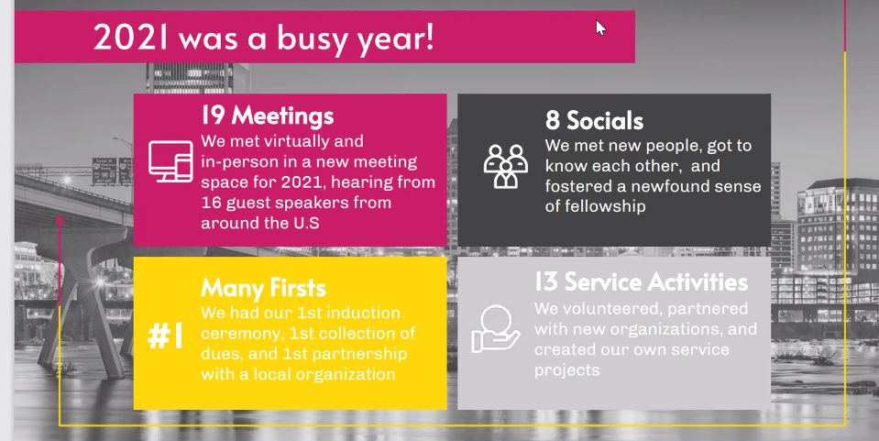

They did a number of fun service projects including picking up trash, helping at the food bank and planting trees.

They would like our help in recruiting members to clubs.

After Judson led the Club in the 4-Way Test, Brenda adjourned the meeting at 7:32 p.m.

Michelle Nelms

