2016 Foundation Awards Banquet
Rotary District 7600
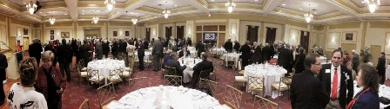 Panorama courtesy of Bill Billings
Thursday, November 10, 2016
Colonial Heritage Golf Club
6500 Arthur Hills Drive, Williamsburg, Virginia
Keynote Speaker
John Smarge
Past Rotary International Director

Featuring
2015-16 Club Foundation Awards
^
Outstanding Alumni Award
^
James Pierce Leadership Award
^
Americana Buffet
Cash Bar 5:45 pm
Dinner Seating 6:45 pm
$45 per person
Register on dacdb.com
October 1 - November 3

Business Attire

Contact Carol Woodward for additional information woodwardcd@aol.com 804.691.8486
