Name of Project: Build a four unit preschool classroom block and three toilet blocks for the Yawhima SDA Basic School in Sunyani in the Bono Region of Ghana.
- PLANNED ACTIVITIES
Tell us a little about your project. What are the main objectives of the project, and who will benefit from it?
Our goal for Rotary Global Grant 19-82390 is to build four classrooms for Yawhima SDA Basic School for use as a preschool and three toilet blocks in Sunyani in the Bono Region of Ghana. The preschool will have four classrooms for Kindergarten 1(A & B) and Kindergarten 2 (A & B). It will also have an office and a small storage area. The preschool will also be supplied with books, desks, chairs, tables and training will be provided to the teachers and attendants who are already teaching in the school and paid by the government. We will also provide three (3) toilet blocks of ten Microflush toilets each for the school: one for the new preschool, and one each for the two existing basic school blocks. The current school blocks do not provide access to sanitation for the students or faculty. It is our plan to provide access to sanitation for all the students attending school at Yawhima SDA Basic School. The total project budget is $59,969.
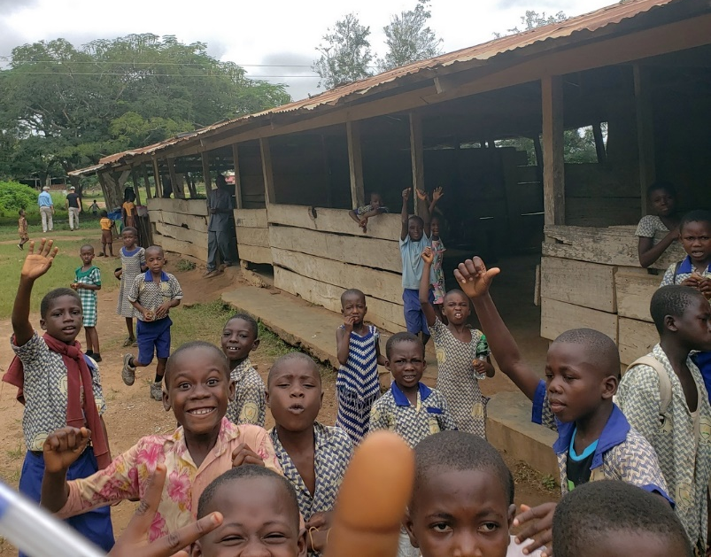
Yawhima SDA Preschool is a temporary school structure. This project will correct the unhealthy learning situation and provide the kids with opportunity to learn and build strong foundations before proceeding to first grade. We have a very strong partnership with the Sunyani Municipal Assembly on previous projects. This project will explore further, the partnership we have with the Municipal Assembly and the Municipal Education Department to successfully implement this project. Yawhima Elementary School is in the city of Sunyani.
A borehole was drilled for the primary school to provide safe drinking water for the school children and the community in 2013. The preschool will have electricity from the national grind and an eLearning board that will use offline learning materials. A 40" LED screen and computers will augment the learning environment. The host Rotary Club is Sunyani Central led by Assistant Governor Frank Kofi Owusu Debrah and President Dominic Mary Kornu. The international Rotary Club is Prince George County, VA led by Assistant Governor Shel Douglas and President Mark Creech. Walter K. Hughes, Jr., Rocky Mount Rotary Club, is partnering on the project.
Photo 1: The existing Yawhima Preschool was built and supported by the community.
Areas of Focus
Which of the following activities will this global grant fund?
- Basic education and literacy

Which goals of this area of focus will your project support?

- Involving the community to support programs that strengthen the capacity of communities to provide basic education and literacy to all
How will you measure your project’s impact?
Measure | Collection Method | Frequency | Beneficiaries
Number of benefiting school-age children | Public records | Every year | 100-499
Number of new school-age students | Public records | Every year | 20-49
Other: Number of Students enrolled with access to microflush toilets | Grant records and reports | Every year | 100-499

Do you know who will collect information for monitoring and evaluation?
Yes.

Briefly explain why this person or organization is qualified for this task.
The Sunyani Municipal District Education Directorate is the district administrative body responsible for supervision, management of educational statistics, training and development of pedagogy and teacher training, and, generally, in charge of all pre-tertiary educational institutions and activities at the district level. The office has administrative and technical staff that does annual data collection and processing for decision making at local and national levels. The office will be vital to the implementation of the grant activities.
The Directorate will be responsible for providing and training the teachers for the Yawhima Preschool. The Education Directorate will provide trained teachers and attendants, who are employees of the Education Directorate.
Also, Sunyani Central Rotarians including Assistant Governor Frank Kofi Owusu Debrah and President Dominic Mary Kornu will be very active in collecting the metrics for this global grant. They and their fellow club members are passionate about education.

COOPERATING ORGANIZATIONS PARTNERS
List any other partners that will participate in this project.

Sunyani Municipal District Education Directorate,
Ghana Education Service, Opposite Presbyterian Church, Sunyani –Odomase Road, Sunyani, Ghana

Sunyani Municipal District Assembly, PO Box 25, Sunyani, Bono Region Ghana

Why did you choose to partner with these organizations? What are their roles?
The Sunyani Municipal District Assembly is the political body for administrative of central government policies and programs in addition to local political initiatives. The Sunyani Municipal District Education Directorate is the mandated body responsible for management all pre-tertiary education activities. They both bring on board the technical, political and supervisory resources and technical expertise necessary for the collaborative implementation of the project.
We've trained many new Microflush toilet makers in the Sunyani area over the last five years to implement the Microflush toilet technology which has improved sanitation in our communities successfully. Seth Jiam owns Sukoff Ventures. He is experienced Microflush toilet business based in Sunyani. Seth Jiam has been a trusted partner to build Microflush toilets and to provide UNICEF WASH training or WATSAN training when it is needed. Seth is also an excellent trainer for how to maintain the school borehole and Microflush toilets.
Where will your project take place?
City or town: Sunyani
Province or state: Bono Region
Country: Ghana

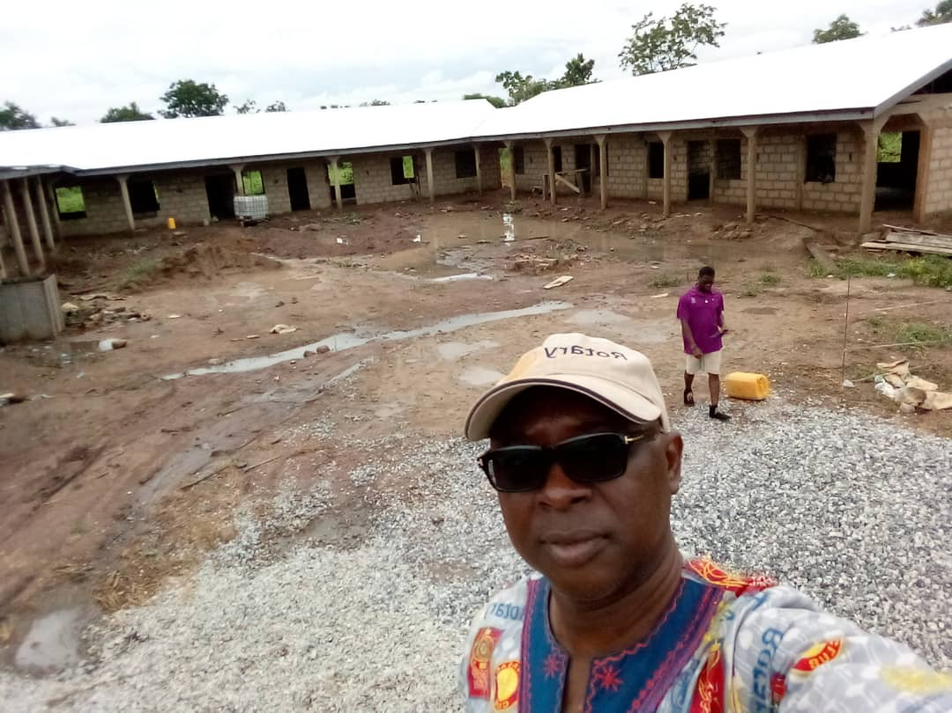
When will your project take place? 1 May 2020 – 31 December2021
ROTARIAN PARTICIPANTS
Describe the role that host Rotarians will have in this project.
The need at Yawhima Preschool was presented by the school first to Sunyani Central Rotarians in a written request in April 2019 and then again, when host and international partner Rotarians visited the school in September 2019. The Sunyani Central Rotarians will be directly involved in selecting a contractor, supervising and monitoring of the implementation of the project, and reporting on grant activities as well in active partnership with the PTA, the education office, municipal assembly, and international Rotarians.
Photo: AG Frank Kofi Owusu-Debrah and President Kafui Kornu inspecting Soronoase Elementary School in 2019.
The Rotary Club of Sunyani Central is very involved in planning this global grant. They will lead follow up meetings and phone calls. The host Rotarians explained to the Yawhima community leaders and School PTA members the need for them to volunteer time and resources to enable Rotary funding to achieve more work. The community leaders are expected to take ownership for solving their own problems with our help. The Sunyani Central Rotarians are actively meeting with cooperating organizations. The Sunyani Central Rotary Club regularly meets to discuss and plan for global grants. In addition, the progress of grant applications are discussed regularly at club meetings. The same will continue during implementation. Rotarians will travel to the work sites to monitor and evaluate the progress of the activities being funded. The host Rotarians will manage the budget and checking account, write checks, and collect the receipts. The Sunyani Central Rotarians have extensive expeience with managing Rotary global grants. The Rotary Club of Sunyani Central met with the international Rotarians in February and September of 2019 to plan this project and to review the results of the previous global grants.
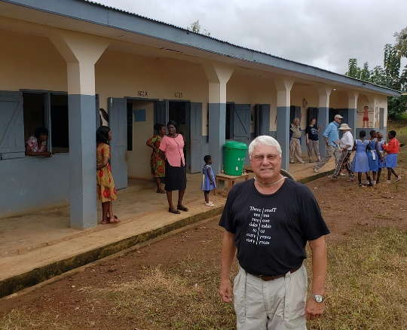
Describe the role that international Rotarians will have in this project.
The Prince George County Rotary Club, Virginia will be the implementing international Rotary Club. They will partner with many other Rotarians who will help fund and implement the project. Walter Hughes of the Rocky Mount Rotary Club, VA, and other international Rotarians met with the Sunyani Central Rotarians in February and September 2019 to plan this project and to see the results of the previous global grant. Gary Bradham, Peter Verbeeck, PRID David Michaux visited Estate Experimental Preschool (see photo on left.) Stephen Beer, Amber Wilborne and Shel Douglas joined in the review of the existing projects. The international Rotarians are very active in keeping the donor international Rotarians informed of activity of the Rotary Foundation.
The international Rotarians are involved in communication with the cooperating organizations, host Rotarians, and some of the contractors. International Rotarians travel to Ghana to plan the work to be done to provide adequate sanitation, improved access to water, and simple schools. International Rotarians are raising funds and providing updates to the funding clubs and districts. Also, presentations are being made at club meetings and district conferences. Press releases will be sent to local newspapers about the work in Ghana. We will also provide information for the Rotary Foundation; provide videos, and blog for their World Health Day articles about clean water. The international Rotarians are publishing articles in local newspapers and newsletters telling the story of the needs in Ghana.
The international Rotarians are actively working to raise funds in the USA and Canada. Many of our international Rotarians speak at local clubs, district conferences, and zone meetings to raise awareness and support for our projects in Ghana.
International Rotarians, like Shel Douglas of D7600, communicate with host Rotarians and cooperating organizations on planning, design, implementation, and reporting of grant activities. International Rotarians visit annually to tour and inspect all grant activities. The international Rotarians work with the host Rotarians to review and approve the choice of suppliers, contractors, and payments for the agreed upon grant activities.
What local currency are you using in your project’s budget?
GHS Ghanaian Cedi $1 = 5.71 GHS
What is the budget for this grant?
List each item in your project's budget. Remember that the project's total budget must equal its total funding, which will be calculated in step 9. Every global grant includes a match of at least 15,000 USD from The Rotary Foundation's World Fund. Project budgets, including the World Fund match, must be at least 30,000 USD. Photos Below: This is the existing preschool building with preschool and elementary school children smiling to welcome the host and international Rotarians from the USA.

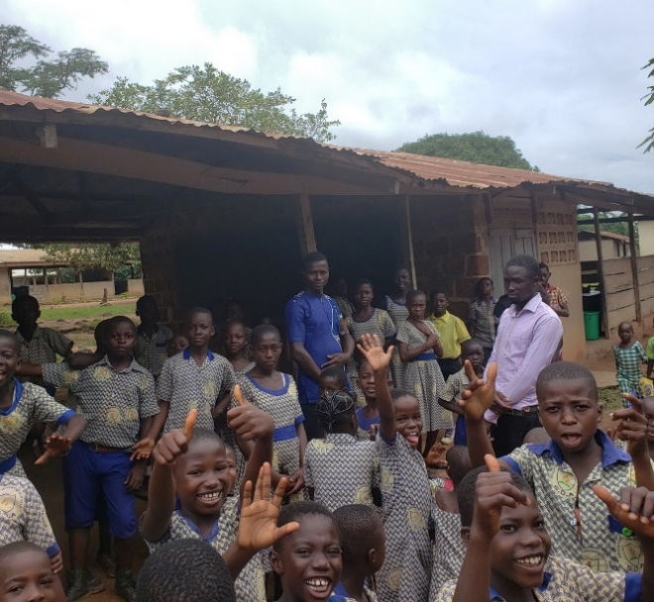
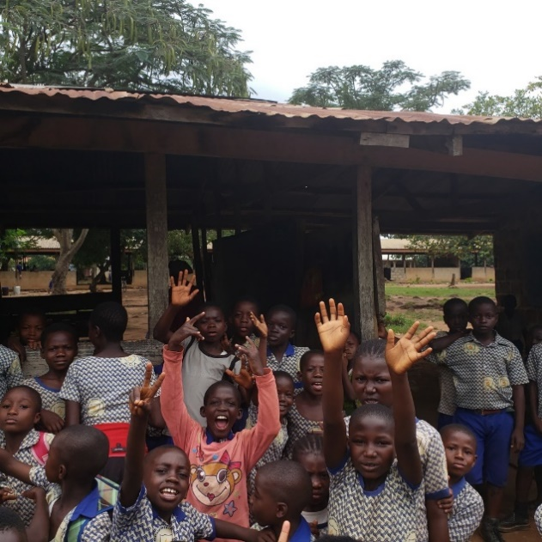
TOTAL BUDGET FOR PROJECT

FUNDING FOR PROJECT

DETAILED BUDGET
TEXTBOOKS, LIBRARIES AND TECHNOLOGY

Sustainability
Sustainable projects provide long-term solutions to community problems — solutions that community members themselves can support after grant funding ends. Your answers to the questions below will help us understand the components of your project that will make it sustainable.
HUMANITARIAN PROJECTS
Project planning
Describe the community needs that your project will address.
Yawhima Basic School has been teaching children for many years with the PTA exploring potential sponsors to help them address the need for a permanent preschool building. Yawhima Elementary School has two school blocks on the site. A new preschool building would support early learning opportunities for vital early childhood development skills and provide training to children from the suburb and surrounding low income communities.
Building a preschool in the community for children younger than age six with access to literacy and sanitation will provide families with greater resources. Access to preschool will no longer be limited to only those who can afford to be sent to neighboring districts. Early childhood development and learning will be supported by a new school preparing children for even greater success by the time they reach the elementary and higher-level classrooms. Additionally, starting toileting practices at a preschool age ensures a greater likelihood of developing a lifetime of positive hygiene practices. Providing access to toilets throughout the school will increase the likelihood that the toilet practices started in preschool will not only continue to be available to those students as they progress through their school levels but will be reinforced by the modeling of older students around them.
How did your project team identify these needs?
The parents and teachers have been raising money to mold concrete blocks to build a permanent school block. They’ve funded and molded hundreds of concrete blocks but haven’t been able to find and engage a potential partner to build their preschool. The need was identified through Sunyani Central Rotary Club's interactions with the school on many visits. The Sunyani Central Rotarians prioritized the need for a new school and brought it to the attention of the international Rotary team in September 2019.
In addition to the school structure, the project will include three (3) blocks of 10 Microflush toilets for the students and teachers. One toilet block will provide access to sanitation for the new preschool classrooms while the other two toilet blocks will provide access to sanitation for the current students attending Yawhima SDA Elementary School. There is currently no access to sanitation for these students. Providing microflush toilets throughout the school for all students has been a primary goal for the community leadership and is an important component of this project.

How were members of the benefiting community involved in finding solutions?
The request for the new school is the initiative of the Yawhima PTA. The PTA brought out the need to the Sunyani Municipal Chief Executive. They offered to support the project with building materials and their unskilled labor. Host Rotarians visited the existing school to discuss and confirm the needs as presented by the PTA. The host and international Rotarians were impressed that the parents and teachers were saving money and molding concrete blocks to show their seriousness for the effort.
The community asked Rotary to include toilets in the school project. The project will use the microflush toilet designed by Dr. Stephen Mecca of Providence College in Rhode Island. Dr. Mecca designed a solution for the sanitation needs for schools and household across Ghana. This Microflush toilet is a low-cost, off-grid, sustainable, and environmentally friendly toilet. It avoids bad smells, flies, and danger to the sources of local drinking water. Dr. Mecca won a grant from the Bill & Melinda Gates Foundation to build the prototype toilets several years ago.

We plan to use the Microflush toilet design at a cost of about $500 per school toilet stall. The school children wash their hands in a sink next to the toilet. The design allows for one (1) cup of grey water from a user’s hand wash to drain from the sink into the toilet. The grey water in turn will be used to flush the waste in the toilet for the next patron.

A patron’s flush of waste falls directly into a filter-digester where the solids and liquids are separated. The solids are composted in an aerobic process enhanced by simple red wriggler earthworms (E. fetida) found everywhere in the world. The small filtrate volume is processed naturally in a soak hole – a miniature version of a rural leaching field in the US. There is no dislodging of sludge or transporting it to a waste processing plant. Every two years, the rear cover of the toilet is removed and organically rich compost is harvested for use in farming. We will continue to train local businessmen and contractors to build the Microflush toilets. The microflush toilet blocks for schools are being used throughout Ghana, Africa and the world. Below, is a Microflush toilet school block built in Ghana by a previous global grant.
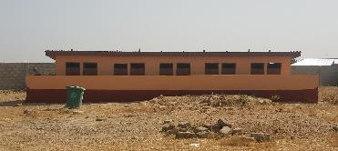

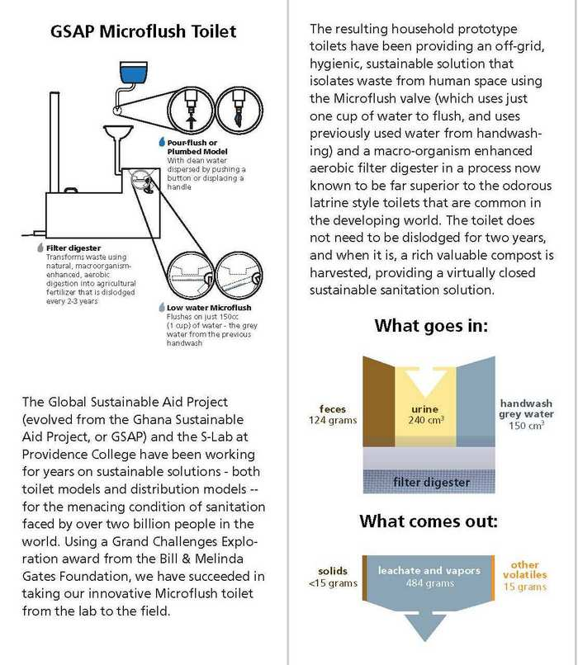

How were community members involved in planning the project?
- The PTA brought out the need as the school's priority at previous project inspection visits and discussions.
- The PTA has already started mobilizing resources in the form of a supply of materials to help implement the project such as concrete blocks.
- The PTA gave suggestions as to the building design and materials to be used.
- The PTA has members on the project implementation committees to articulate their concerns and suggestions.
- Local government authorities through unit committees and area councils and the development planning offices do community needs assessments and establish development priorities to inform decision making and cooperative action for community development. The project is within the priority areas of the municipal assembly.
Will you work in coordination with any related initiative in the community? Yes
Briefly describe the other initiatives and how they relate to this project.
Rotary funded a mechanized borehole at Yawhima Elementary School in 2013. Sunyani Rotarians are very active in local elementary schools in Sunyani. The US and Ghanaian Rotarians visit the school to check on the stewardship and sustainability of the previous Rotary WASH project. We learned in September 2019 that the water project is well maintained. It is our belief that making a long-term commitment in our communities is a great way to empower communities and schools to plan ways to dream and get things done on their own and in partnership with Rotary.
Please describe the training, community outreach, or educational programs this project will include.
The Sunyani Municipal District Education Directorate identified these needs and recommended these training components, especially for the preschool teachers to improve their capacities to effectively facilitate teaching and learning.
Training will be provided in the following:
- Sanitation, hygiene, and child care knowledge and skills for recruited attendants.
- Regular refresher training for professional teachers posted to the school.
- Preschool management, usage of instructional materials and teacher-pupil relationship management.

Project implementation

TRAINING MATRIX

How were these needs identified?
The needs are the recommended training needs by the Municipal Education Office especially for preschool and basic school teachers to improve their capacities to effectively facilitate teaching and learning.
What incentives (for example, monetary compensation, awards, certification, or publicity), will you use, if any, to encourage community members to participate in the project?
Teacher trainees will be given certificate of attendance by the Sunyani Municipal District Education Directorate which will add to the curriculum vitae of the teachers and attendants and the other participants. This aids significantly in time of promotions evaluations. The teachers and attendants will be placed on the public payroll and be paid monthly by the Ghana Education Service. They will thus be automatically enrolled into the national social security scheme for the Tier 1 and 2 and thus benefit from secured retirement packages. The community is encouraged to support the teachers and attendants with foodstuffs as a means of local motivation. Other than access to greatly improved school facilities and learning opportunities, the school project with microflush toilets itself will not offer incentives to local community members. Many children in this community have never had access to a toilet.
List any community members or community groups that will oversee the continuation of the project after grant-funded activities conclude.
Yawhima Parent Teacher Association (PTA), Sunyani Municipal District Assembly, Sunyani Municipal District Education Directorate, and the Chief and elders also commit to be good stewards of the Yawhima Preschool.
BUDGET
Will you purchase budget items from local vendors?
All contractors are local businessmen. All parts will be manufactured and purchased within Ghana. We will not be importing equipment from the USA. All budget items align with the local culture and technology standards. Everything purchased will be locally available.

Did you use competitive bidding to select vendors?
A market survey is done and bids will be requested from at least three vendors. The project committee then meets to discuss the bids to decide on which to choose to supply the needed items. Even when we settle on a vendor or contractor, we still negotiate prices where possible so we can achieve more within the budget. The common criteria we have used in the past have been the lowest cost bidder with superior quality items or technical capacity to deliver within stipulated duration.

Do any committee members have a potential conflict of interest related to a vendor or community?
No. None of the US or Sunyani Central Rotarians have any conflict of interest related to this project.
Please provide an operations and maintenance plan for the equipment or materials you anticipate purchasing for this project. This plan should include who will operate and maintain the equipment and how they will be trained.
The School Management Committee and the PTA shall conduct inspection every three months at the school and document any defect, leakage, cracks, etc., and report same to the Sunyani Municipal District Educational Directorate and the Municipal Assembly. Local artisan and trained community members with appropriate technical capacities shall then be employed to correct the defect or leakage or crack, etc. Attendants shall carry out daily cleaning of sanitary facilities, classrooms, compound and the community shall undertake monthly communal labor to clean the surroundings of the schools.
Describe how community members will maintain the equipment after grant-funded activities conclude. Will replacement parts be available?
All the construction equipment and instructional materials are locally available. PTAs are granted permission in Ghana to levy the pupils for use in the schools. The PTA will thus use part of its levy collected from pupils to undertake routine maintenance works and supplies in the school. The PTA shall have a dedicated account with a recognized local bank for its levy and managed by the PTA leaders.
All repair parts for the sanitation components of the project are readily available within Ghana. The beneficiaries will possess the skills to operate and maintain the equipment after the necessary Committee training is completed. The books, desks, chairs, and solar panels are all purchased locally.
If the grant will be used to purchase any equipment, will the equipment be culturally appropriate and conform to the community’s technology standards?
All equipment and instructional materials that will be supplied shall be verified and certificated by the Sunyani Municipal Education District Directorate and PTA as being culturally acceptable and child friendly before being purchased and supplied. The desks, chairs and tables are standard for preschools in Ghana.
After the project is completed, who will own the items purchased by grant funds? No items may be owned by a Rotary district, club, or member.

The school is a public school and therefore the property of the Government of Ghana. The Sunyani Municipal Education District Directorate represents the government at the local level and thus has the responsibility of custody for the public use. The Sunyani Municipal Education District Directorate is responsible for supervising the school's activities including personnel and curriculum and evaluation and use of materials for instructions and play.

All equipment will be owned by the local community and school that we are serving. None of the items will be owned by a Rotary club or Rotarian.

FUNDING

Have you found a local funding source to Sunyani Municipal project outcomes for the long term?
Yes:
- Sunyani Municipal Education Directorate shall provide for the school needs and staff.
- PTA levy for routine maintenance works.
- The Sunyani Municipal District Assembly Common Fund makes annual allocations to local governments for infrastructure and services provision at their jurisdictions.
- The Yawhima SDA Elementary will have a WATSAN Committee to raise funds to maintain the borehole at the school.
Will any part of the project generate income for ongoing project funding? If yes, please explain.
No. The PTA levy paid by pupils and managed by the PTA is considered public funds and therefore require to be used only on the school's improvements. The funds will be used for routine maintenance, supply of reading and learning materials, teacher motivation where possible and general school support activities.

Questions from the Rotary Foundation

Topographic site map that shows that the site of the school is above the flood plain. An area site plan that includes the locations of the intended simple school buildings, roads, public transit access points, home and communities that would benefit from the school, neighboring future development sites, and any demolition sites near the property.
Answer: Yawhima is within the city of Sunyani. Yawhima SDA Preschool is located at the red dot on the map below. https://goo.gl/maps/o5wacD2LWNMYP2UN9. The latitude and longitude is 7°20'46.7"N 2°15'04.6"W.
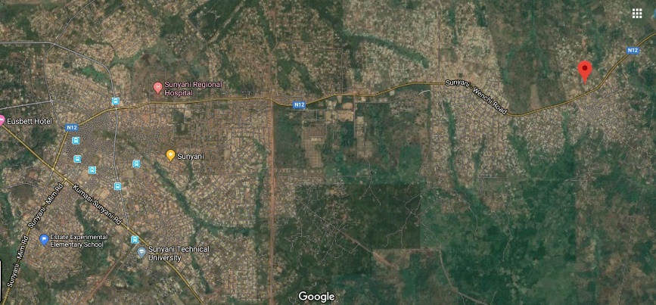
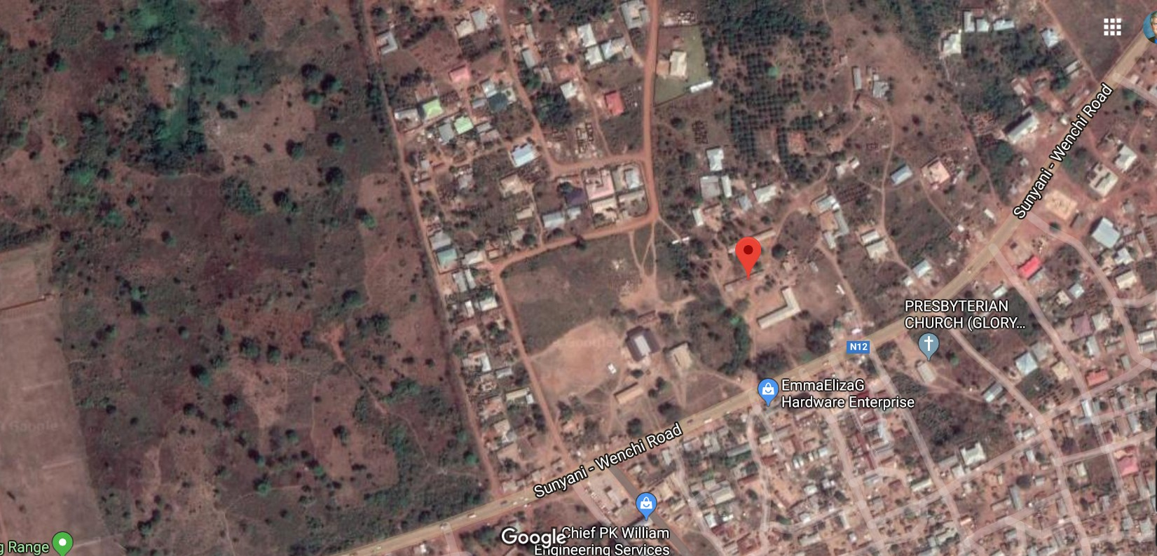
Map 1.1 This is the Google Map showing the school in relationship to streets in Sunyani.
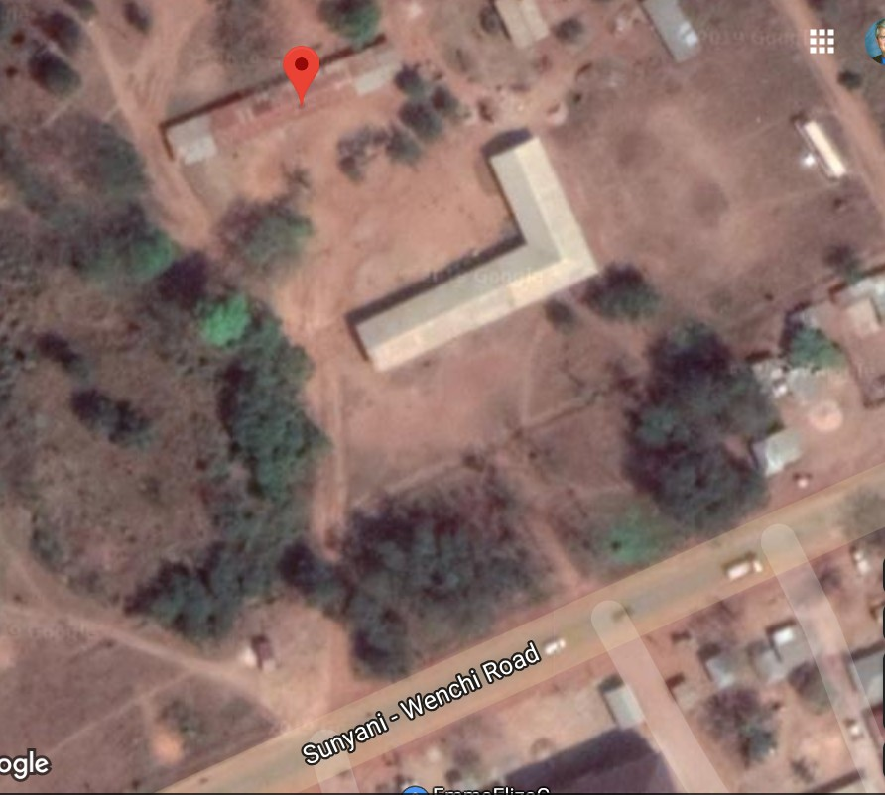
Map 1.2 This is the Google Map showing the major roads meeting in Sunyani. Yawhima Preschool is at the center of this map.

Map 1.3 This is the Google Map showing the community. The existing school buildings are near the red dot.

- Building site plan (relation to other school buildings, school kitchen, toilets, hand-washing stations, water storage on site, waste removal system, administrative buildings).
ANSWER: The site plan shows the location of the new school building. The school currently has no toilets or, hand-washing stations, waste removal system, or preschool classrooms. The land for the preschool is already owned by the school. The land does not currently have any homes or other structures on the site.
- Soil contamination documentation from the site.
Answer: The soil around the Yawhima School is not contaminated. There is no gold mining in this neighborhood. The existing school does not have a toilet block. The Sunyani Municipal District doesn’t have soil testing equipment to identify pollution in the soil. We will provide Sunyani Municipal a report on the information that the engineers are able to provide. Those reports will be provided once the testing has been completed.
- Letter from the local government that states that there are no legal encumbrances on the land, the land is not the subject of any disputes, is zoned for school construction, and is suitable for the purposes of the global grant
ANSWER: The existing Yawhima School PTA and Sunyani Municipal District Assembly highly support this project. There are no legal encumbrances on the land. There are no disputes. The land is suitable for our global grant. The land is already school property prior to this project. The preschool will be built on open space on the existing Yawhima School grounds. It is already zoned for school construction by the Sunyani Municipal District Assembly. There’s no need for an additional letter since the ownership of the school property is already established.
Ghana receives high wind and rain storms. Please also include a detail section drawing of the roof ties to the building structure
Answer: The photograph 5.1 below is also very helpful to show how buildings are constructed in Ghana. Please notice the support columns that are tied bars of rebar with poured concrete around the rebar column. The rebar extends to the roof level. The rebar will be connected to the roof beams with the “lentil level” (See Photos 5.2 & 5.3). The effective design provides “hurricane straps” from the walls to the roof. (See Photo 5.4) The hurricane straps will help to prevent the roof from blowing off. Also, we set a standard for the distance between the roof rafters so that there is more strength in the roofing structure. The poured length of concrete called the lentil will connect the support columns below. This is a photo from a construction site in Ghana to show our knowledge of school construction. We have a detailed side section drawing below called Figure 5.5. This is very standard construction methods in Ghana.
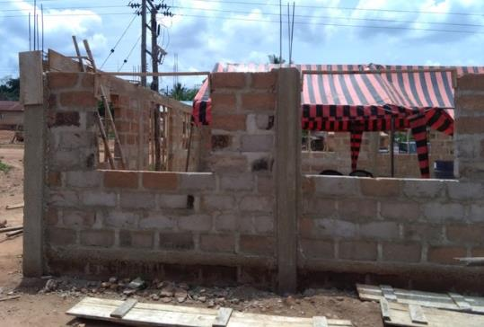
The columns are poured concrete around rebar. See arrows.
Photograph 5.1 Rebar columns give strength to walls and in turn the roof.
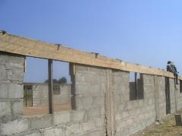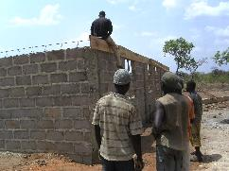
Photographs 5.2 and 5.3 show the construction of the lentil level. Rebar is tied together. A frame is built to pour the concrete that ties the walls together and gives it strength. The lentil level and the hurricane straps help the school withstand strong wind storms.
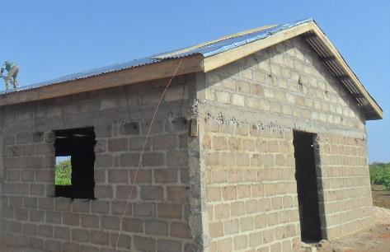
Photograph 5.4 "Hurricane straps” made of strong metal ties roof into the wall.
The poured lentil is above in Photographs 5.2-5.4 with the solid poured concrete level above the laid levels of concrete block in the walls. The “hurricane straps” connect the strength of the walls into holding the roof down during strong wind storms in West Africa. The purple arrows show how the roof is secured into the strength of the concrete block wall. The exterior wall will be finished with stucco so the straps will not be noticed in the end.
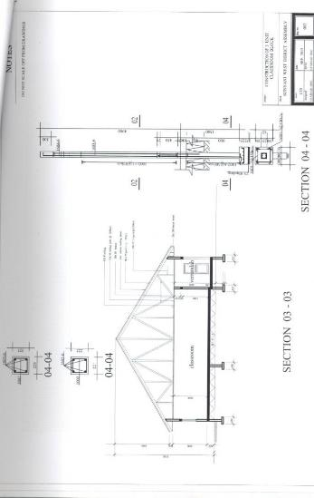
Below are the architectural drawings for the new school building.
Detailed Sectional Drawing included in the school plans.

Figure 5.5 Wall drawing
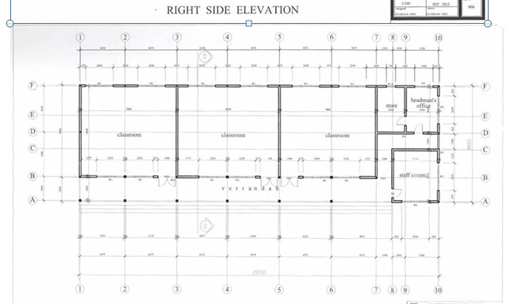
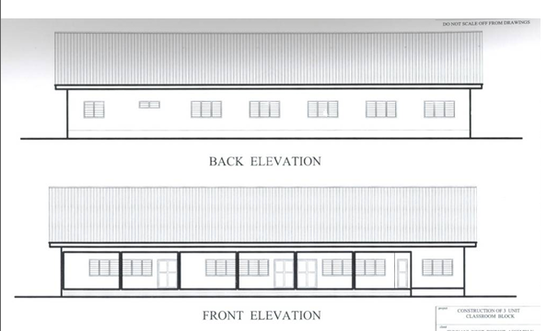
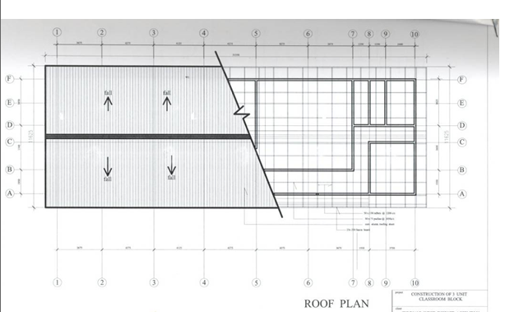
- Donor Letter. The Yawhima Preschool will be owned by the Sunyani Municipal District Assembly. Rotary does not have any legal liabilities except to be a good steward of the construction funds. The property is adjacent to the location of the existing school built by the local PTA and is zoned for a school.
- MOU with Education Office. Thank you for providing MOU’s with the Sunyani Municipal Municipal assembly and the Sunyani Municipal Education Directorate that describes the role of each of the government agencies in the creation of this school. Please work together to create an additional MOU that does not follow our standard MOU format but instead one that follows the format included in the Guidelines and Appendix beginning on page 1 and ending the middle of page 2, which lists the following items to be included in the MOU with the education department. The information is in GG_19-82390_MOU_Sunyani Municipal_District_Education_Directorate.pdf .
- Name of school: Yawhima School
- Number of students anticipated: 20-30 for each class.
- Number of teachers anticipated: Minimum number of 6.
- Education levels, or grades, of school: Kindergarten through sixth
- Size of school: 90 students in the Yawhima SDA Preschool
- Agreement to form a school management committee: School Committee agreement is done. Please see
GG_19-82390_Project_Implementation_Committee_Yawhima_Elementary_School.pdf.
- Verification that all stakeholders agree to be involved in planning and implementation throughout the project’s lifecycle
Answer: Agreed in the Implementation Committee document.
- Verification that the government’s education office or the owning entity, in the case of a private school, agrees that it will not sell or lease the school or conduct other business in the school within the first five years of occupancy.
Answer: Agreed. The Yawhima Preschool has a long-term plan to educate students from this community and the surrounding area.
- Confirmation that the teachers, students, and maintenance staff will complete the training agreed upon in the application.
Answer: The teachers are trained by the government of Ghana. The PTA will be trained how to maintain the new preschool.
- Verification that the teachers are trained and certified by the government’s education office.
Answer: Done. Please read the school MOU. The teachers to be recruited or posted to the school by the Sunyani Municipal Education Office are professionally trained teachers. They have gone through 3 years of training in either a Teacher Training College or a University offering Teacher Training curriculum all aspects of pre-tertiary education level pedagogy, psychology, education, classroom management, use of teaching and learning materials, English, mathematics, science, social studies, music and art, etc. Within the three years of training, trainee teachers undertake one full academic year of practical teaching under the supervision of mentors and supervisors. They are either certified as Teachers with Diploma in Basic Education or Bachelor of Education degree with professional registered numbers. The training the grant is proposing to provide refresher training.
- Verification that either the government’s education office or the owning entity, in the case of a private school, will be responsible for paying all utilities.
Answer: This has been agreed to. Please read the school MOU.
- Acknowledgment that teachers must be hired and certified before the project can be closed.
Answer: This has been agreed to. Please read the school MOU. The teachers will receive at least three years of training before they teach at the school by the government of Ghana.
- Verification that those benefiting from the school are neither Rotarians nor their lineal descendants.
Answer: Please read the school MOU. Rotarians do not own or work at the school. Family members of Rotarians will not benefit from the school.
- Confirmation that Rotary’s responsibility is limited to the amount of the grant award.
Answer: This has been agreed to. Please read the school MOU. Rotary’s responsibility is only the amount of the grant award.
- Verification that the government or owning entity of the private school will be responsible for maintaining the school and property.
Answer: This has been agreed to. Please read the school MOU. The parents constructed the existing school building. They have an active PTA. The PTA, with the approval of the Education Directorate and local government authority, levy each pupil a token amount every school term. The proceeds are managed and expended by the PTA for the school’s improvements and maintenance.
- Verification that tuition will not be charged for public schools and that tuition costs for private schools will be reasonable and affordable.
Answer: This has been agreed to. Please read the school MOU. The parents will be assessed fees for the school as needed.
- Provision of Electricity. One of the requirements established by the Trustees for Simple Schools applications is that electricity be provided to the school either by municipal power entities, through solar panels, or other means. We want to ensure that the school can grow with the needs of the students and function even during times of the year where sunshine may be low or in a raining season. The application states that there is currently a government initiative to provide electricity to municipalities. It may be beneficial to seek out the government office personnel and see if the community could be a pilot community. Please discuss how the project partners would like to proceed with this requirement.
Answer: The Yawhima Preschool will have access to electricity for running computers. We will use solar panels to provide LED lights to reduce operating costs at the school.

- Trainer Qualifications and Duration. Please provide the names and training qualifications for all trainings that are completed with this project, along with the frequency and duration of each of the trainings.
Answer: Seth Jiam of Sukoff Ventures will be available for the Water, Sanitation and Hygiene training. There will not be the master trainer for the additional training for the new teachers at the school since the education directorate will be providing trained teachers for the school.

- Teacher Training Curriculum. Please clarify what specific skills the teachers would have after the completion of the new pedagogical teacher training.
Answer: Please see the trainer’s qualifications GG_19-82390_Trainers_Qualification_Yawhima_Preschool.pdf. Lydia Abrafi Nsiah will be the lead trainer.

- Emergency Procedure Training. To ensure that the teachers are trained to assist children in the case of an emergency; teachers should receive training on how to evacuate children safely from the building. Please see that includes plan to teach about emergency evacuation procedures.
Answer: Please see GG_19-82390_Evacuation_Diagram.pdf

- Maintenance Training for Maintenance Personnel. The guidelines state that training is required for
Answer: Please see the maintenance training identified on the training grid.

- Teacher to Student Ratio. Please provide the teacher to student ratio for the existing school, as well as for the new school building. Please provide this by grade level, including nursery, preschool and kindergarten classroom.
Answer: The teacher student ratio will be one teacher to 20-30 students for each grade. The existing building will no longer be used once the new school has been constructed.

- Building Permits and Insurance. Please clarify who will be in charge of acquiring building permits to complete construction on-site, as well as who will be purchasing construction insurance for the project.
Answer: The Sunyani Municipal Assembly is the statutory planning authority for the project area and therefore, the assembly which is a cooperating partner will issue the Building Permit for the construction site. For insurance, construction laws in Ghana require contractors and building owners to procure insurance for workers and third parties. Contractors provide the insurance as part of their bids for evaluation before the award of contract to start construction. They are also required to secure the construction parameters and provide security. The project implementation committee and municipal assembly will ensure this is followed and done. The contractors who bid on the preschool include building insurance as part of their bid. The contractor in partnership with the PTA will obtain the necessary building permits.

- Question: Plans and sections of the toilets that will be provided with this project.
Answer: Please see the plans. The training material that is provided to the Microflush toilet maker is provided. The training material is only given after the half day classroom training. Please see the plans and information in Microflush Toilet Maker manual 18 Nov.pdf. We use three standard designs for school Microflush toilet blocks. Photograph 15, Photograph 16 and Photograph 17 show the three styles of Microflush toilet blocks.

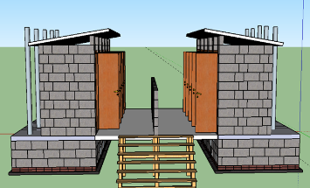
Photograph 15: Toilet blocks facing each other.
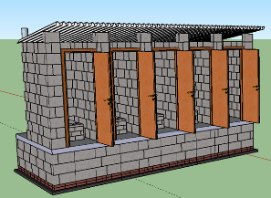
Plan A: (Left) Shows school boys and girls Microflush toilets for the Yawhima Preschool toilet blocks. The roof line is reduced and streamlined.

Plan B: (Right) Shows one side of Microflush toilet stalls for either the boys or the girls. Each stall serves 25 students. We will provide enough stalls to satisfy the school population.

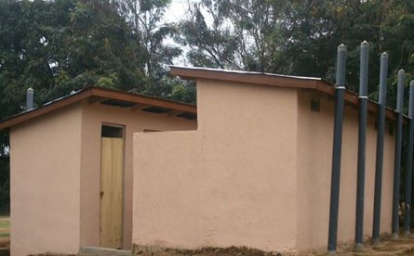
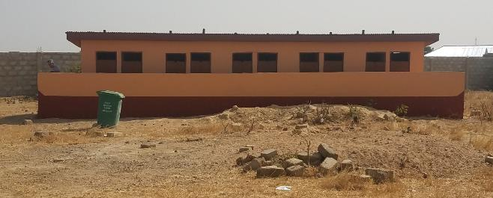
Photograph 16: Microflush toilet school block following designs in Plan A & B.
Photograph 17: Microflush toilet school block in Bolgatanga, Ghana. It is like Photograph 16 except the boys’ and girls’ blocks are not facing each other.
- Question: Water testing documentation – done.
Answer: The borehole for Yawhima borehole report and water quality report is available from the grant 17-72693.

- Question: Construction management. The budget provided includes a 2% allocation towards project management. Does this include costs for construction management? Beyond project management, we also strongly suggest simple school projects include a licensed construction manager to ensure the contractors are coordinated, the construction timeline is met and that the quality of construction is maintained. Could you please discuss your plans for construction management in any capacity?

Answer: The Sunyani Municipal District Assembly will provide an engineer who is part of the management team as their cooperation contribution to oversee the construction. The district engineer’s name is Engineer Gift A. Y. Larnyoh. Rotary will fund his travel to and from the preschool construction site and pay his fee to supervise the construction project. We will sign a MOU with the district to identify the tasks that he will be responsible to make sure the construction goes smoothly. In addition, Engineer Gift A. Y. Larnyoh approved the design of the school.

- Question: Fire abatement. Please confirm that adjacent rooms will have appropriate fire abatement materials used in the separating wall.

Answer: The buildings have concrete block walls between the classrooms which will provide fire abatement. The concrete block walls will prevent fire from spreading. We will also install a metal roof which prevents the school from catching fire from the roof. The floor will be made of concrete which also reduces the fire risk.

- Question: Please provide information about the utility access drawings.

Answer: We are using solar panels that will be installed on the roof of the school. The borehole is located adjacent to the school grounds and available to both the school and the local community. The donated school land is accessible to the community and food/markets. The school will not be connected to electrical or water lines.

- Question: Safety design. Please confirm the safety provisions the school design encompasses (for example lockable doors and windows). Please also confirm the construction site will have proper security measures.

Answer: The preschool has concrete block construction, so it is safe from most fire threats. We have one classroom that will have metal burglar proof windows and doors in addition to regular windows and doors. The rest of the windows and doors will be locked. We will have a secure and lockable storage safe to store the computers and related equipment. The contractor will provide a safe work environment. The school children will be kept out of the construction site.

- Question: Sanitation & Hygiene Training: please discuss the qualifications the host Rotarians must train the children to use Microflush toilets.
Answer: Host Rotarians have secondary responsibility for training. Seth Jiam of Sukoff Ventures will be available to supervise the WASH training and the use of the Microflush toilets. He has extensive water and sanitation background. The training will focus on the UNICEF standard training material. Seth was trained by Michael Anyekase who is also an expert Microflush toilet trainer who is working all over Ghana. Host Rotarians of the Sunyani Central Rotary Club have been in WASH for many years, the club also has health workers (nurses) who will volunteer their time to undertake the H&S component of the project.

- Question: Menstrual hygiene management training: please provide the curriculum for this training which the Simple School Guidelines require projects to provide teachers.

Answer: This is a pre-school program so menstrual hygiene management training will not be part of the curriculum for working with this age group of students.

- Question: School budgeting and financial management training: please provide the curriculum for this training which the Simple School Guidelines require the school management committee to receive.

Answer: . Sunyani Central Rotarians have extensive experience with finance. The club can draw from resources of its membership and the region to review the school budget and financial management. Also, MCE Dr. Evelyn Ama Kumi- Richardson will bring in her District Education Director, Theresa Kyere-Boakye, to review the financial management of the school as it is incorporated into the Sunyani Municipal District Education Department. We have gathered significant financial training materials from Franklin County, Virginia as resources to include the four Blue Book training volumes. We also have a beginner’s guide to planning and managing school finances.

- Question: What about handicapped Microflush toilet design?
ANSWER: We are including our handicapped design from our US work at Camp Creek State Park in West Virginia. The dimensions are the same; we just have to adjust to what is expected in Ghana compared to a state park.
The bottom slab can be 64 in x 114 in x 2 in thick sloped 1.5 in front to back. This will accommodate the range of block sizes to be found. The excavation can be 6 inches to 12 inches extra on each dimension to facilitate fabricating the digester box (to have enough space to work on the outside walls of the digester).
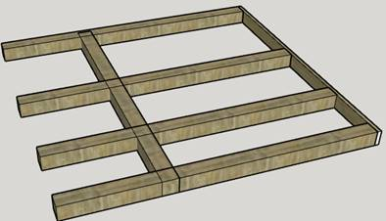
Note: The handicapped Microflush toilet stall at Yawhima Preschool will be 100% made from concrete blocks and poured concrete pads instead of wood due to termite issues. The digester will be underground so that the wheelchair can easily get into the toilet stall. The Microflush toilet is placed as close to the right rear corner so that wheelchair has maximum space to move around. Interior dimensions of the digester: 46” wide x 94” long.
Cut 4 x 4 PT lumber 68” long (ADA) or up to 56” long (HH); save short pieces for blocks between the beams. Make sure the beam second from the rear is set forward enough so as not to interfere with the user interface. For the ADA system, you will need 2 pieces of 3/4” thick x 4’ x 8’ pressure treated plywood.
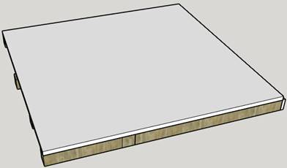
For ADA, cut one piece 68” x 48” and another 20” x 68”.

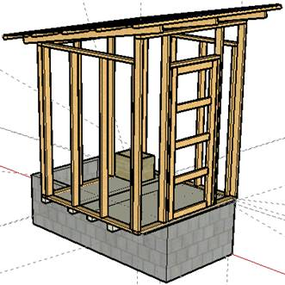
Top of Digester (Floor of Superstructure) will overhang the digester
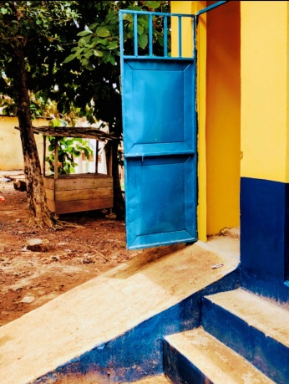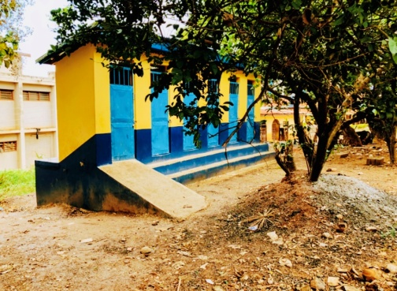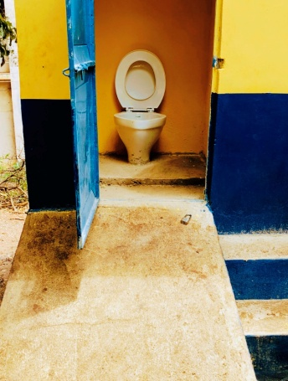
Above: Sample of ramp accessible, raised Toilet in another Kumasi project.

