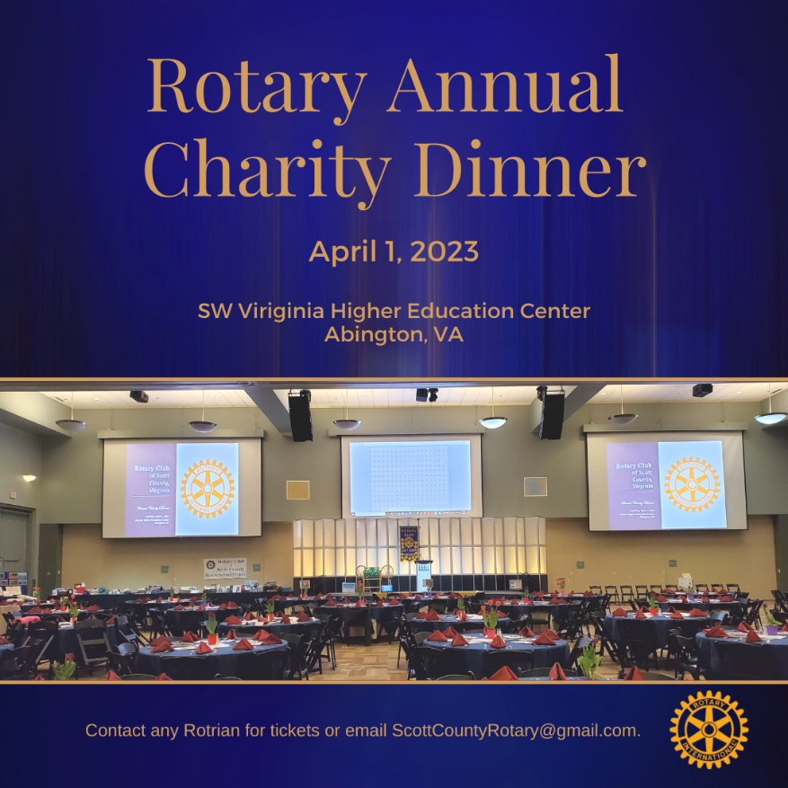

**Schedule of Events**

6:00 p.m. Social

7:00 p.m. Dinner

8:00 pm. Reverse Raffle

Door Prizes

Live Auction

Tickets: $125 – Admits two guests

For more information or to purchase tickets, email **ScottCountyRotary@gmail.com** *or* message us on our Facebook page **facebook.com/scottcountyrotary**

**The purpose of the event:**

The Annual Charity Dinner is our main fundraising event. The club’s projects support education, literacy, and basic needs such as food, clothing, and health care to those in-need.

Projects include scholarships for high school students and adult learners, Back-to-School project which provides needy students with clothing, shoes, hygiene products, and school suppliers at the beginning of each school year. The club recently completed a *Service Above Self* project for 4th graders, an essay contest for high school juniors, and a *Wells for Malawi* project which provided three villages with clean, safe water.

The Club’s mission is to foster programs that provide for the emotional, academic, and physical well-being of developing children in a way that will motivate them as adults to promote service above self. As a service organization, the Rotary Club of Scott County exists to improve the quality of life in our community.

**How does it work?**

A total of 225 tickets are sold for the event. Each $125 ticket admits two persons to the gala dinner. Each ticket entitles the holder of record to a cash drawing of more than $6,500 with the grand prize last ticket drawn being worth $5,000. The club acts as a broker with a 10% fee for anyone wishing to sell their ticket for a profit. The event also includes door prize ticket sales and a live auction.

“The Charity Dinner event is an example of Rotary’s motto *Service Above Self*. Because of the support we receive from the community, we have been able to continue providing services to those in need and improve the quality of life in our community. Together we truly make a difference.” ---Roger Lane, President