YPA 2022-23 UPDATE District 7360 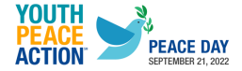
Greetings District 7360 Rotarians,
On September 21st, Int’l. Peace Day, YPA announced that 1,000 high schools in the US can access My Peacebuilder Foundations 2022-23…. FREE!!!! My Peacebuilder Foundations (MPF) is the award winning, interactive 10-hour online course through which students can become certified NewGen Peacebuilders. It’s part of Youth & Peace in Action (YPA), the largest youth peacebuilding initiative in the US.
Last year, 45,000 hours of content and experiences were delivered, and 1,500 students received peacebuilder certifications and service hours.
This year, My Peacebuilder Foundations also incorporates a Toolkit developed with teacher input that includes:
• Course-at-a-glance
• Content crosswalks
• Supporting slides and classroom conversation prompts
• Downloadable exercises and activities
• https://www.youthpeaceaction.org/
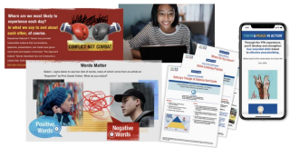
Here is a current video summarizing the program for Rotarians
https://www.youtube.com/watch?v=d8WMqEqX5Pc
Contact Jack Richford, District YPA Chairman with questions and support.
jrchfrd@ptd.net

