

HAPPY 50TH ANNIVERARY TO RONALD “RON” LOMBARD and JOHN “JACK” FINNEGAN

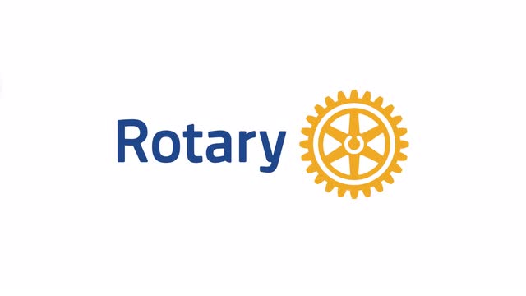

**Ron Lombard**

Ron was admitted to the practice of law on October 1, 1973, and joined the Rotary Club of Monroeville on April 4, 1974. He then served as the club president for the Rotary year of July 1, 2013, to June 30, 2014. Ron and his wife Diane have given much of themselves to our club and the many projects that are a part of past which means are a part of present and future.

**Jack Finnegan**

Jack was admitted to the practice of law on March 18, 1968, and joined the Rotary Club of Monroeville on April 11, 1974. Jack then served as the club president for the Rotary year of July 1, 1994, to June 30, 1995. Jack has been such a terrific rotary club member that he not only had the help of his wife Virginia, but sponsored her as a member of our club back in January of 2017.

**Rotary Club of Monroeville**

Just over a month ago our club celebrated it’s 69th Anniversary of being chartered. We are a diverse group who continue to thrive. Like Rotary itself, we are not brick and mortar but flesh and blood. This is evident in the way we can change the locations of where we may meet and never skip a beat. We are not a place and time, but timeless and in every place. The Club is 69 years old which means it was just 19 when Ron and Jack became members. We are here today because they have continued to be here and a part of us. An endless stream of giving which we are here today to recognize and celebrate. We are joined today in celebration and recognition by current and past members of the club, district leaders, friends and family too.

**1974**

Today we look back to 1974 when the Club was changed forever and when Ron and Jack began their 50-year journey. The Rotary International Theme for 1973-74 was a “Time for Action” and this is what was going on that year…

* In 1974, median household income in the U.S. was $11,100,
* In 1974, a gallon of whole milk cost $1.39, bacon cost 99 cents for a one-pound package, and eggs were 58 cents a dozen.
* Americans paid an average of $4,441 for a new car.
* Annual tuition for a public college averaged $512. At a private college, the average tuition was $2,130.
* In 1974, the average price of a new home sold in the United States was $34,900.
* Ketchup (Heinz): Four 14-ounce bottles for $1.00
* All in the Family was the number one tv show.
* Blazing Saddles was the number one film in 1974.
* Al Green was the most popular music artist.
* The number one song of 1974 was *The Way We Were* by Barbara Streisand

What was Monroeville like in 1974? This photo shows Burger King in 1974 and we can see what people were driving:

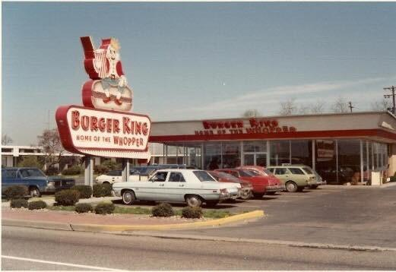

*It would not be surprising to see if one of these cars had been sold by Ron and Gary’s father.*

*A warm thank you to both Ron and Jack for their 50 years of service and contribution to the Rotary Club of Monroeville.*