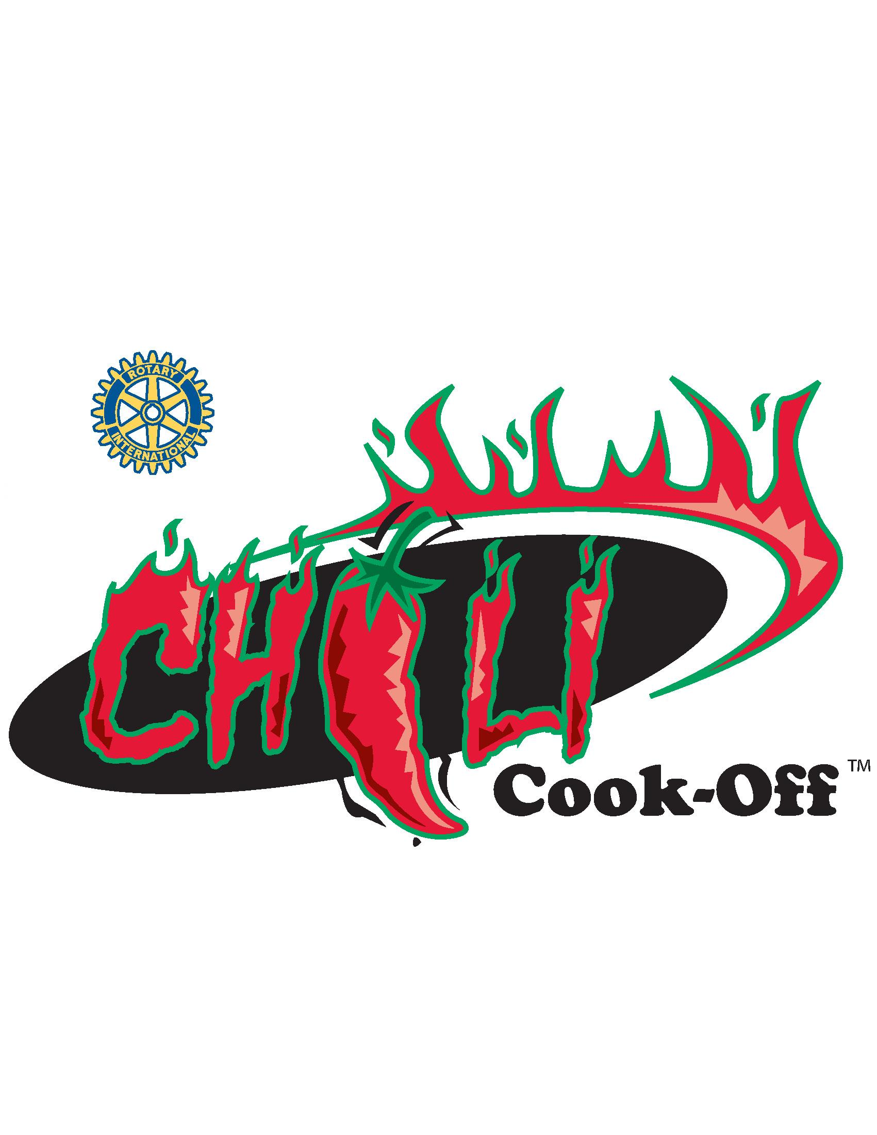
Your Entire Donation Will Benefit The Following:

• Bridgeville Parks & Recreation • Local Meals on Wheels
• Local High School Scholarships • Friends of the Library
• Local Historical Societies • Boy Scout Troop #2
• South Hills YMCA – Camp AIM • Bridgeville Public Library
• South Fayette Public Library • Bridgeville Food Bank
• South Fayette Parks & Recreation • Many other local charities

Contacts
Contestants Dave Danziger 412-427-1208 Joe Verduci 412-576-0940
Sponsors Ben Meyer 412-853-5877

Sponsored by:

THE BRIDGEVILLE -
SOUTH FAYETTE
ROTARY CLUB
P.O. Box 38 Bridgeville, PA 15017
www.bridgeville-sfrotary.org

2024 Chili Cook-Off Sponsorship Opportunities
Sunday, October 20, 2024 - Noon to 4 PM
Additional details available at: http://www.bridgeville-sfrotary.org

• Green Bell Pepper Sponsorship: $100
- Small size ad on placemats
- Company Name will be included on printed material
- One free team entry with booth location at the Cook-off
- Two (2) Chili Tasting Wrist Bands
• Red Bell Pepper Sponsorship: $250
- Company name mention on Chili Cook-off website including a link to your website
- Medium sized placemat ad
- Company name and logo will be included on printed material
- One free team entry with booth location at the Cook-off
- Laminated sign with company name and logo
- Four (4) Chili Tasting Wrist Bands
- Free Vendor Entry
• Cayenne Sponsorship: $500
- Company name, logo and link to your company website on Chili Cook-off website
- Large sized placemat ad
- Company name and logo will be included on printed material
- Company name on the back of Chili Cook-off shirts
- One free team entry with booth location at the Cook-off
- Laminated sign with company name and logo
- Eight (8) Chili Tasting Wrist Bands
- Four (4) Event T-shirts
- Free Vendor Entry
• Jalapeno Sponsorship: $1,000
- Company name, logo and link to your company website on Chili Cook-off website
- Extra Large sized placemat ad
- Advertising on welcome banner
- Company name on the back of Chili Cook-off shirts
- Company name and logo will be included on printed material and advertising
- Free team entry with booth location at the Cook-off
- Twelve (12) Chili Tasting Wrist Bands
- Eight (8) Event T-shirts
- Laminated sign with company name and logo
- Free Vendor Entry

