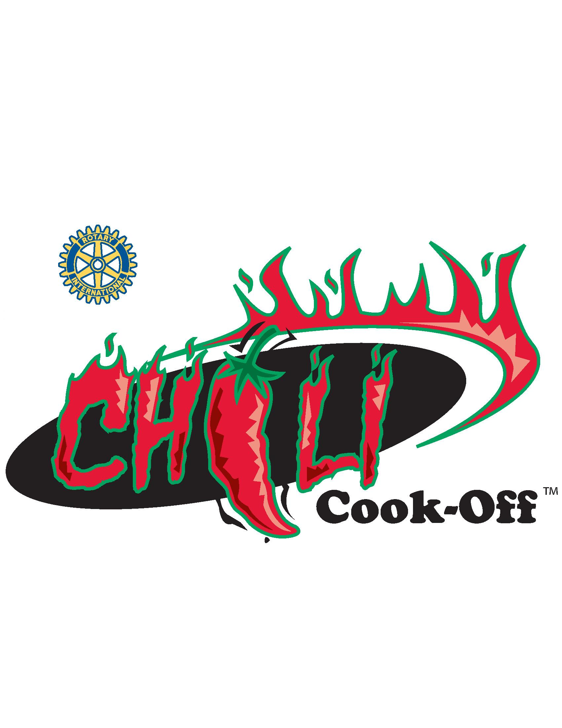
Sponsored by:

THE BRIDGEVILLE -
SOUTH FAYETTE
ROTARY CLUB
P.O. Box 38 Bridgeville, PA 15017
www.bridgeville-sfrotary.org

Your Entire Donation Will Benefit The Following:

• Bridgeville Parks & Recreation • Local Meals on Wheels
• Local High School Scholarships • Friends of the Library
• Local Historical Societies • Boy Scout Troop #2
• South Hills YMCA – Camp AIM • Bridgeville Public Library
• South Fayette Public Library • Bridgeville Food Bank
• South Fayette Parks & Recreation • Many other local charities

Contacts
Contestants Dave Danziger 412-427-1208 Joe Verduci 412-576-0940
Sponsors Ben Meyer 412-853-5877

2024 Chili Cook-Off Contestant Information
Sunday, October 20th - Noon to 4 PM

We are expecting between 800 and 1,000 chili eaters in attendance again this year and we would like to extend to you the opportunity to participate in our event. This event provides great exposure for your organization and builds goodwill within the community. In addition to the exposure at the event, your organization will be listed in our program and on our website.

Contestants are divided into three categories, professional restaurants, non-food related businesses/individuals, and non-profit organizations. Each chili has two opportunities to win prizes - a Judged Tasting Award and a People's Choice Award. Additionally, we encourage teams to compete for "Best Decorated Booth" by picking a theme and decorating your crew and booth accordingly.

Your Entry Fee Includes: (all applications must include payment with entry form)
- 10x10 booth space including tent, table and 2 chairs
- Two contestant T-shirts. (Additional shirts are available for purchase before and during the Chili Cook-Off.)
- Two adult tasting wristbands. (Additional tickets/wristbands are available for purchase before and during the Chili Cook-Off.)
- Spoons, napkins and tasting cups for public use.

Additional Information
Set up starts at 9:00 AM on the day of the event and must be completed by 11:00 AM. The Judging Competition is from 1:00 - 3:00 PM. Awards will be presented after 4 PM. At a designated time during the Judging Competition, you will be given 10 minutes to prepare a sample of your team's chili to be presented to the judges.

THE CHILI COOK-OFF ON SUNDAY, OCTOBER 20th IS A "RAIN OR SHINE" EVENT. IF FOR ANY REASON IT CANNOT PROCEED (I.E. ACT OF GOD/VERY INCLEMENT WEATHER/UNAVAILABILITY OF SITE, ETC.) AN APPROPRIATE CREDIT WILL BE GIVEN TO ALL TEAM ENTRIES FOR THE SUBSEQUENT CHILI COOK-OFF.

Feel free to contact us at any time for questions or further clarifications

For more information see our web-site at http://www.bridgeville-sfrotary.org

