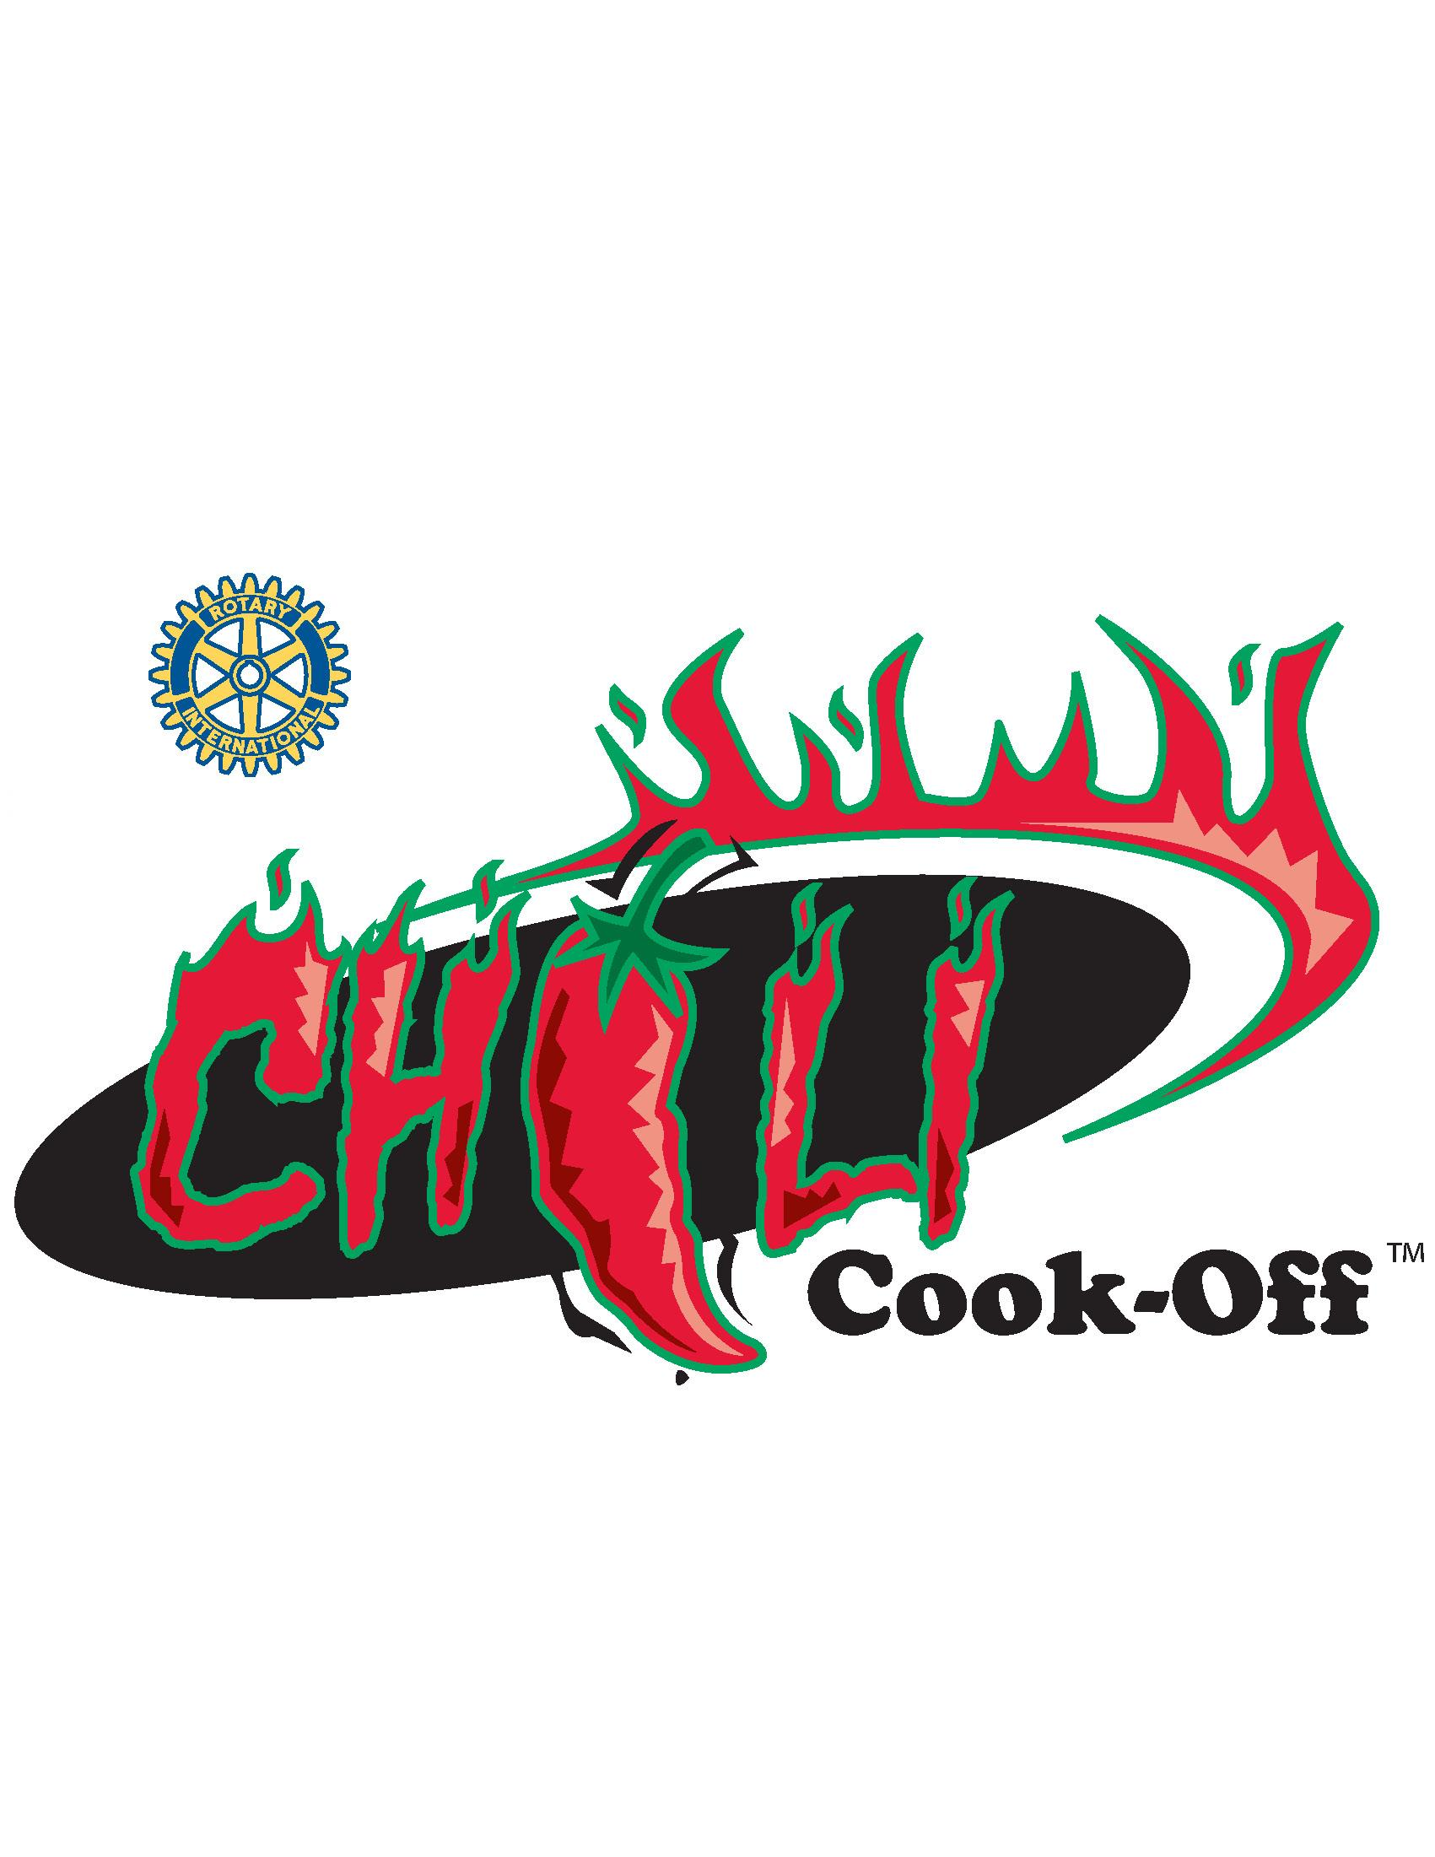
Sponsored by:

THE BRIDGEVILLE -
SOUTH FAYETTE
ROTARY CLUB
P.O. Box 38 Bridgeville, PA 15017
www.bridgeville-sfrotary.org

Your Entire Donation Will Benefit The Following:

• Bridgeville Parks & Recreation • Local Meals on Wheels
• Local High School Scholarships • Friends of the Library
• Local Historical Societies • Boy Scout Troop #2
• South Hills YMCA – Camp AIM • Bridgeville Public Library
• South Fayette Public Library • Bridgeville Food Bank
• South Fayette Parks & Recreation • Many other local charities

Contacts
Contestants Dave Danziger 412-427-1208 Joe Verduci 412-576-0940
Sponsors Ben Meyer 412-853-5877

2024 Chili Cook-Off Contestant Application
Sunday, October 20, 2024 - Noon to 4 PM
Application and fees must be received no later than October 1st, 2024

Applicant: _______________________________________ Team Name: ______________________________________
Name of Chili (required): _____________________________________________________________________________
Name of Chili (required): _____________________________________________________________________________
Name of Chili (required): _____________________________________________________________________________
Mailing Address: ____________________________________________________________________________________
City: _____________________________________________________ State: _________ Zip: ___________________
Cell Phone ________ -___________________________ Business/Home Phone: ________ -_________________
Email: (required) ____________________________________________________ Fax: ________-________________
Shirt Sizes: (required) XS (child) ____ S ____ M ____ L ____ XL ____ XXL ____ XXXL ____
Divisions -0940and Entry Fees (Please Check Box):
________ Professional Restaurant - Restaurant will compete against other restaurants $50.00
Please prepare a minimum of 5 gallons of each chili.
________ Businesses & Individuals – non food businesses, families & friends $50.00
Please prepare a minimum of 5 gallons of each chili.
________ Non-Profit Organization - Non-profit or philanthropic clubs No Charge
Please prepare a minimum of 5 gallons of each chili.
Please make your check payable to "Rotary Club of Bridgeville-South Fayette" and mail to:
Chili Cook-Off Rotary Club of Bridgeville-South Fayette P.O. Box 38 Bridgeville, PA 15017
Or email: bvsfrotary@gmail.com

Additional Details Available at: http://www.bridgeville-sfrotary.org

You should review the practices in Article 3 of the Allegheny County Health Department regulations about temporary food service and food safety. The regulations are online at http://achd.net/regs.html

