`

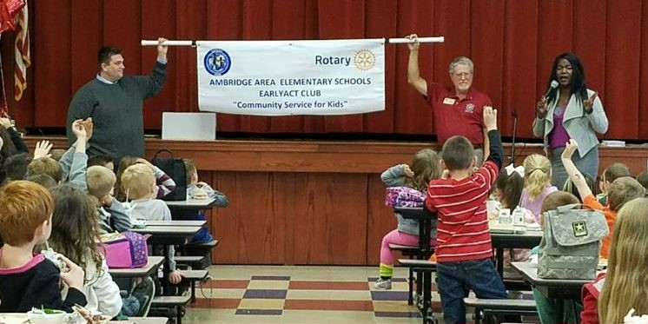
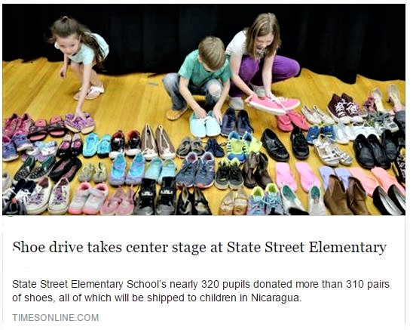
EarlyAct
Rotary District 7305
2021-2022 Chair – PDG Walt Sickles
724-462-6929 - walt.rotarydg1314@yahoo.com
****************************************
Community
Service
for
Kids

****************************************
“Service Above Self”

