Rotary District 7305
EarlyAct Committee
EarlyAct – A School-Wide Service Club for Elementary Students Ages 5-13

2021-2022 Chairman – Walt Sickles, PDG
706 Ridge Road, Ambridge, PA 15003
Cell Phone – 724-462-6929
E-mail – walt.rotarydg1314@yahoo.com

Does your Rotary Club or one of your members…

…have a connection with someone in your local school district (an official, a teacher or a staff member) or does your local school have an Interact Club in your High School or Middle School?

If so, your club has the perfect means to possibly start an EarlyAct Club which is, of course, a Rotary Youth Organization for Elementary School students ages 5-13.

What better time is there to get our young folks involved in service?

Your District 7305 EarlyAct Committee will be glad to assist your club in any way we can to get the ball rolling and, hopefully, start such a club in your area.

For more information about EarlyAct check out the attached “Handbook”.

Have questions or need assistance with this idea, contact EarlyAct Chairman, Walt Sickles, of the Ambridge Club.

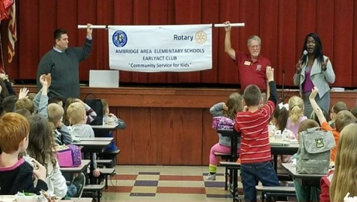

“Community Service for Kids”

