Rotary District 7305
EarlyAct Committee
EarlyAct – A School-Wide Service Club for Elementary Students Ages 5-13

2021-2022 Chairman – Walt Sickles, PDG
706 Ridge Road, Ambridge, PA 15003
Cell Phone – 724-462-6929
E-mail – walt.rotarydg1314@yahoo.com

Interact Officers and Members -

Looking for a Fun, Free Project for your Interact Club?

Consider working to start an EarlyAct Rotary Youth Club in your Elementary School.

What better time is there to get our young folks involved in service?

Your District 7305 EarlyAct Committee will be glad to assist your club in any way we can to get the ball rolling and, hopefully, start such a club in your school district.

For more information about EarlyAct check out the attached “Handbook”.

Have questions or need assistance with this idea, contact EarlyAct Chairman, Walt Sickles, of the Ambridge Rotary Club.

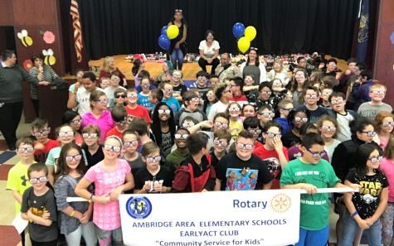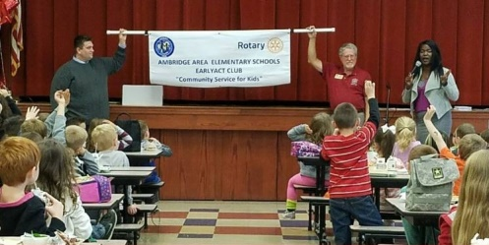

“Community Service for Kids”

