Presents: A remake of a great one

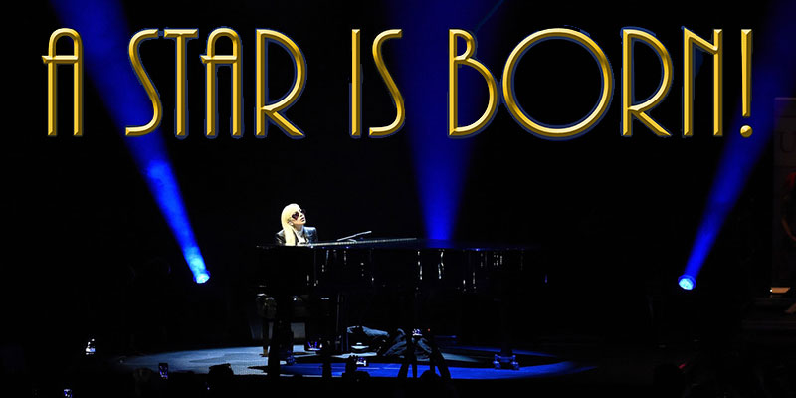

THE ROTARY BLOCKBUSTER
CHARITY EVENT
Friday, October 5th, 2018
Bronze
Silver
Gold
Platinum
Company _________________________
Contact _________________________
Address _________________________
City, State, ZIP ___________________
Phone _______________________
Email ______________________
$500
- Popcorn, soda, candy, beer, wine sponsor
- 2 ticket package
- Company logo included on Bronze sponsor event reception
- Table sponsorship of 1 table at event reception (8.5x11max)
- Option to include flyer/giveaway in event bags given to all attendees
$1,000
- 6 ticket package
- Company banner placement at event reception (3x5 max)
- Table sponsorship of 1 table at event reception (8.5x11 max)
- Option to include flyer/giveaway in event bags given to all attendees (max 300)
- Recognition at event reception
$ 5,000
- 20 ticket package
- Title sponsor on all marketing material
- Table sponsorship of 2 tables at event reception (8.5x11 max)
- Spotlight announcement throughout event reception
- Company name/logo on event tickets
- Company name/logo on event posters
- Recognition in all press releases & media advertising
- Option for company display tables with literature at reception
- Reserved VIP seating at movie theatre

$2,500
- 10 ticket package
- Company banner placement (4x8 max)
- Table sponsorship of 2 tables at event reception (8.5x11 max)
- Announcement throughout event reception
- Company name/logo on event tickets
- Company name/logo on event posters
- Recognition in all press releases & media advertising
- Option for company display tables with literature at reception
- Reserved VIP seating at movie theatre
Sponsor Information

