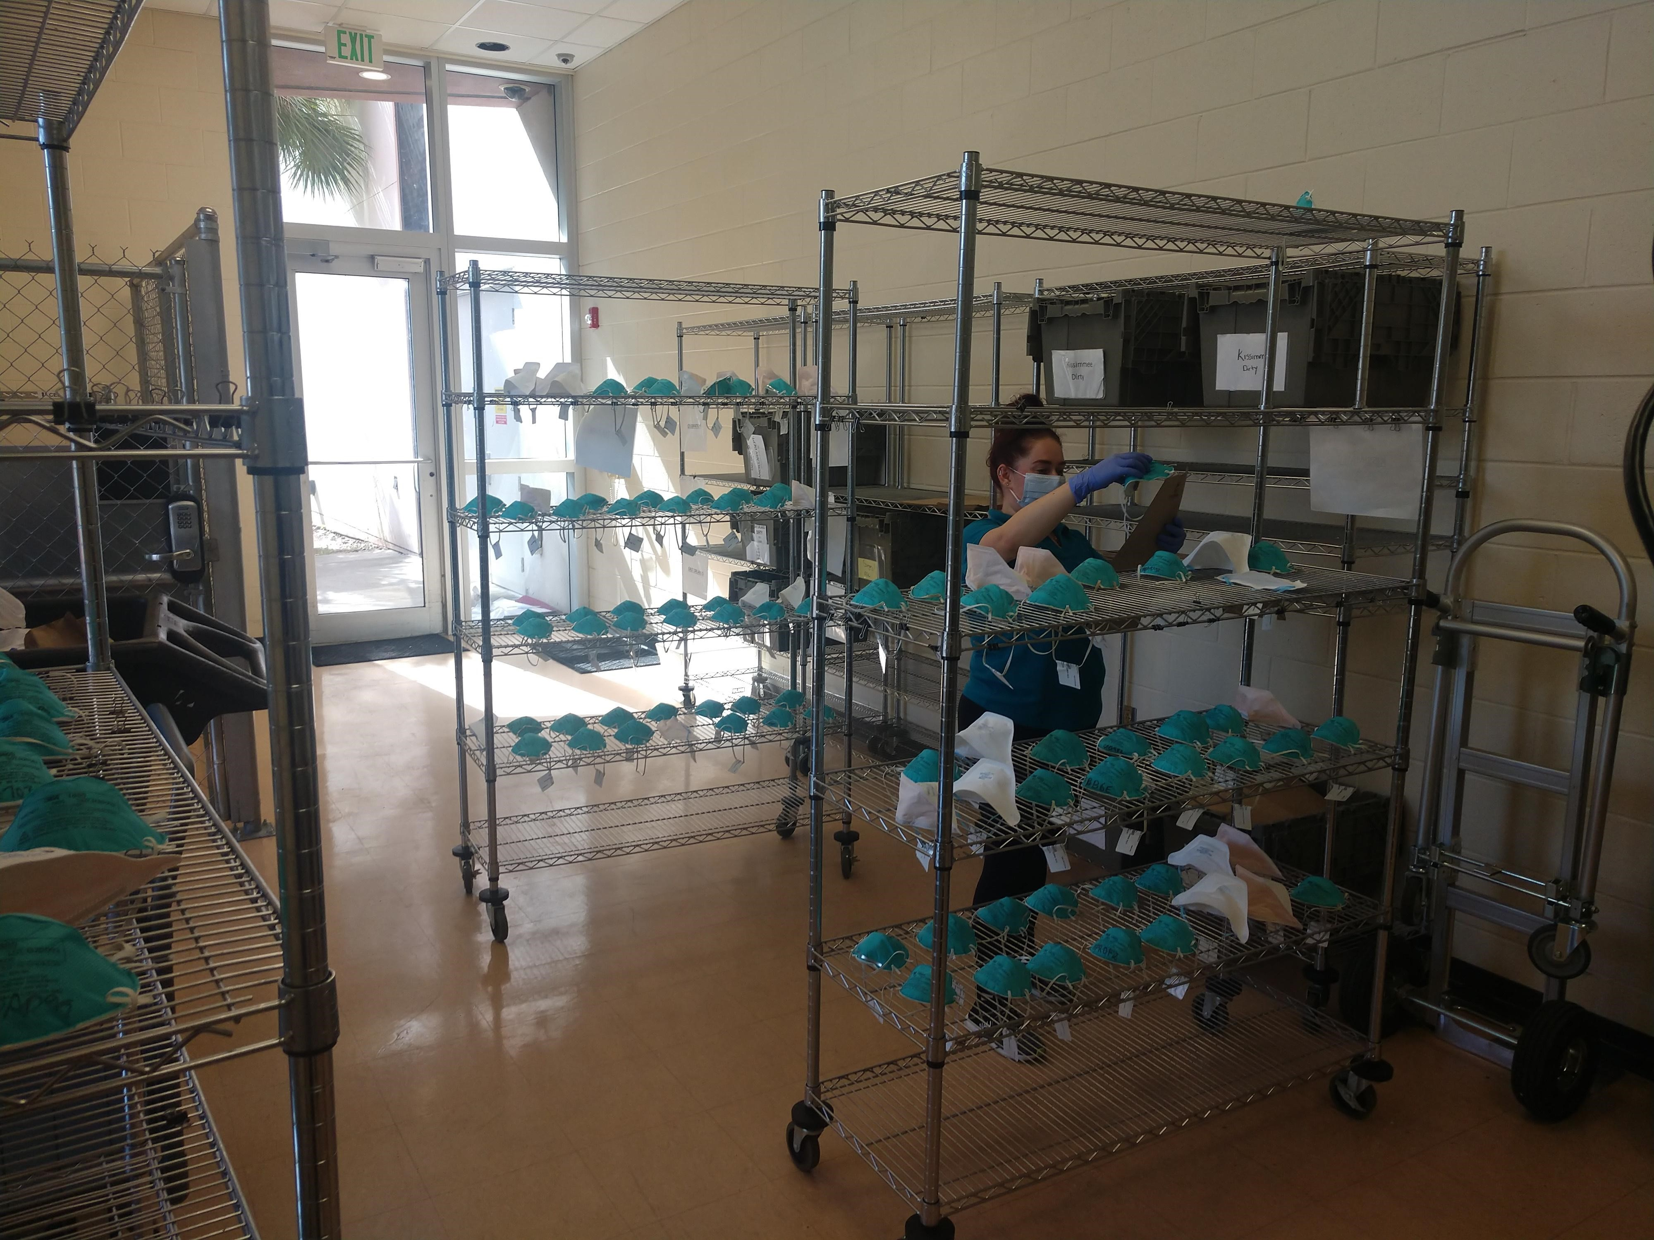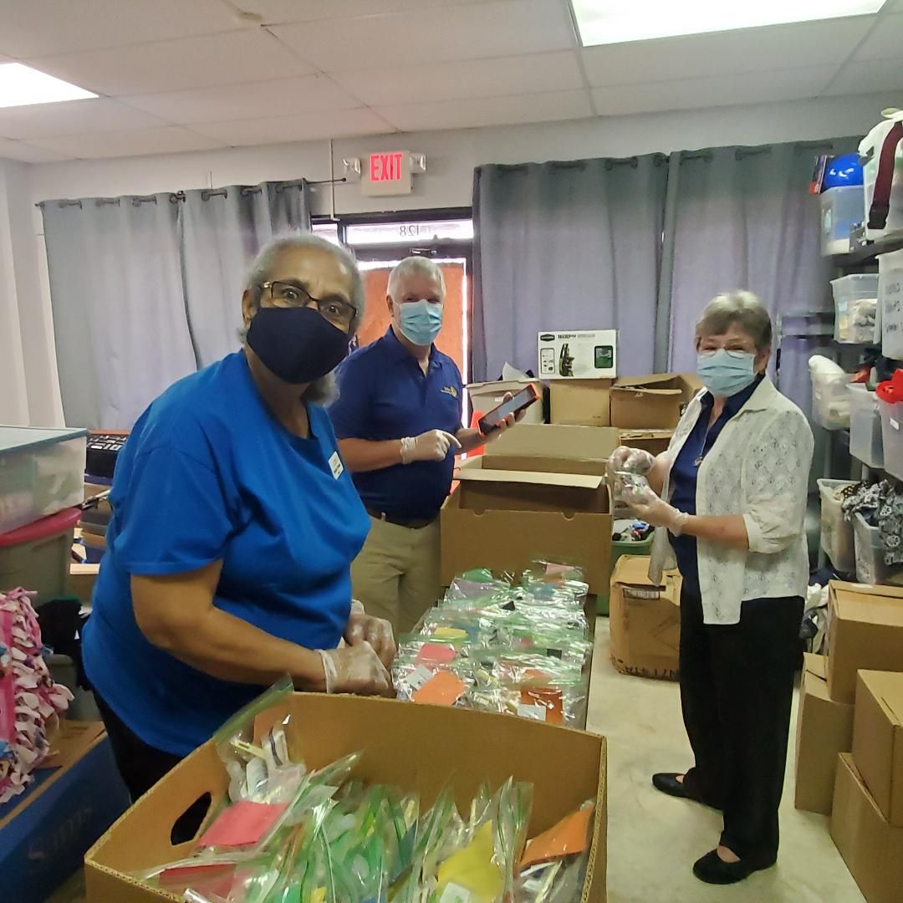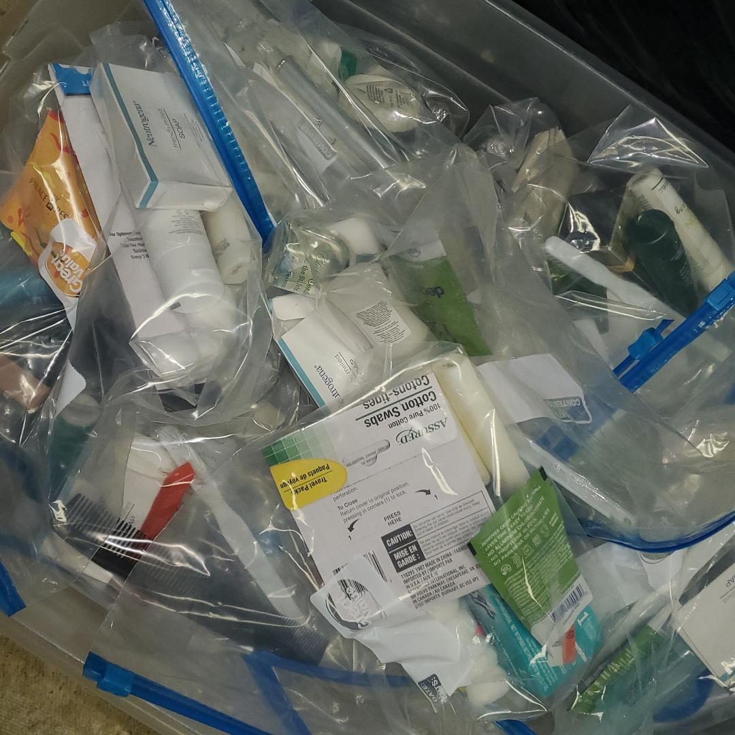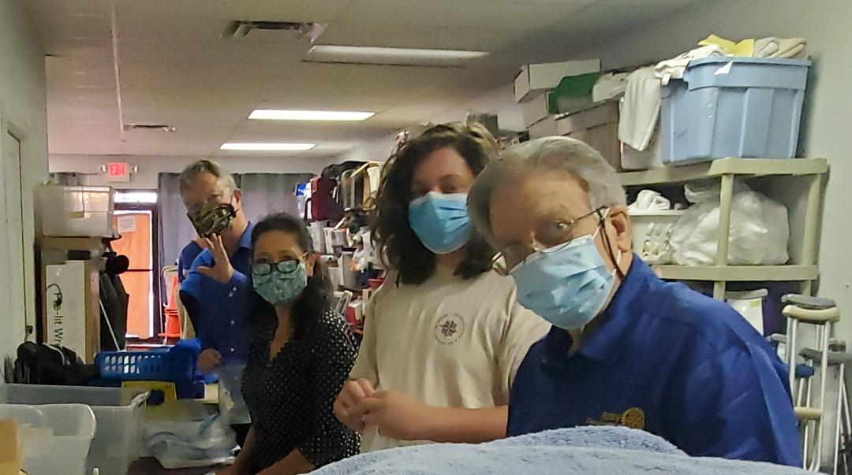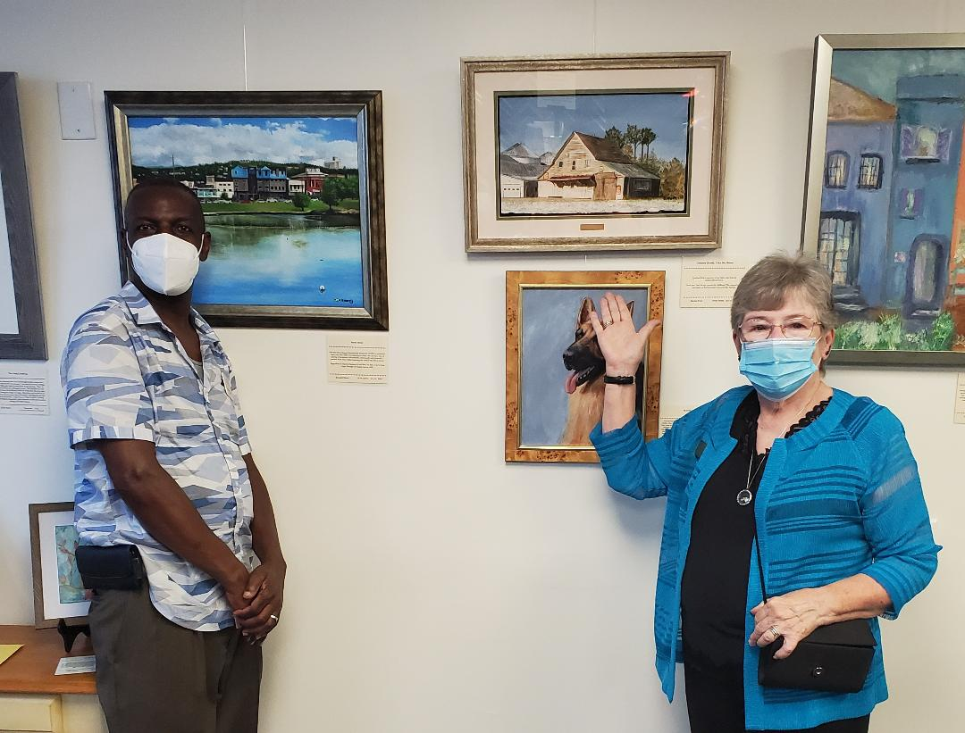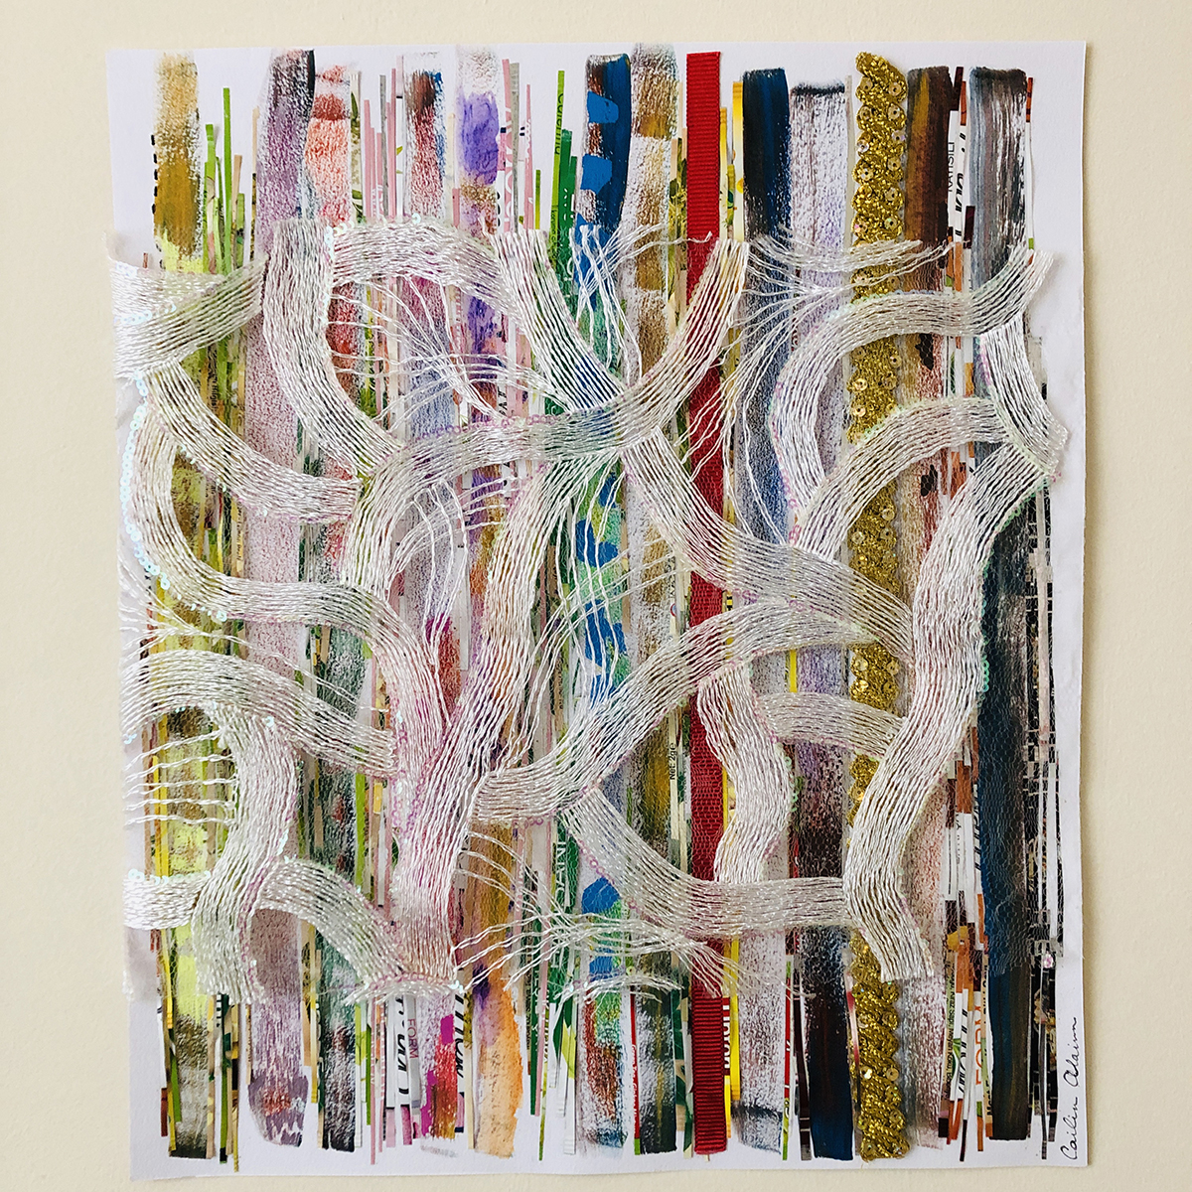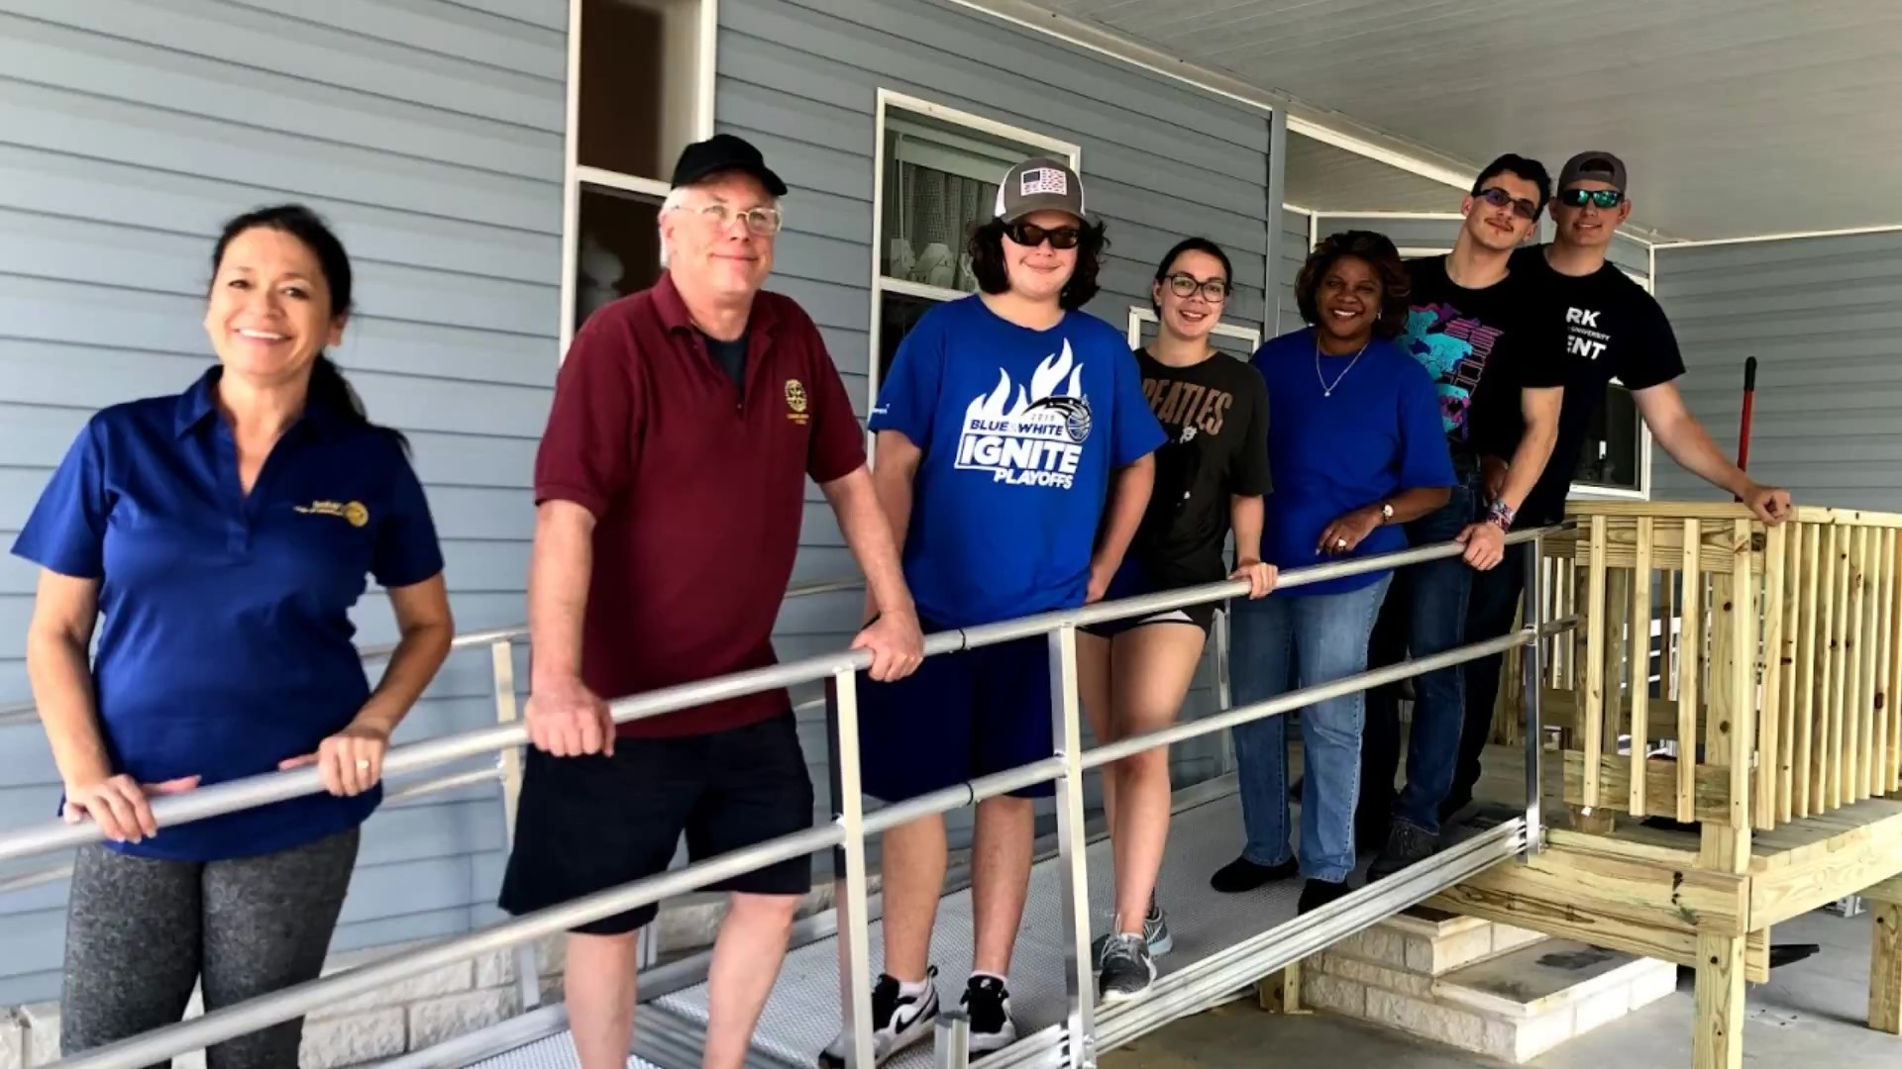

* COVID 19 Grant
* Oasis at the Sharing Center
* Journey to Recovery Exhibit
* Center for Independent Living

**TAKE ACTION:** www.rotaryclubofcasselberry.org

www.facebook.com/rotaryclubofcasselberry

www.instagram.com/rotaryclubofcasselberry

@RotaryClubofCa2

### Connecting Rotary and our community

Along with ten other clubs, Rotary Club of Casselberry participated in a Global Grant that was presented to Advent Health. The grant totaled $36,896. The contribution purchased a CURIS vaporized hydrogen peroxide room sterilizer shown above decontaminating masks. Along with the CURIS system, the grant also provided five portable CLEANIS germicidal enclosures to be used locally here in Central Florida. This equipment is essential to help in the fight against COVID 19. District 6980 is proud to be a part of this endeavor.

In this issue…

3rd Quarter 2020

# CASSELBERRY ROTARY CLUB newsletter

Casselberry Rotarians Ken Harris and Sharon Hunt’s art was showcased at the recent Journey to Recovery VI – Art Heals exhibit. Along with other P.O.W. (pastel, oil, watercolor) artists and friends, they were featured during the month of July at the Casselberry Art House.

Congratulations Ken & Sharon on a job well done!

Even a pandemic cannot stop the Rotary Club of Casselberry’s dedication to service. Over the past months, our club supported the Southeastern Guide Dog’s virtual walkathon, Feeding Children Everywhere Full Cart Good Deeds program, partnered with the Casselberry Art House to host the 2020 Recycled Art Show contest and provided a bouncy solution to protecting the floors at Community United Methodist Church’s youth room.

The Sharing Center

In August, our club volunteered at the Sharing Center packing hygiene bags for the Oasis. The center is open for homeless children and adults to come take a shower, have clothes washed, get a haircut and use computers for schoolwork or job searches. The Oasis serves around 40 clients a day. We are so glad our club has been able to make an impact on our local homeless community.

Journey to Recovery Exhibit

### OUR STORY THIS QUARTER

Club Meeting Information

Every Wednesday 7:30a-8:30a

Community United Methodist Church

4921 US Highway 17-92 in Casselberry

In the CLC building behind the church, look for the Rotary banner on the door.

**Everyone Welcome!**

### CENTER FOR INDEPENDENT LIVING

Just as the pandemic ensued, Casselberry Rotarians and friends decided to move ahead with the scheduled Rampage project for local resident Jim. Our President and club were highlighted in the Fall edition of Access Quarterly.

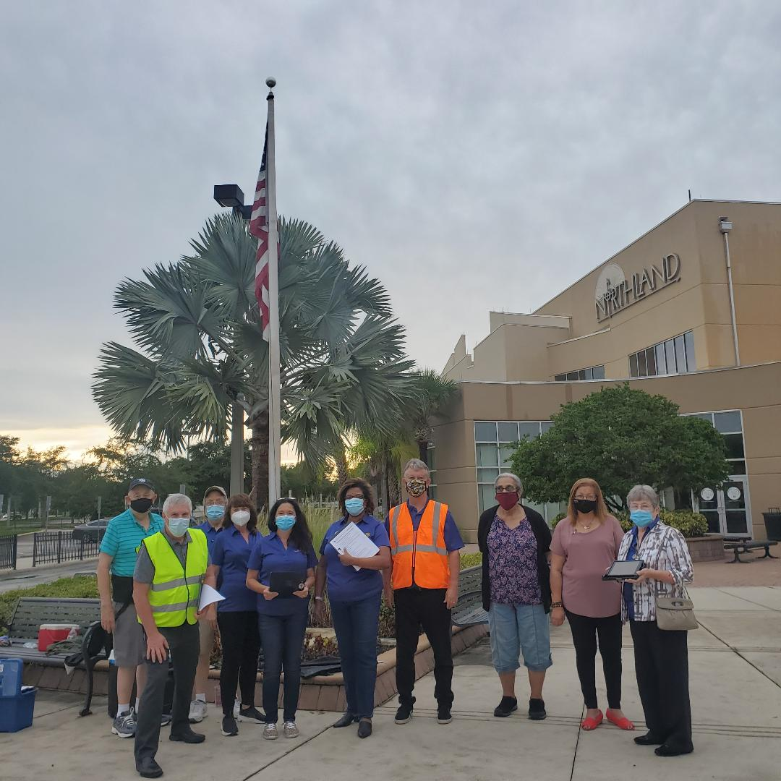

Upcoming Meeting Speakers

October 7 Hasim Bozkurt/Lifeskills

October 14 Christian Help service project

October 21 Grace Busa/Humana

October 28 Tina McIntyre/Seminole County Landscaping Agent

November 4 Casselberry Police Chief Kranz

November 11 Sandra Burgos/Notadoc

November 18 Coalition for the Homeless Preschool service project

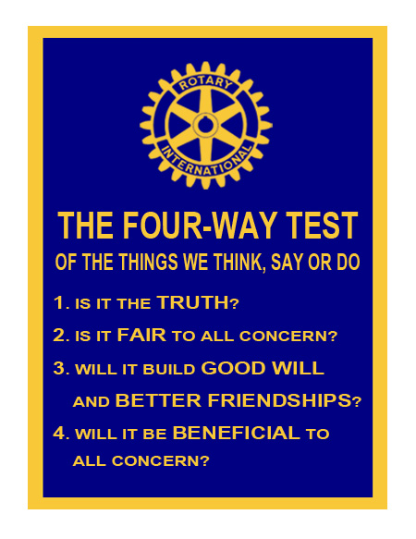

For this year’s primary, our club partnered with the Seminole County Supervisor of Elections to help receive and inventory polling place contents. Our teams of three collect items from about 20 precincts in our local area and have the poll workers sign off on the secured transfer. The Rotary Club of Casselberry is honored to be a part of the election process in Seminole County.

Partners in Democracy

#### [Your Club Name]

[Street Address]

[City], [State] [Postal Code]