My dear DG classmate Michael,

I hope that you and your family are well and healthy.

Please, take a look at my last email.

It is very important to hear your opinion and to help as to find partners

in the US for some of these five proposals for Global Grants (your clubs and your District with DDF).

Looking forward to your reply,

With best Rotarian regards,

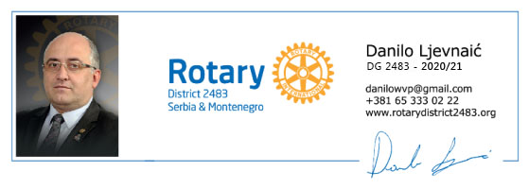

*USAID AND ROTARY INTERNATIONAL*

*“HEARTS OF EUROPE GLOBAL GRANTS”*

Dear Michael,

The whole world has experienced some very difficult times since I had the pleasure of meeting you in San Diego last January. I hope this email finds you well and that you and your family have been healthy and safe during the pandemics. The situation in this part of Europe is a little better now and we are slowly returning to normal life.

In spite of the difficult time behind us, we in District 2483 have made big plans for the next Rotary year. Beside other activities, we have undertaken preliminary actions and assessments for five Global Grant projects within the new HEARTS OF EUROPE program where **USAID**matches 100% the amount of DDF granted by TRF.

My club, Rotary Club of Sremska Mitrovica, is going to be the Host Club in one of the five Global Grant projects for donation of drones as teaching aids to Serbian schools.  The donated equipment will facilitate implementation of ICT curriculum in grade 5 and 6 (programming languages Scratch and Python), with the objective to improve the students` digital literacy and prepare them for new professional challenges which will emerge in the future with accelerated technological development.

We consulted our RI Regional Grants Officer about the project details, we met with the representatives of USAID Serbia and we are ready to fill in the application and submit it to the Rotary Foundation as soon as we have the International Partner and provide enough DDF contribution (as you are aware, according to the new regulations, as of July 1, 2020 the TRF is not going to match cash contributions).

As you also know, one of the requirements for projects within the new HEARTS OF EUROPE program is to have a US club or District as International Partner, so I am writing to you with the question would your Club or your District be willing to be the International Partner of RC of Sremska Mitrovica in this project?

The budget plan for our project is $184,800.  As result of the new regulations we are going to need a substantial amount of $50,000 from international DDF to close the financial structure. In view of that, I also ask you to please designate an amount from your DDF which would be significant in the support of our project.

I hope you find the above information on our project interesting and consider our requests.

Rotary Club of Sremska Mitrovica and I personally would be very happy to have you as partner in this Global Grant. Partner.