From: **Abhijit Mhasakar** <[president1718rcpoonamidtown@yahoo.com](mailto:president1718rcpoonamidtown@yahoo.com)>  
Date: Sat, Jul 11, 2020 at 11:14 PM  
Subject: Proposed Global rant project - Happy School  
To:   
Cc: Abhijit Mhasakar <[president1718rcpoonamidtown1@gmail.com](mailto:president1718rcpoonamidtown1@gmail.com)>

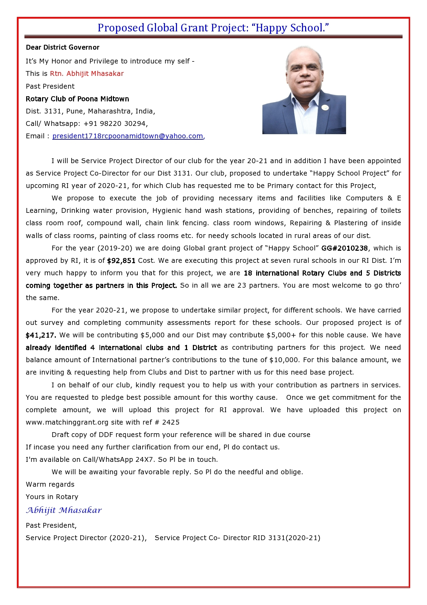

Abhijit

**Call/Whatsapp: +91 98220 30294,**

**Past President , Rotary Club Of Poona Midtown**

**ROTARY CLUB OF POONA MIDTOWN**

**RI Dist. 3131, Pune, Maharashtra, India**

@RCPoonaMidtown

[**Abhijit**](https://twitter.com/promptengineers)

[@promptengineers](https://twitter.com/promptengineers)