Nassau County Sheriff services for Rotary 5K race description and payment method:

1. Create a description of services required (directions used for 2025 race. Update/modify as needed).

Assist runners/ Provide Traffic Control.

**5K Race Route:**

* Runners will go **north** on **Bill Howard Way**.
* Turn **east**on **William Burgess Blvd**.
* Continue 2.5K to **Augustus Ave**.
* Turn **right** on Augustus Ave. and go through the neighborhood.
* **Exit** at the **Augustus/Cartesian Street** intersection.
* Turn **left** on **William Burgess Blvd**.
* Return to the starting point.

**1 Mile Fun Run Route:**

* Follow the same5K race course.
* **Turn around**at the marked **½-mile point on William Burgess**.
* Return via the same route to the finish line.

**Safety & Monitoring:**

* Station a vehicle at Bill Howard Way & William Burgess
* Station a second vehicle at the intersection of William Burgess & Augustus.
* After the last 5K runner exits the Cartesian Point neighborhood, **follow to the marked ½-mile location to await the Fun Run runners.**
* Once runners turn around, follow them back to the intersection of **William Burgess & Bill Howard Way**.

**Key Concern:**Our priority is to keep runners safe on William Burgess Blvd., especially the Fun Run participants.

1. Go to: [app.powerdetails.com](http://app.powerdetails.com/)

Site ID is: NCSOF

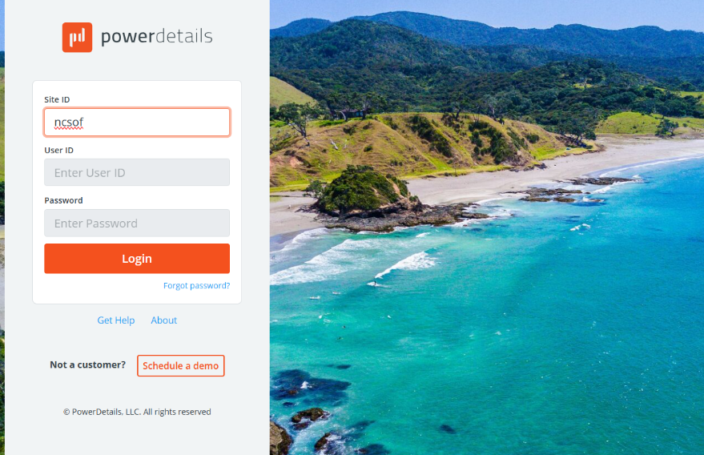

Login: [4mroeyes@gmail.com](mailto:4mroeyes@gmail.com)

Password: h^uYBfho!A3Q

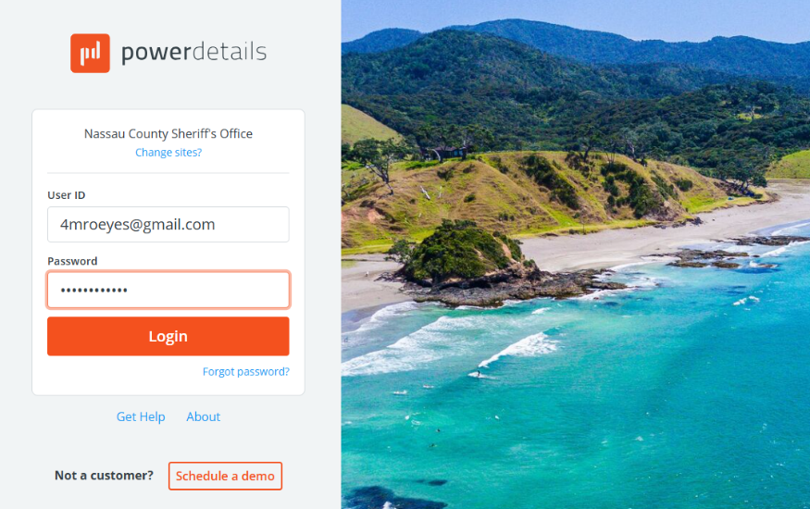

Click on "I Agree"

1. Once you are in the account, you can change password and user name.

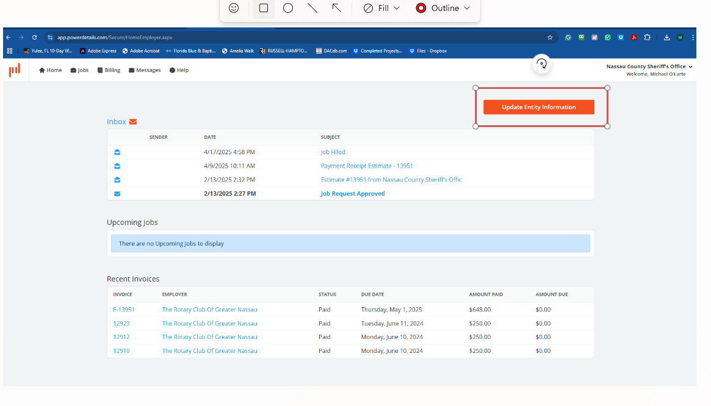

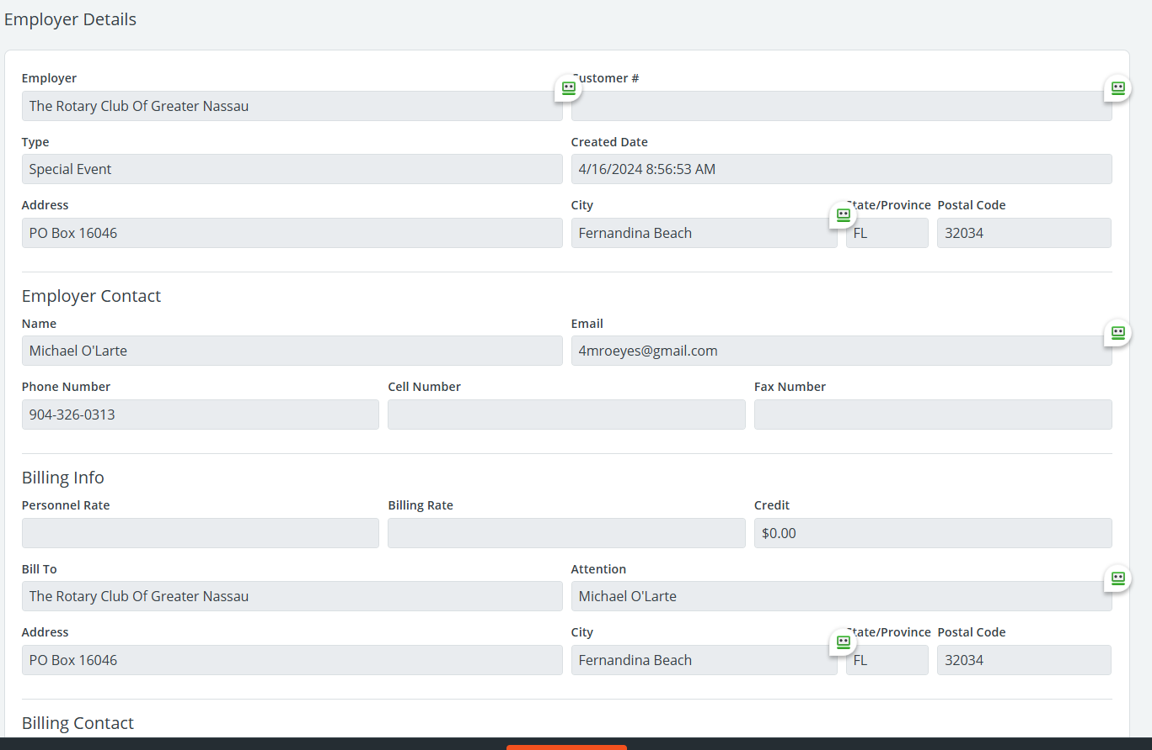

1. Inbox section has latest action.

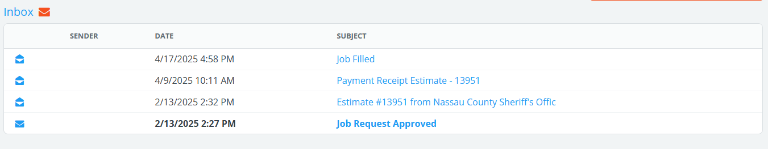

1. Click on “New Job”

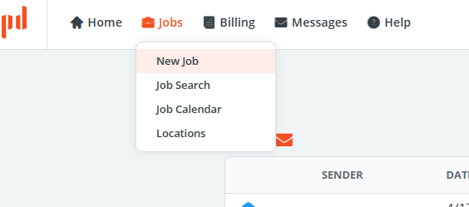

1. Fill out new job form. Be aware that the description has a character limitation (very frustrating).

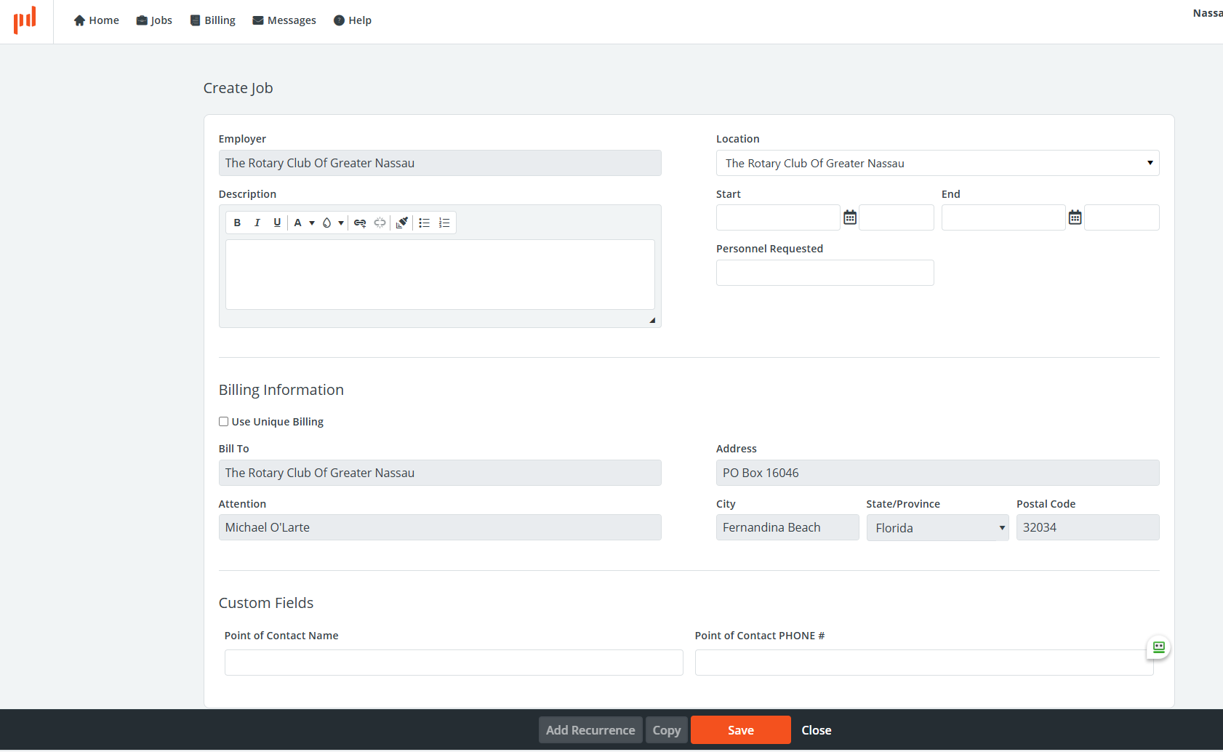

1. Click the save button at the bottom and within a few days, you will receive emails indicating that there is a new message waiting. Log on and proceed:

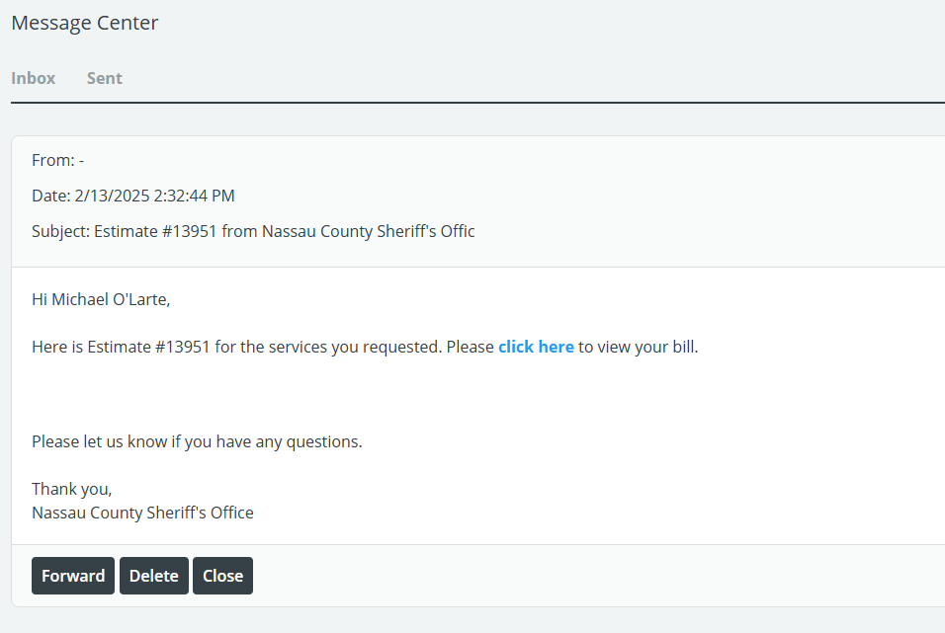

1. When you click the link, you will proceed to payment by CC. Once paid, it should look like this:

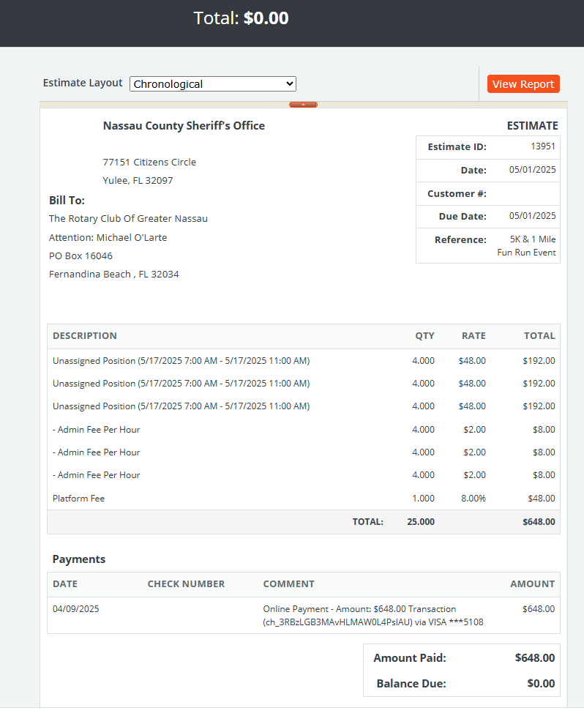

Complete!