Hello, Everyone!!!!
Here are the minutes from our last meeting

Meeting Minutes – April 11, 2023 – Rotary Club of Downtown DeLand
Joining us at the Elk’s Club | We missed you!!!!
Alldredge, Steve  Birnie, Matt  Budzinski, Bill  Carelli, Robbie  Carrell, James  Cheshire, JoAnne  Cloudman, Chris  Cockayne, Josh  Evans, Steve  Fetterhoff, Elizabeth  Feyk, Bill  Flynn, Luke  Graver, Ed  Harland, Maureen  Jenkins, George  Lacey, Mark  Lawrence, Susie  Lawrence, Tom  Levings, Chris  MacNeill, Darin  MacNeill, Kathy  McDaniel, John  McDermott, Mark  Mendoza, Monica  Merriam, Harland  Morehouse, Bruce  Rivera, Rick  Seaman, Ted Sr.  Walker, Zeke  Waters, Jeff | Autry, Jerry  Booth, Quin  Cantrell, Brian  Devlin, Jeff  France, Jim  Goldberg, Ken  Gonzalez, Charley  Hall, Elmer  Jackson, Bill  Jackson, Mary Jo  Powell, Bee  Preston, Aaron  Ramsey, Watt  Rogers, Johnny  Sabatini, Ed  Seaman, Ted Jr.  Thomas, Kendrick  Wedekind, Doug  Whitehead, Warren
Guests: Heather McLean, Grant Seaman, Sean Beery, John Ward, Tara GLeason
Cares and Concerns:
- Mike Orr – mother passed away
- Chris C – neighbor had a stroke
- Ken – missing tonight because he has a fever

Happy Dollars
- A whole bunch of people just happy
- Many had a great time at Rotary Golf Tournament
- Matt – family will be gone in 1 ½ weeks
- Maureen – got to check something big off her “list” this week
- Heather – son’s 6th birthday
- Harlan – iDignity thanks
- Elizabeth – had been sick for a month – happy to be back
- Ed G – girls will be coming back home
- Sean – missed meetings – got to go to Italy and Germany
- Josh – on the mend from back issues

Birthdays
- No birthdays this week
Minutarian Minute
- Hoping it was a safe week for all those celebrating Ramadan, Passover and Easter
- DG had a good Easter and got to visit with his niece
- This is Maternal and Child Health Month so if you are doing anything for that, let the district know
- Published a bunch of Myth Busters for when we try to recruit new members
  - 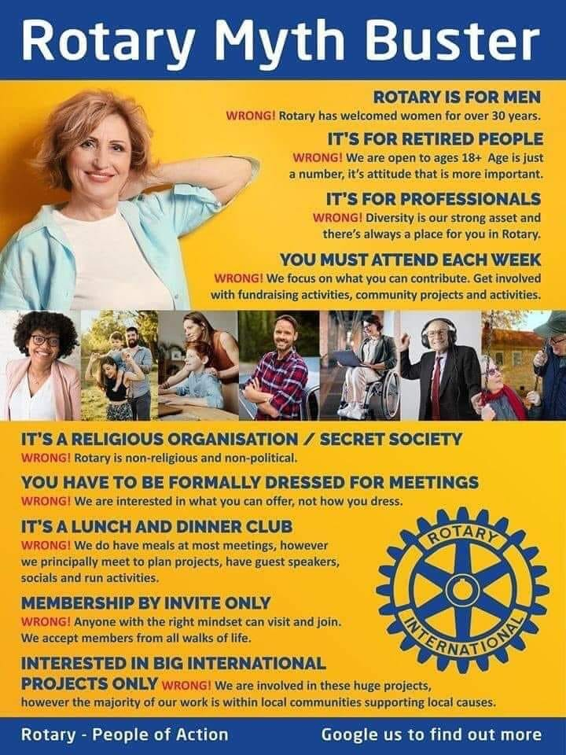
- District Training and Assembly coming up May 12-13 beginning with an opening dinner and ending with a Social Gathering

Correspondence
- No correspondence

Speaker: No speaker

Announcements
- April 22 – Keep DeLand Beautiful – looking for chair as possible cooking event
  - Would feed about 25-30 people
  - Not enough available members to do this
- IDignity
  - Larger Group of volunteers to help people get the documents the get a Florida ID
  - Served about 60 clients
  - Thank you to all who helped
  - Will do it again in October
- Rotary Golf Tournament
  - Made food for about 200 people
  - 2 teams had fun playing
  - Extra food given to the Homeless Shelter in Daytona Beach
- Wine to Water – Will be in August at Granville Farms in Lake Helen (moving from The Elusive Grape)
- Report from Foundation Committee
  - Grant was for $67,000
  - 1st trip was late last year – they did 19 surgeries plus follow-up, etc
  - Spent $24,000 so far
  - Will do another trip this year and then maybe a third early next year
- New possible grant – Elmer is thinking about a grant to supply computers to underserved children

Club Calendar
- Apr 15 – Deltona/Debary/Orange City 5K
- Apr 15 – DeLand Craft Beer Fest
- Apr 21 – Keep DeLand Beautiful – Not Doing This
- Apr 30 – Deadline for Charity Disbursement Application
- May 4 – Wild Game Feast (Breakfast Club)
- May 6 – KY Derby Party at Deltona Center (Rotaract) 4:30 PM – 8:30 PM
- May 12-13 District Training assembly and Conference (club will pay if you want to go)
- May 20 – Elks Golf Tournament
- May 20 - 5th Tuesday – Need a location
- June 17 – Installation – Bee Powell’s House – will be a luau

Service Above Self - One profits most who serves best!

