Gainesville Sunrise Rotary
Cedar Key Weekend
May 5-7, 2023
Come for the Weekend or Come for the Day on Saturday
For the Weekend: Weekend events begin at 5PM on May 5 and conclude with a breakfast on your own on May 7. In between, you’ll enjoy a program on Saturday morning at the Nature Coast Biological Station. You’ll learn about the history of fishing in Florida, a bit about Florida’s leading fisheries and about significant events that have affected those in Cedar Key who make their living from the sea. You’ll then hear the story of the importance and significance of the shellfish industry in Cedar Key over the last 20 years. Following that, learn about current rehabilitation of some of the historic buildings on second street. Lunch at Duncan’s on the Gulf is next, followed by an optional visit to the Cedar Key Historical Museum, combined with some free time. The day will be capped with a fish fry and dinner at Laraine Teiss’ beautiful home.
For the Day on Saturday: Those that want to come for the day on Saturday can leave Gainesville about 8:30AM and arrive in time for all of Saturday’ events. Following the fish fry, depart around 7:30PM and be back home around 9PM.
Parking on Saturday: Parking is limited. Best to find a spot and leave your car for the day. Everything is walkable.
Friday, May 5
5-8PM
Early Bird Happy Hour
B-301 Nature’s Landing Condominium
Snacks and Drink’s Provided with a Great View. Adjust your attitude. Get it ready for the weekend.
Hosted by Cato’s and Smith-Austin
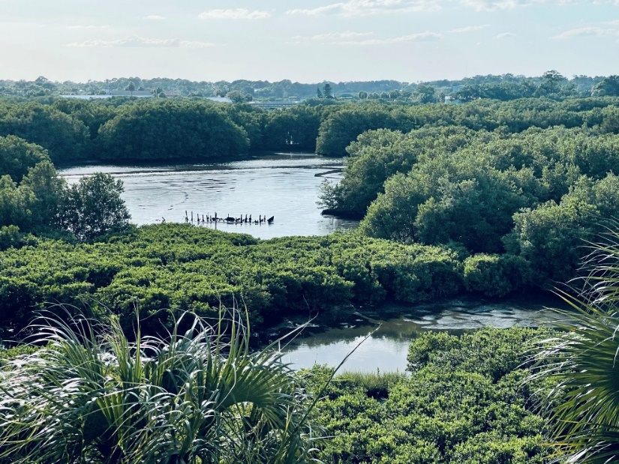

Saturday, May 6
Nature Coast Biological Station (NCBS)
9:45AM
Enter NCBS and browse updated Aquarium
9:55AM
Proceed upstairs to classroom
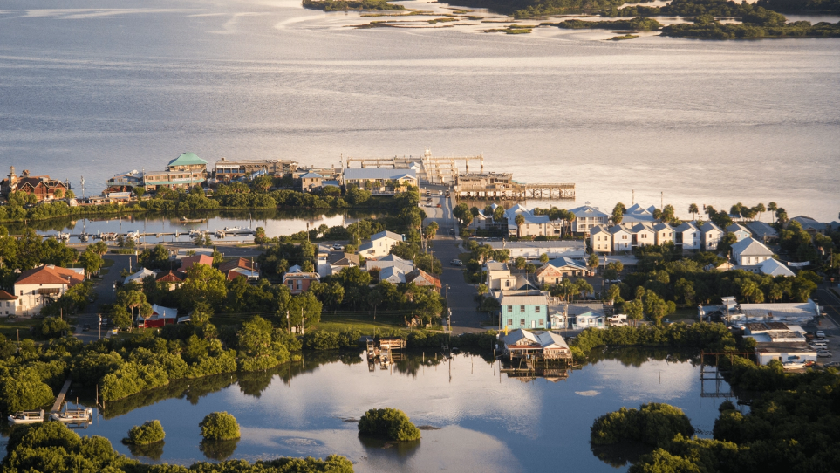

10:00-10:30AM
Welcome to NCBS
Welcome to NCBS, Mike Allen, Director
Florida Commercial Fishing: Top Ten, Methods and Location and
Three Significant Changes Affecting Cedar Key—Jim Cato

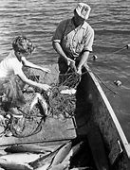

Brief Break

10:35-11:35AM
The Story and Significance of the Shellfish Industry in Cedar Key
Leslie Sturmer—UF/IFAS Aquaculture Extension Program
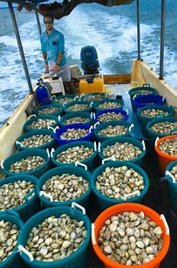

Brief Break

11:40-12:30
The CARMEN Project
Mendy Allen—Pelican Realty
This includes a short presentation and walk around for some of the buildings on 2nd Street.
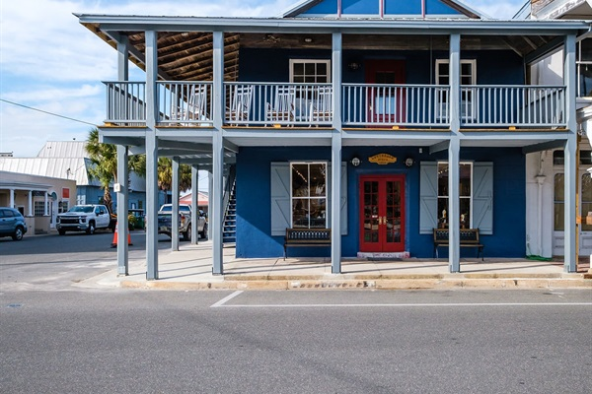

1:00PM
Lunch Duncan’s on the Gulf
Dock Street
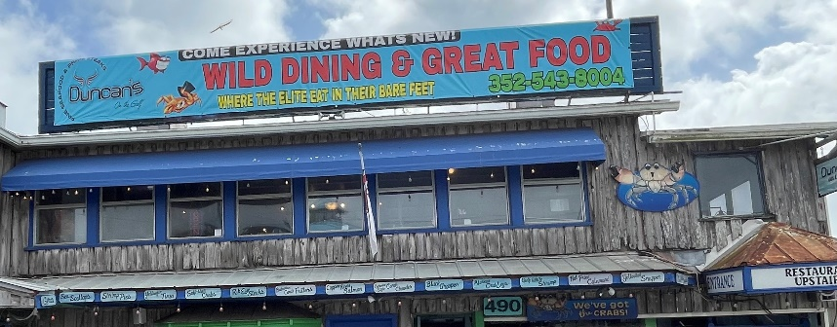

2:15PM
Cedar Key Historical Museum (optional)
30 Minutes or as long as you like. The Museum has new exhibits.
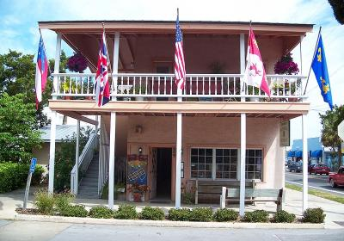

Free Time

5:00PM-8:00PM
Fish Fry and Dinner at Laraine and David Teiss’ Home
Fun with the Kentucky Derby—Mitzi Austin
16320 SW Airport Road. A map is attached.
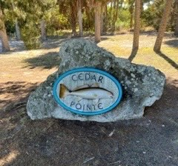

Sunday, May 7
Breakfast on Your Own
Suggestions: 2nd Street Café or Annie’s
