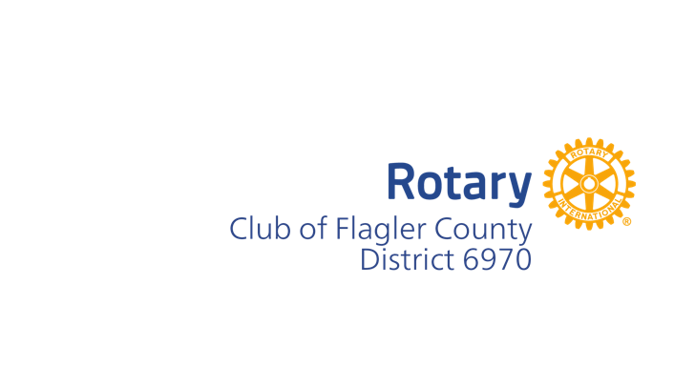

**Rotary Club of Flagler County**

**Board of Directors Meeting Agenda**

**April 15, 2025**

1. Call meeting to order – Meeting called to order at 1:00 PM.

Attendees: Michelle Bartlome, Ken Costa, Bill Lyon, Selena Hernandez, Guilio Lancia, Christy Butler, Derrick Hardin, Jim Callender, Vijay Jain, Jeanette Loftus, Maralee Walsh., Susan Steadman, Charles Barbel.

1. Secretary’s Report - Susan
   1. Approve minutes from previous meeting – Christy made a motion and Derrick seconded, minutes were approved.
2. Treasurer’s Report – Derrick Hardin
   1. Review Treasurer's Report – Derrick had emailed reports to us. Some CD’s are renewing but Intracoastal rates are competitive so we will renew. We discussed the past due report, Michelle Jeanette and Derick will work on an approach for each person on the list. Work will begin next month on next year’s budget. Selena moved to accept the treasurer’s report and Ken Costa seconded – reports were accepted.
3. Club Administration
   1. Fellowship events, socials, etc – About 35 people attended the picnic in April, nothing planned for May due to things on the schedule.
4. Membership Report - Charles
   1. New Members, Resignations, Red Badge status – Mike Kuypers will be moving to North Carolina full time and will be resigning in the future.
   2. Review member attendance/participation – Net membership for the club is about flat. Laura will be moving into the membership chair role for the coming year.
5. Public Relations Report – Selina
   1. Booth at Palm Coast Expo - May 7 – we will have a table at this event with materials about Rotary
   2. Bill Butler was named the Citizen for the Year for Palm Coast – well deserved!
6. Community Service Report – Maralee
   1. We will plan a road cleanup sometime in May (Guilio).
7. Old Business
8. New Business
9. New board members – two board seats will be open for term of 2025-2027 – one is available now, one in July. Michelle recommended that Laura Salazar take one spot, and Selena Hernandez take the other. Jim Callender will cycle off the Foundation Board as well. Foundation Board members must be past presidents (we had approved Vandana for this but she is not a past president). A motion was made by Jeanette to move Jeanette to the Past President spot on the board, and Charles will stay in a Board position until July 1st, Derick seconded this. Motion was approved.
10. Four-way test for High Schoolers on Friday, May 2 – Selina – Selina is getting approval from the school for visitors, and will be setting up training for those who will be helping with this pilot. We will have 9th and 10th graders involved. Materials available from Yvonne are being modified.
11. Susan will be sending our members info to update their info in DacDb – this will come via PMail.
12. We had some discussion about potential interest in the future in revitalizing Youth Exchange. We will consider this in the future.
13. Motion to Adjourn 1:44 Christy motioned to adjourn, Ken Costa seconded.