Giving slum residents hope to improve their own sanitation

Ben Tidwell, PhD Candidate, London School of Hygiene and Tropical Medicine

Rotary Global Grant Scholar, 2016-2017, Host District 1260
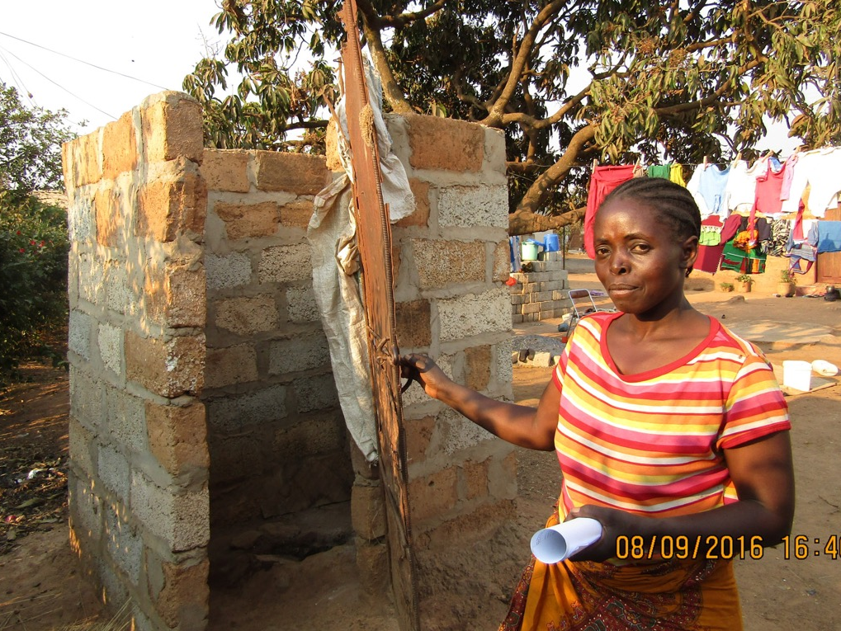
Jamia was born in a rural village in Zambia miles away from the nearest road. As she grew up, her community slowly grew and developed. A well was dug to provide clean water and cell phone towers spread across the landscape. One day, someone came to tell her family about the importance of building a pit latrine. Her father was reluctant at first, but eventually asked his brother to help him build a latrine. They dug a hole, covered it with a concrete slab, and built a shelter over it for privacy and safety. It wasn’t much to look at, but it was their own and they took great care to keep it clean and maintain it.
Figure 1: Jamia and her toilet

Years later, Jamia moved to a peri-urban slum in Zambia’s capital, Lusaka. She came searching for work and educational opportunities and a better life. When she arrived, she was shocked to find that the toilets anywhere she could afford to live were shared by several families. They were filthy and sometimes even full and unusable. She rented the nicest flat she could afford, but the smell and the mess created by the children of other tenants using the same toilet made it so that she had to sneak into a nearby friend’s toilet at night so that no one would see her and complain. Her own landlord tells her that if she doesn’t like the toilet, she should move. Jamia feels hopeless to improve her situation.

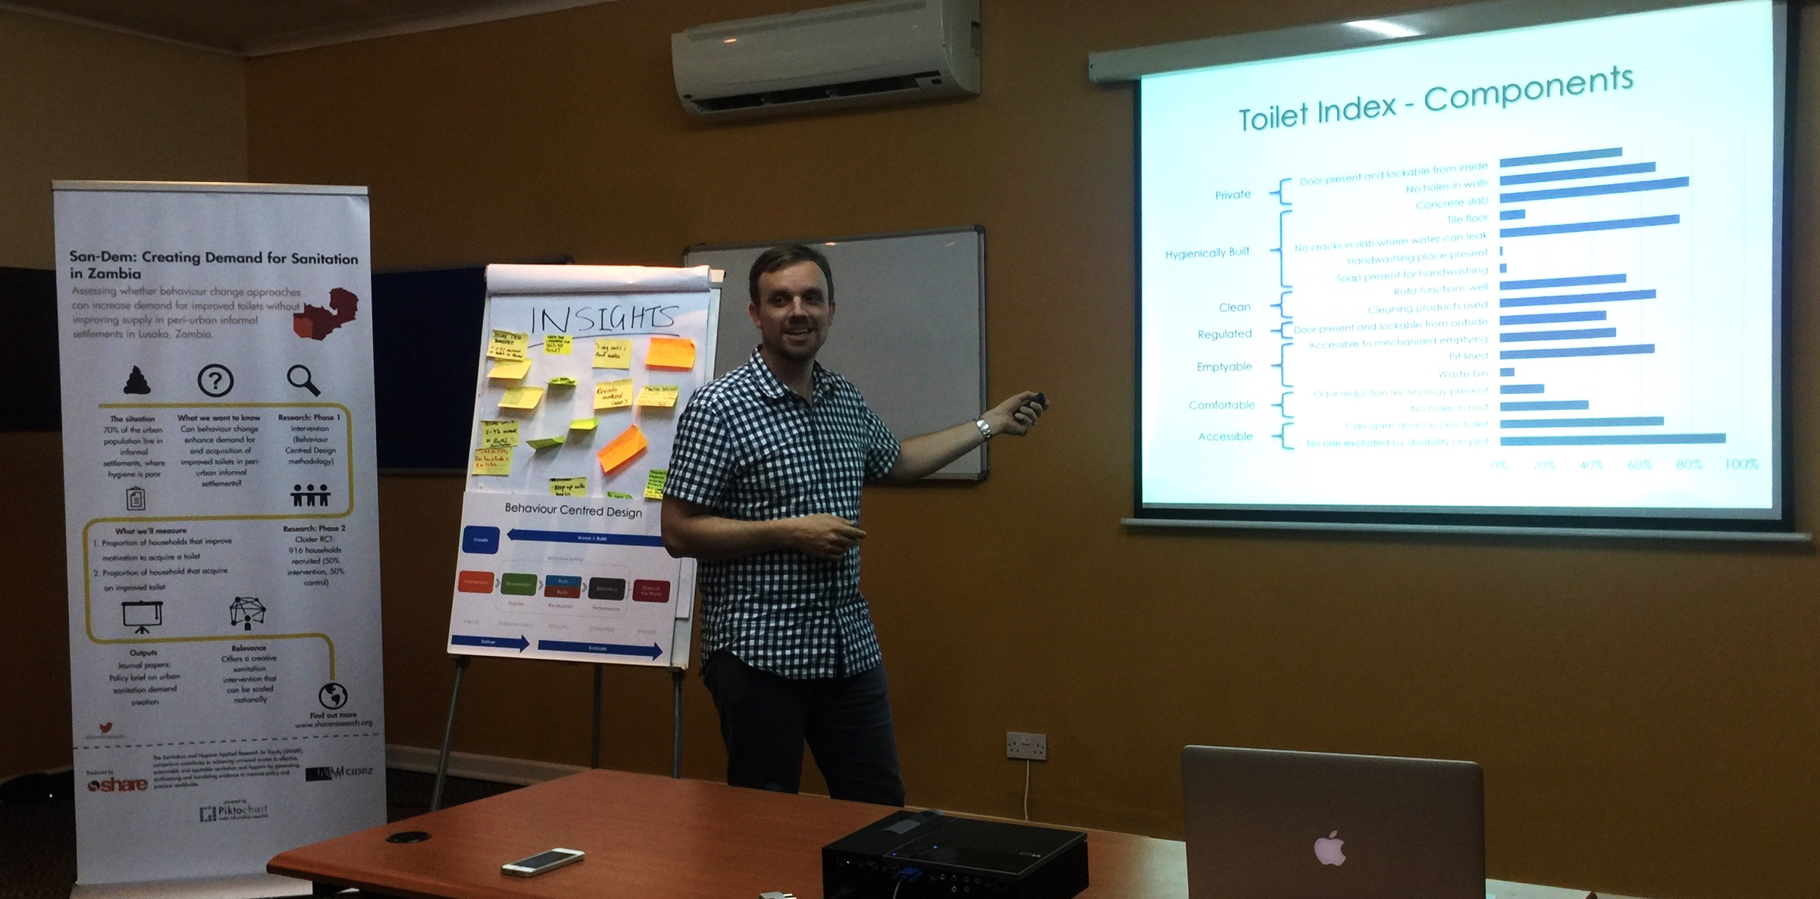
Jamia’s situation is typical of many living in peri-urban slums. More than 2 billion people lack adequate sanitation worldwide, and hundreds of thousands die every year as a result. Peri-urban areas generally have poor sanitation and are rapidly growing, from 860 million in 2015 to an estimated 2 billion in 2035! Governments have tried to regulate household sanitation or provide sewerage lines or toilets. But, this has been ineffective or too costly in most countries.
Figure 1: Presenting research findings to local government and community leaders

Rotary is supporting my PhD research at the London School of Hygiene and Tropical Medicine. I am working with landlords to help them understand the financial incentives for improving sanitation. I am also working with tenants to increase their collective ability to negotiate with landlords. I am learning what motivates people to desire sanitation and how they can work together to solve their own problems. I am studying how to fix market failures that undervalue sanitation because it is a taboo subject. My goal is that the next Jamia that moves to a peri-urban slum will experience the health benefits and basic human dignity that comes from proper sanitation. He or she will be able to make this the first of many positive changes leading to a longer, better, more empowered life. Thank you for your support, from me and the people like Jamia that will benefit from this research.

