Rotary Club of Palm Coast

2018 Community Star

Nomination Instructions
Nomination Forms due to Rotary Club of Palm Coast by Friday, August 31
Questions? Email: palmcoastrotary@gmail.com
Celebrating our Community Stars Event Date – Saturday, October 6
Sponsorships available Tickets on sale starting August 10

The Award:
People, organizations and businesses making a difference in the lives of our community members whether through a helping hand, supplying specific resources or being a great role model. Making a difference comes in all shapes and sizes; these individuals, organizations or businesses put people first!

Eligibility:
Nominations are open to the public. The nominee must have demonstrated commitment to the Flagler County community and contributed positively to our quality of life. Community Stars may be awarded posthumously.

Instructions:
Community Stars will be chosen based upon the information you provide. Please answer each question as completely as possible and include a response for each question. We will not be contacting any nominators or nominees for additional information.

Submit your nominations to:
Rotary Club of Palm Coast – Community Stars
PO Box 352151
Palm Coast FL 32135
or email to palmcoastrotary@gmail.com

Awardees will be announced on September 10 and will receive their awards at our Celebrating Our Community Stars event on Saturday, October 6, 2018 at the Palm Coast Community Center. All nominees will receive recognition in the event program. In acknowledgement of your nomination, your name will be printed next to your nominee’s name in the program.

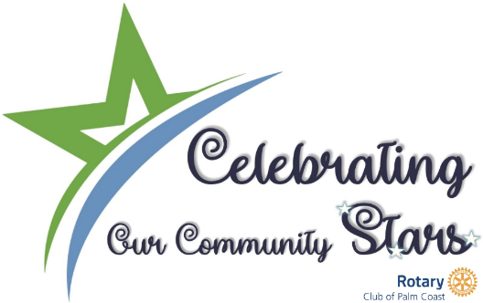

Rotary Club of Palm Coast 2018 Community Star Nomination Form

Nomination Deadline - August 31, 2018

NOMINATOR (YOUR information):
Full Name: Click or tap here to enter text. Phone Number: Click or tap here to enter text.
Email Address: Click or tap here to enter text.
Street Address: Click or tap here to enter text. City, State, Zip: Click or tap here to enter text.

PLEASE COMPLETE THIS FORM AS ACCURATELY AS POSSIBLE. We will not be contacting any nominators or nominees for additional information.

I am nominating: Click or tap here to enter text. as a Community Star in the following category (please choose only one category per nominee)

☐ Making a Difference Star: Individual
☐ Making a Difference Star: Organization
☐ Making a Difference Star: Business
☐ Star Senior Advocate
☐ Volunteer Star
☐ Star Educator
☐ Public Safety Star (Police, Sheriff, Fire Fighter, EMS etc.)
☐ Star Entrepreneur
☐ Name Your Own Community Star Category Click or tap here to enter text.

NOMINEE INFORMATION:
Name: Click or tap here to enter text.
Nominee Phone: Click or tap here to enter text. Email Address: Click or tap here to enter text.
Street Address: Click or tap here to enter text. City/State/ Zip: Click or tap here to enter text.

Nominee’s business or organization: Click or tap here to enter text.

Nominee notable achievements: Click or tap here to enter text.

Why are you making this nomination? Click or tap here to enter text.

You may attach ONE additional page with any information you think we should consider during the selection process. Thank you for your nomination!

