CERTIFICATE
OF APPRECIATION
Presented to:

[NAME]
In honor of your presentation to the Rotary Club of Ponte Vedra Beach, the club has made a donation to Rotary International to vaccinate children worldwide against poliomyelitis (polio)

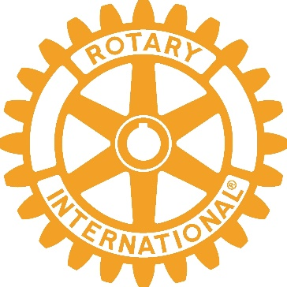
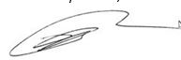
Date
[Date]
Ronald “Doc” Renuart
President, 2022-2023
Rotary Club of Ponte Vedra Beach

