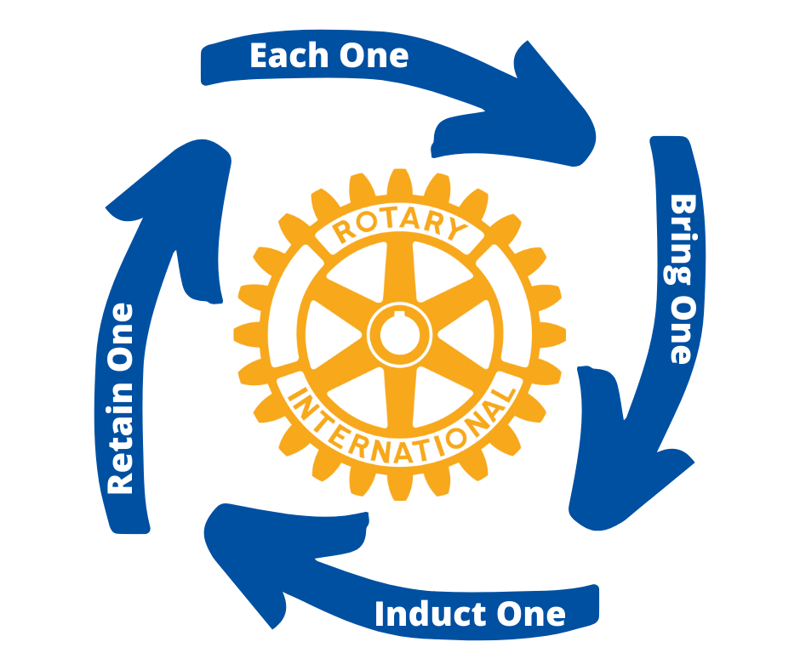

Rotary Zone
Membership Contest
2021 – 2022
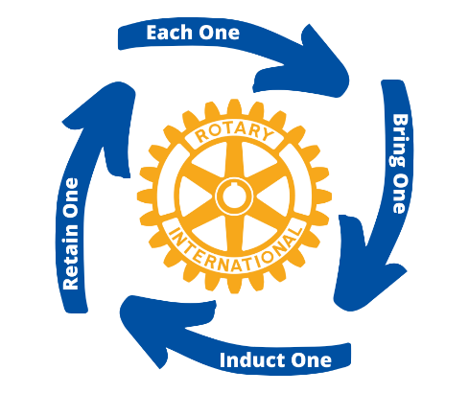
Rotary Zone Membership Contest 2021 – 2022

What is it?
- The Rotary Clubs in each District will compete with other clubs their size to win the Zone Membership Award.
- Each club will earn points (see attached scorecard) for the activities that will result in an increase in NEW MEMBERS, and an increase in the RETENTION of their current members.

How does it work?
- Each club in each district will be categorized by their size:
  - Club size categories (measured on 7/1/21):
    - Small club: up to 29 members
    - Medium club: 30-59 members
    - Large club: 60-89 members
    - Extra large club: 90+ members
- Keep track of your club’s progress on the Zone Membership Scorecard (attached) from February 1 to July 1, 2022.
- The three clubs with the highest point totals in each size category will receive the Zone Membership Award. (12 winners/district)
  - Award levels are Platinum (#1), Gold (#2), Silver (#3)
- NOTE: To win your club must have increased in size from 7/1/21 to 7/1/22.
- Club Membership Chairs: Email your completed scoresheet to your District Membership Chair by 7/10/22.
- District Membership Chairs: Verify club results and send verified forms to Zone Rotary Coordinator at MikeHDarragh@gmail.com by 7/17/22.

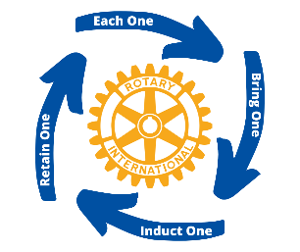
Rotary Zone Membership
Contest Scorecard

DISTRICT: CLUB:

PRESIDENT: CLUB SIZE 7/1/2021:

ACTION | VALUE | POINTS EARNED
Each One Bring One (Potential Rotarian) | ONE (1) point per unique visit;  Multiple visits by the same person do not count
Induct One New Member | FIVE (5) points per New Member Inducted between 2/1/22 and 7/1/22
Implement Member Retention Program | FIVE (5) points One time only
Briefly Describe Retention Program:

Hold Rotary Social Recruiting Event | TEN (10) points for each event
List Social Dates:

Achieve ALL FOUR of the Above Activities | TWENTY (20) points One time
Certify Net Positive | Club had a Positive Gain in size from 7/1/2021 to 7/1/2022 | YES / NO
Club Size 7/1/2021: Club Size 7/1/2022:
(Apply 4-Way Test to all your answers) | TOTAL POINTS EARNED
 | RESULTS VERIFIED BY DMC: | YES / NO

CLUB: Email Completed Form to District Membership Chair by 7/10/2022.

Insert DMC Name DMC Email

DISTRICT MEMBERSHIP CHAIR: Email to Rotary Zone Coordinator by 7/17/2022.

Mike Darragh MikeHDarragh@gmail.com

