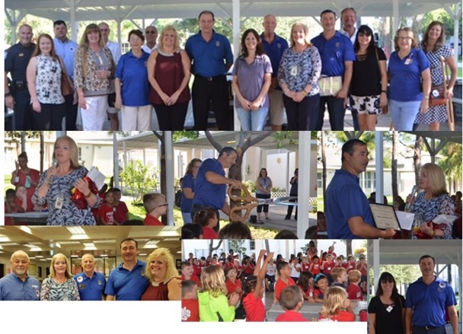

Club of Pinellas Park, Florida
District 6950, Area 3
First Annual Hero Awards
Nomination Form
Nominate a Hero! Individual or Organization…
It’s EASY and its FREE! Deadline for Entries is April 30, 2021
Nomination Categories: Promoting Peace…Fighting Disease…Promoting Clean Water, Sanitation and Hygiene…Saving Mothers and Children…Supporting Education and Economic Development…Protecting the Environment in Your Communities!

(Form is in Fillable Format, Just Click and Type)
In 250 words or less, tell us about your HERO…Click on to Describe your Hero Here

Please check the category or categories that apply to your HERO… ☐ Promoting Peace… ☐ Fighting Disease…☐ Promoting Clean Water, Sanitation and Hygiene…
☐ Saving Mothers and Children…☐ Supporting Education and Economic Development… ☐ Protecting the Environment in Your Communities

Please provide your HERO’s contact information…
CONTACT PERSON: Name
ORGANIZATION IF APPLICABLE: Organization’s Name
EMAIL: Email Address
CELL: Number

Please provide YOUR contact information…
CONTACT PERSON: Name
ORGANIZATION IF APPLICABLE: Organization’s Name
EMAIL: Email Address
CELL: Number

We cordially invite you to attend the First Annual Hero Awards Luncheon taking place on May 20th, 2021 at Noon. Banquet Masters located at 13355 49th Street North, Clearwater, Florida 33762
☐ Yes, I will be in attendance.
☐ Yes, My HERO will be in attendance.

VISIT www.rotarypinellaspark.org to Nominate Your HERO!

