Goat Day Food Application
October 21, 2023
Sam Adkins Park, Blountstown, Florida

PLEASE RETURN APPROPRIATE FEES WITH APPLICATION

Name of booth or organization: Person in charge of booth:

Types of food to be served: (attach additional pages if necessary)

Tax ID # Non-Profit ID# (if applicable)

Only the food types listed on your application, and approved by the Committee, may be served. THERE WILL BE NO EXCEPTIONS. Any violation of this rule will be cause for expulsion. Setup time is on Friday between 8:00 AM - 6:00 PM

Fee for booths 20’ wide by 20’ deep which includes water, trash removal, electricity, etc., are:
$200.00 (If trailer including tongue is over 20’ you will need two spaces).

Number of Spaces Needed: Fee Submitted:

Total amount of amperage/voltage your booth will need during event: /

At what location will any food be prepared in advance?

Method of keeping food hot and/or cold at event site:

Food must be protected from dust, insects, coughs, and sneezes. How will you provide this protection?

Describe your structure:

CONTACT PERSON:

Name (print):

Address:

Cellphone #: - -__________ E-Mail: ____________________________________

I have read and agree to the CRITERIA AND RULES FOR PARTICIPATION.

Failure to comply with applicable food service requirements in accordance with Chapter 10D-13, Florida Administrative Code, or the rules set forth by the Blountstown Rotary Club, will result in enforcement action. Do you understand this completely? Yes No

I certify that to the best of my knowledge and belief, all statements contained herein and on my attachments are true, correct, complete, and made in good faith. I understand that these regulations include food intended for service to the public, regardless of whether there is a charge for the food. I agree to assume complete responsibility for this establishment, and I certify that said business will be conducted in compliance with the Florida Administrative Code, Chapter 10-D-13, and rules set forth herein.
I/we hereby agree to, in all events, indemnify the Blountstown Rotary Club, and all sponsors, their representatives and successors and hold same harmless from and against any and all claims, actions, damages, liability and expense in connection with the loss of life, personal injury or illness and/or damage to property arising from or out of the sale of any product of the operation or conduct of lessee’s business from same, by lessee their agents, contractors, employees, servants, or others, without limitation.
For further information contact: Sharon Chason (850) 557-1764 or sharon_chason@yahoo.com

Signature of Applicant/Lessee Date

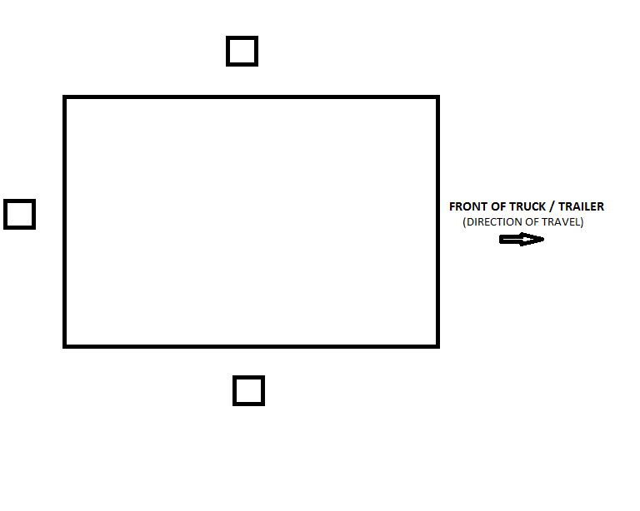
To assist us with assigning appropriate vendor lots for your specific needs please indicate on the diagram below the side(s) from which you will serve your merchandise.

