Rotary International District 6940
District Leadership/Council
Rotary Year
District Governor
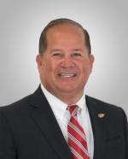 | Medina, John A Sr.  Office: 386-755-0600 (3473) | 453 SW Rosemary Drive  Lake City, FL 32024 | Home:  Mobile: 850-694-0040  Fax:
DG-Elect
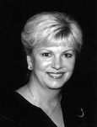 | Richards, Innes C.  Office: 850-380-5454 | 6625 Calle de Laurel  Navarre, FL 32566 | Home: 850-380-5454  Mobile: 850-380-5454  Fax:
iPDG
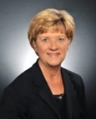 | Weeks, Lisa Broxson (DG Lisa)  Office: | 4480 Highway 90  Pace, FL 32571 | Home:  Mobile: 850-324-1882  Fax:
District Rotary Foundation Chair
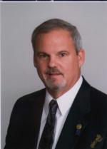 | Rauch, David M. (Dave)  Office: 850-424-3134 | 207 Windward Cove S.  Niceville, FL 32578 | Home: 850-865-0897  Mobile: 850-865-0897  Fax: 850-424-3137
District Secretary
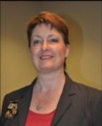 | Rodebaugh, Belinda  Office: | PO Box 14267  Tallahassee, FL 32317 | Home:  Mobile: 480-748-1254  Fax:
Treasurer
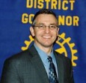 | Tatem, Michael  Office: 386-752-0681 | 268 NW Lake Jeffery Road  Lake City, FL 32055 | Home:  Mobile:  Fax:
Finance / Co-Chair
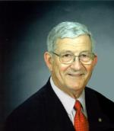 | Mancuso, Ralph M.  Office: | 4019 Kilmartin Drive  Tallahassee, FL 32309-2861 | Home: 906-0543  Mobile: 850-933-0351  Fax: 850-906-0543
Assistant Governor, ASSISTANT GOVERNOR AREA 1 PENSACOLA AREA
Navarre,Pensacola,Pensacola Seville,Pensacola Suburban West,Pensacola-Five Flags,Perdido Key
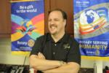 | Sulger, Daniel J. (Dan)  Office: 850 797-0257 | 1685 Tidewater Ct  Navarre, FL 32566 | Home:  Mobile: (850) 797-0257  Fax:
Assistant Governor, ASSISTANT GOVERNOR AREA 2 . GREATER PENSACOLA
Cantonment,Gulf Breeze,Milton,Pace,Pensacola North,Pensacola-Cordova
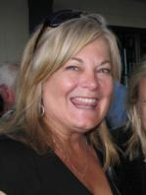 | Erickson, Lynn  Office: 850-444-6249 | 106 Highpoint Dr  Gulf Breeze, FL 32561 | Home:  Mobile: 850-293-4614  Fax:
Assistant Governor, ASSISTANT GOVERNOR AREA 3 . FT WALTON
Crestview,DeFuniak Springs,Destin,Fort Walton Beach,Mid-Bay Bridge,Niceville-Valparaiso,South Walton County
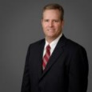 | Lindsley, Bill  Office: 850-650-9935 | 359 Kelly Plantation Drive  Destin, FL 32541 | Home: 850-269-1630  Mobile: 8509743966  Fax:
Assistant Governor, ASSISTANT GOVERNOR AREA 4 . PANAMA CITY
Emerald Coast (Panama City Beach),Lynn Haven,Panama City,Panama City Beach,Panama City-Northside,Port St. Joe
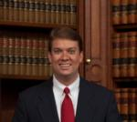 | Morris, Dana (Dana )  Office: 850-257-5680 | , | Home:  Mobile: 850-393-8570  Fax:
Assistant Governor, ASSISTANT GOVERNOR - AREA 5 - Central
Apalachicola Bay Rotary Club,Blountstown,Chattahoochee,Marianna,Quincy
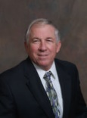 | Duell, Ron  Office: | 323 Compass Lake Drive  Alford`, FL 32420 | Home: 850-579-2975  Mobile: 850-894-3200  Fax:
Assistant Governor, ASSISTANT GOVERNOR AREA 6 . TALLAHASSEE AREA
Tallahassee,Tallahassee Northside,Tallahassee Sunset,Wakulla County
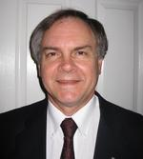 | Kubiak, Larry Curtis  Office: 850-431-5879 | 5398 Pembridge Place  Tallahassee, FL 32309 | Home: 850-668-9763  Mobile: 850-339-7519  Fax: 850-431-6150
Assistant Governor, ASSISTANT GOVERNOR AREA 7 . LAKE CITY AREA
Branford,Lake City,Lake City Downtown
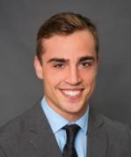 | Walker, Noah E.  Office: 386-269-2959 | 340 NW Commerce Drive  Lake City, FL 32054 | Home: 386-965-2917  Mobile: 386-965-2917  Fax:
Assistant Governor, ASSISTANT GOVERNOR AREA 8 . LIVE OAK AREA
Live Oak,Madison,Mayo,Perry
 | Taylor, Dawn V.  Office: 850-584-5366 | P.O. Box 892  Perry, FL 32348-0892 | Home: 850-838-2038  Mobile:  Fax:
Assistant Governor, ASSISTANT GOVERNOR AREA 9 . TALLAHASSEE AREA
Monticello,Tallahassee (Capital),Tallahassee Southside,Tallahassee Sunrise
 | Nelson, Linda  Office: | 3202 Lakeshore Drive  Tallahassee, FL 32312 | Home:  Mobile: 850-321-2486  Fax:
Assistant Governor, ASSISTANT GOVERNOR AREA 10 . CHIEFLAND AREA
Chiefland,Dixie County,Suwannee Valley,Trenton,Williston
 | Carlisle, Jana  Office: 352-528-1726 | 342 E Noble Ave  Williston, FL 32696 | Home: 352-538-2073  Mobile: 352-538-2073  Fax: 352-529-4626
Public Image
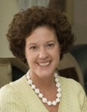 | Thompson, Maureen  Office: 668-0948 | 2978 Giverny Circle  Tallahassee, FL 32309 | Home: 668-0948  Mobile:  Fax:
Youth Service Coordinator
 | Cowan, Gregory J. (Greg)  Office: | 1415 Alshire Court South  Tallahassee, FL 32317 | Home: 850-509-7036  Mobile: 850-509-7036  Fax:
PDG, Club Extension Chair
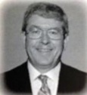 | Hirsh, Leon B.  Office: 850-477-3336 | 4623 Calle Arenoso  Pensacola, FL 32514 | Home: 850-485-0738  Mobile: 850-485-0738  Fax:
Alumni Coordinator
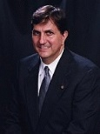 | Liner, Stephen Ewell (Steve)  Office: 850-567-9331 | P.O. Box 564  Tallahassee, FL 32302 | Home: 850-567-9331  Mobile: 850-567-9331  Fax:
Annual Fund Chair
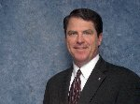 | Mathis, Darrel T. D.C.  Office: 386-752-4313 | 279 S.W. Main Blvd.  Lake City, FL 32025-7050 | Home: 386-752-7816  Mobile: 386-397-5796  Fax: 386-752-8356
District Awards Chair
 | Kendrick, Kaye  Office: 509-5927 | 1606 North Meridian Road  Tallahassee, FL 32303 | Home:  Mobile: 8505095927  Fax:
District Conference Chair
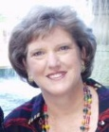 | Pooley, Jan  Office: 850-585-3497 | 2805 Jerry Pate Court  Shalimar, FL 32579 | Home:  Mobile: 850-585-3497  Fax:
District Fellowship Chair
 | Rupert, Jennifer  Office: 850-599-8945 | 710 Forest Lair  Tallahassee, FL 32312 | Home: 850-656-5686  Mobile: 850-510-8607  Fax:
District Interact/Rotaract
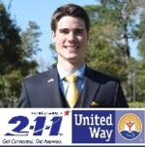 | Hinsch, Cory S. M.  Office: 8509128199 | , | Home:  Mobile: 8507762876  Fax:
District Membership Chair
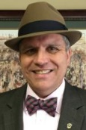 | Lambert, Rick  Office: 850-361-4978 | Iron Horse Wealth Strategies  3000 Langley Ave., Suite 200  Pensacola, FL 32504 | Home: 850-291-7031  Mobile: 850-291-7031  Fax:
District Newsletter Editor
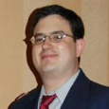 | Viola, Mark Lee  Office: 850-584-5513 | 3384 Slaughter Rd  Perry, FL 32347 | Home: 850-584-8807  Mobile: 850-843-3441  Fax: 850-838-1566
District RLI Chair
 | James, Chris (Christine)  Office: | 4078 Woodridge Rd  Panama City , FL 32405 | Home:  Mobile: 850-819-2437  Fax:
District Social Media Chair
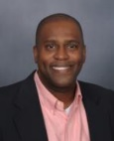 | Boyd, Andre  Office: 407-506-6130 | 6912 Coe Road  Panama City, FL 32404 | Home: 407-506-6130  Mobile: 407-506-6130  Fax:
Grants Committee Chair
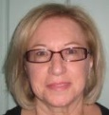 | Isham, Christine Danielson  Office: 407-412-5142 | 1715 Canton St  Orlando, FL 32803 | Home:  Mobile: 850-206-8943  Fax: 407-412-5142
Paul Harris Society Chair
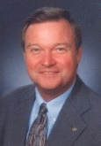 | Kirchharr, Ted A.  Office: 850-898-3937 | 2221 Dupont Dr.  Pensacola, FL 32503 | Home: 850-341-4674  Mobile: 850-341-4674  Fax:
Peace FELLOW Coordinator
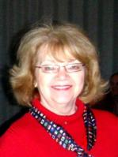 | Suerken, Kathy  Office: | 1532 Glenlake Cir.  Niceville, FL 32578 | Home: 850-897-2616  Mobile: 850-897-2616  Fax:
Polio Programs Chair
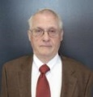 | Rockwood, Charles E (Charlie)  Office: | 4172 Covenant Lane  Tallahassee, FL 32308 | Home: 850-894-4850  Mobile: 850-294-1418  Fax: 850-325-1824
RYLA Chair
 | McNally, Olevia  Office: 850-444-2557 | 130 Chipley Ave.  Pensacola, FL 32503-6338 | Home: 850-432-6006  Mobile: 850-380-0465  Fax: 866-468-9566
RYLA Chair
 | McNally, Stephen D (Steve)  Office: | 130 Chipley Ave  Pensacola, FL 32503 | Home:  Mobile: 850-316-7900  Fax:
Vocational Training Team Chair
 | Deeb, Larry C. M.D.  Office: 4315404 | 2304Trescott Dr  Tallahassee, FL 32308 | Home: 386-6412  Mobile: 509-4864  Fax:
Youth Exchange Long Term
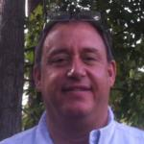 | Blandino, Salvatore M. (Sal)  Office: 556-3882 | 2699 S. Hannon Hill Drive  Tallahassee, FL 32309 | Home: 668-7546  Mobile:  Fax: 562-9100
Youth Exchange Long Term
 | Schmitz, T. Bo (Bo)  Office: | 840 N Forest Drive  Tallahassee, FL 32303 | Home:  Mobile: 616.644.5874  Fax:
Youth Exchange Short Term
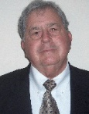 | Pryor, Fred L.  Office: | 621 West Miracle Strip Parkway  Mary Esther, FL 32569 | Home: 850-243-4907  Mobile: 850-585-5824  Fax:
International Services Chair
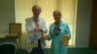 | Nield, Beverly  Office: 850-522-3900 | 4138 Cobalt Cir.  Panama City Beach, FL 32408 | Home: 850-708-1913  Mobile:  Fax:
Training Coordinator
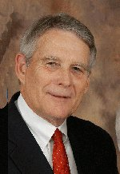 | Kuykendall, John G.  Office: 386-755-9018 | 248 N. Marion Avenue  Lake City, FL 32055 | Home: 386-288-6712  Mobile: 386-288-6712  Fax:
DCO-District Comm. Officer
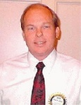 | Schuster, Robert W. (Bob)  Office: | 2387 Reservation Rd.  Gulf Breeze, FL 32563 | Home: 850-934-3683  Mobile: 850-501-4456  Fax:

Date of Report: 11-May-18

