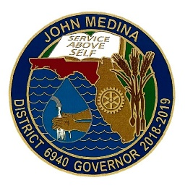
2018-2019
District 6940
District Governor Citation
John A. Medina

We inspire current and future servant leaders and equip them with the tools and resources they need to be successful.

- Achieve Presidential Citation

- Minimum one-page Club Strategic Plan focused on growing membership, foundation giving, and local/global service:
  - Distinction (circle 4 of 6from below)
    - Support a local or global project in water, literacy, or fighting hunger.
    - Develop a Disaster Recovery Plan
    - Club Foundation and Membership Chairs in DACdb by 7/31/18
    - PE Listed in DACdb by 7/31/18
    - >10% of club members have attended an RLI course
    - Submit or co-sponsor a DDF or Global Grant request

- Inspire Current and Future Servant Leaders (circle minimum of 4 from below)
  - Distinction (circle 6 of 10 from below)
    - Host an in-bound or out-bound RYE student
    - Support a Rotaract Club
    - Support an Interact Club
    - Sponsor a RYLA participant
    - Support Rotary Youth Camp
    - Nominate a Peace Fellow
    - >10% of club members attend 2019 District Conference
    - Select a Shining Star & Rising Star for DG Club Visit recognition
    - Sponsor a Rotary 4-Way Test Speech Competition in your community
    - Club is in top 50% of clubs in District for average EREY/member in size category; 1)small (<30 members), medium (31-75), and large (>75)

______________________________ __________________________
Club Name & # Club President Signature & Date
4-Way Test

