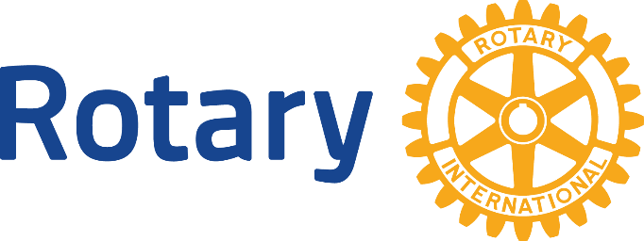

Rotary Principles
About Rotary
Rotary brings together a worldwide network of volunteers dedicated to tackling the world’s most pressing humanitarian challenges. Rotary connects 1.2 million members of more than 35,000 clubs in over 200 countries and geographical areas. Their work improves lives at both the local and inter-national levels, from helping families in need in their communities to working toward a polio-free world.
The Mission of Rotary
The mission of Rotary International is to provide service to others, promote integrity and advance understanding, goodwill and peace through a worldwide fellowship of business, professional and community leaders. Rotary encourages every club to endeavor to include the appropriate range of individuals in their membership. A club that reflects its community with regard to professional and business classification, gender, age, religion, and ethnicity is a club with the key to its future.
Rotary’s Avenues of Service

Rotary’s commitment to “Service Above Self” is expressed through these five Areas of Service:

Club Service: Focuses on strengthening fellowship and ensuring the effective functioning of the Club.

Vocational Service: Encourages Rotarians to serve others through their vocations and to practice high ethical standards.

Community Service: Includes the projects and activities the club undertakes to improve life in its community.

International Service: Encompasses actions taken to expand Rotary’s humanitarian reach around the globe.

New Generations Service: Encourages leadership development among youth and young adults through activities such as RYLA, Rotaract, Interact and Rotary Youth Exchange.
For information contact:

Candace Etzler
Membership Chair
candace@sacklunchagency.com
Mobile: (561) 703-5923

The Object of Rotary
The Object of Rotary is to encourage and foster the ideal of service as a basis of worthy enterprise and, in particular to encourage and foster:

First: The development of acquaintance as an opportunity for service;

Second: High ethical standards in business and professions; the recognition of the worthiness of all useful occupations, and the dignifying of each Rotarian’s occupation as an opportunity to serve society;

Third: The application of the ideal of service in each Rotarian’s personal, business and community life;

Fourth: The advancement of international under-standing, goodwill, and peace through a work of fellowship of business and professional persons united in the ideal of service.
The Four Way Test
Adopted by Rotary in 1943, the Four-Way Test has been translated into more than a hundred languages and published in thousands of ways. It asks the following four questions:

"Of the things we think, say or do:
- Is it the TRUTH?
- Is it FAIR to all concerned?
- Will it build GOODWILL and BETTER FRIENDSHIPS?
- Will it be BENEFICIAL to all concerned?"
Rotarian Code of Conduct
The following code of conduct has been adopted for use by Rotarians:
- Act with integrity and high ethical standards in my personal and professional life
- Deal fairly with others and treat them and their occupations with respect
- Use my professional skills through Rotary to mentor young people, help those with special needs and improve people’s quality of life in my community and in the world
- Avoid behavior that reflects adversely on Rotary or other Rotarians.

