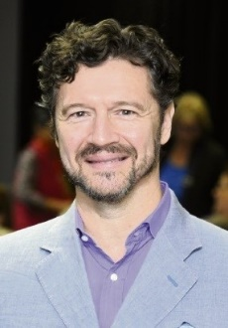
Michael Verde, founder of Memory Bridge
mom

Michael Verde will be returning in February 2020 to conduct programs on the Treasure coast. Michael lectures on the subjects of literature, world religions and communicating with people with dementia. His presentations have been called “life-changing”, join us and you will find out why!
Michael is a published author, professional speaker and an award-winning educator. He has Master degrees in Literary Studies (University of Iowa) and Theology (University of Durham, England).
In December 2018 the premiere of his most recently produced documentary, “Love Is Listening: Dementia Without Loneliness ” was hosted by St. Christopher’s Hospice in London. This masterpiece with a renowned cast has received rave reviews both here and abroad.
Michael is the founder of Memory Bridge (memorybridge.org) an internationally recognized organization which has collaborated with St. Christopher’s Hospice in London and Alzheimer’s Association Western Australia in Perth. The Memory Bridge Initiative on the Treasure coast was the recipient of LeadingAge Florida’s 2017 Best Practices award.
Michael has presented for esteemed organizations which include: Chevron’s World Religions Series, Northern Trust’s Banking on Books, The Federal Reserve Bank of Chicago and the Vero Beach Museum.

