RMB = Rotary Brain Trust 9-14-19
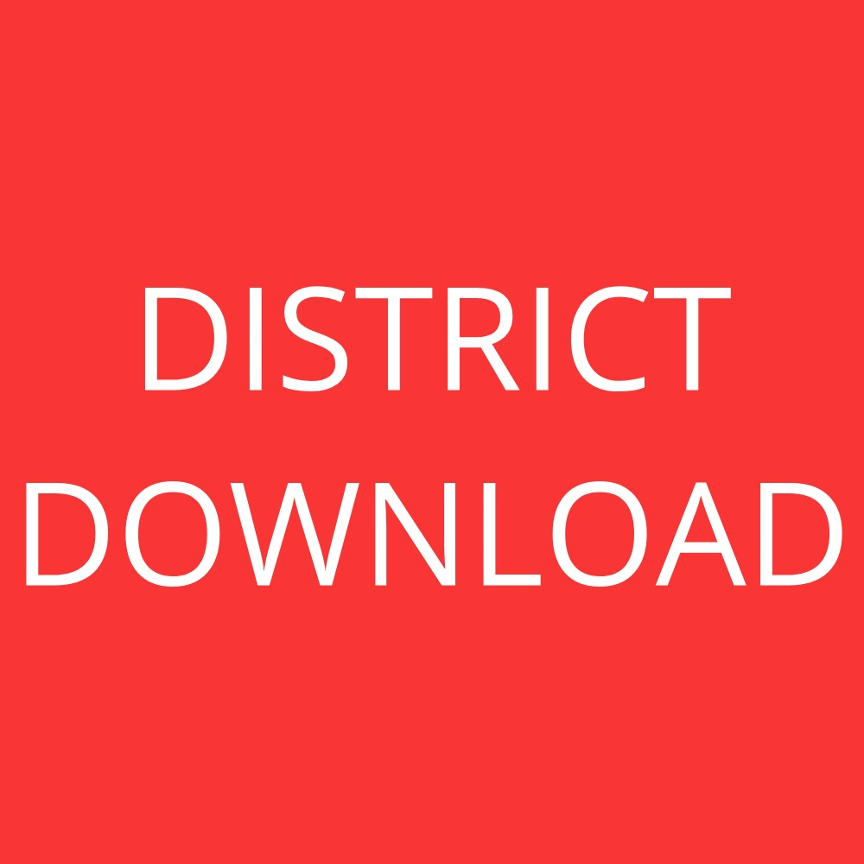
By Al Trembley, Hall County Rotary, 404.931.1151

The Rotary pin is a simple outward sign of something deeper in the heart of members. The heart and minds could be viewed as a Brain Trust, a library of people, gifted with knowledge, experience and wisdom from many generations. Cultivating Rotarian relationships begins with people opening up their “library” with others.

How did this come about and where are we going?
We had our annual “do you know your fellow Rotarian” event and although interesting, there was more.
ATTACHMENT on site. Introduction form for program chair to pre-board program...Do you Know Your Fellow Rotarian
There’s more to members than classifications and job titles.

Roundtable meetings..do you know your fellow Rotarian were conducted to gather more insight about members and what we call their "super powers". Please find the Rotary Member Master attachment. (Yes, always under construction).

We learned;
-Members contribute more than we knew.
-Knowing “super powers” was eye opening initiating quarterly R.O.C.K. presentations. Suggest a panel discussion to keep it simple and easy to present.
-These discussions were great in helping kickstart RMB

What's next?

1). Brain Trust programs 2x school year with Interact.
2). Re-do mini classification talks members.
3). Continued R.O.C.K. presentations
4). Rotary Means Business as one weekly meeting

Rotary Means Business Northeast Georgia launch 8.19.19 (Monthly, second to last Monday)
41 attendees, 14 clubs

-Kickoff RMB within club, same agenda as RMB in Cumming

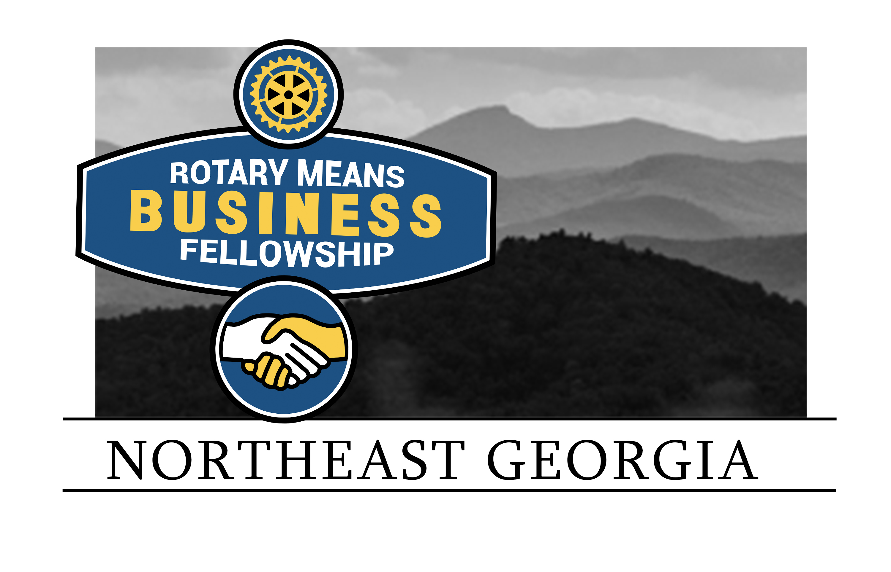
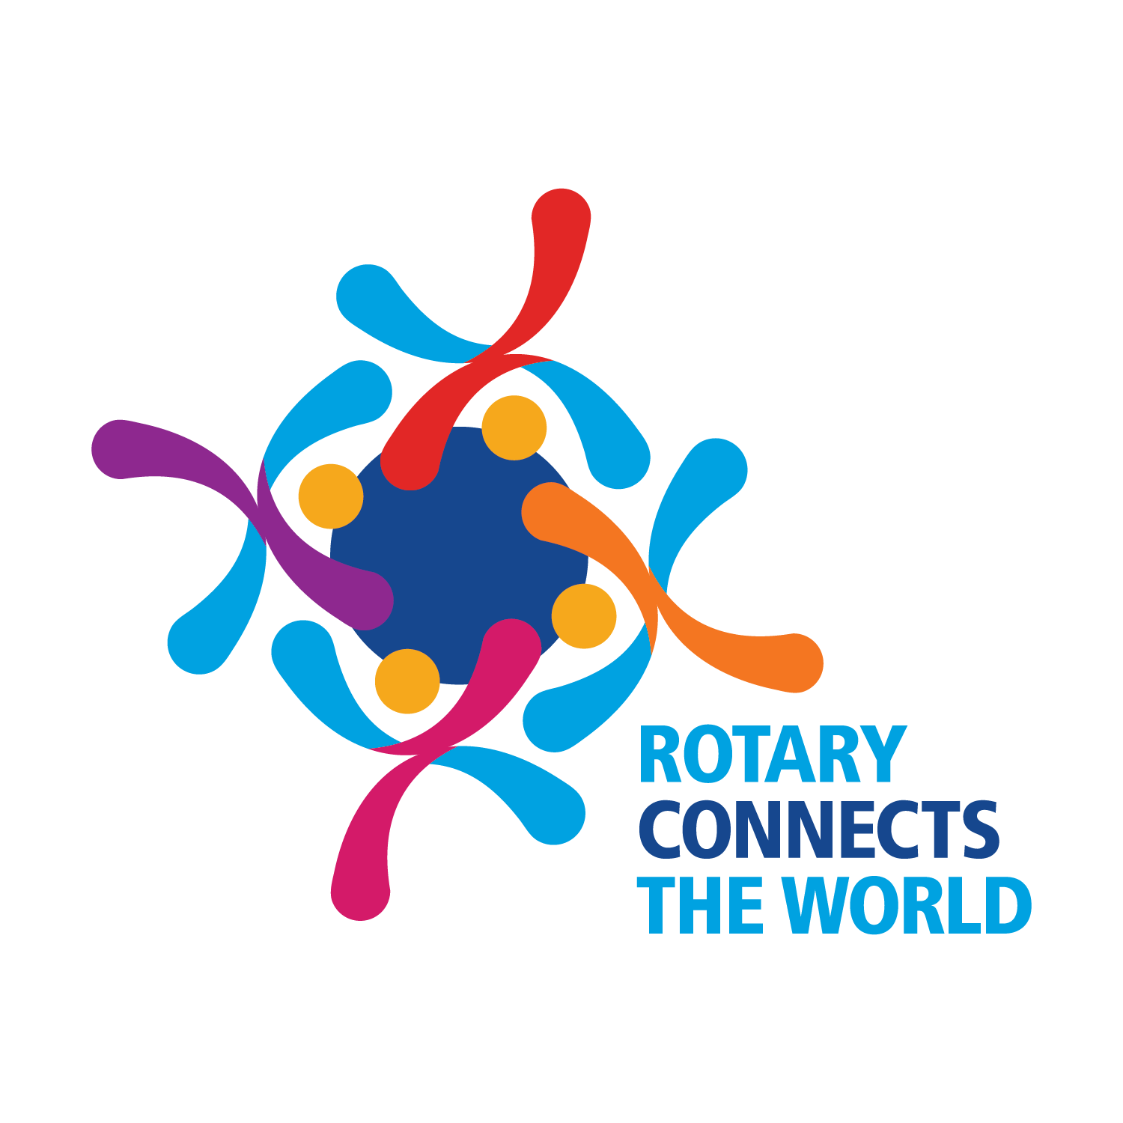
-Visited local clubs with 4.3 minute talk on the event. Invite Interact but also well suited for Rotaract.

-Great support from key spheres of influence promoting and answering questions (thanks Scott, Pepper & Hans)

-Superpowers, get so close it’s hard to miss & everyone is a library!

Have Fun!

Want a copy? Search Hall County Rotary website or hallcountyrotary.org, click “District Download”

Thanks.
By Al Trembley, 404.931.1151

