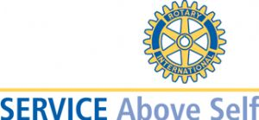
The Rotary Club of Columbia County is part of a world-wide organization of business and professional leaders who provide humanitarian service, encourage high ethical standards in all vocations, and help build goodwill and peace throughout the world. We do this through the development of community service projects that address today's most critical issues including children at risk, poverty and hunger, the environment, illiteracy and violence. We also support programs for young people that extend their educational and professional development opportunities and build their leadership skills for the future. The Rotary motto is Service Above Self and our theme for the 2007-08 Rotary year is "Sharing Rotary". I welcome you to our club and challenge you to the get involved in as many Rotary Club activities as you can. For this will give you the true flavor of Rotary and help us by bring new ideals to our club and the world-wide family of Rotary.

