TAMPA CARROLLWOOD ROTARY

April 26, 2019

AGENDA
OPENING: Welcome - Invocation – Pledge of Allegiance

INTRODUCE GUESTS & VISITING ROTARIANS

CELEBRATIONS
HAPPY BIRTHDAY
Fred Thompson – 4-27
______________________________________________________________________________________________________________
Olga Saro April 19, 2019
On a sad note – Tia Olga, who loved helping us at the Rotary Golf Tournaments & the Hugs for Kids Camp – passed away unexpectedly last Friday while visiting family in Cuba. She will be missed.
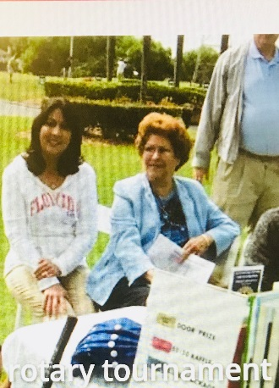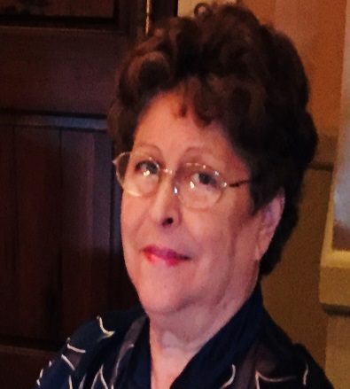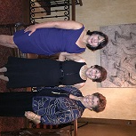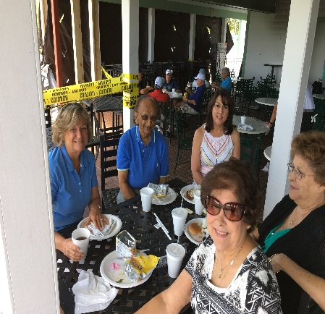
2013 Golf Tournament_____ __________Rotary Installation Party_______________ 2018 Golf Tournament
SPEAKERS
4/26- Crisis Center- Jennifer Moore

5/3- JL Video- Jordan Lung (JL Video)
RECITATION OF FOUR WAY TEST
- Is it the TRUTH?
- Is it FAIR to all concerned?
- Will it build GOODWILL and BETTER FRIENDSHIPS?
- Is it Beneficial to all concerned?
TAMPA CARROLLWOOD ROTARY CLUB

You have an open invitation to come to one of our meetings. You’ll find that our members are community leaders that are the driving force for doing good locally, as well as, on a national and international level.
Rotarians serve by promoting peace; fighting disease; providing clean water; sanitation and nutrition; education; and growing local economies. And we do all this while having fun and building lasting relationships.
Rotarians also support the success of their fellow Rotarians by doing business with them, and by referring others to them.
_______________________________________________________________________________________________________________

JOIN US Tampa Carrollwood Rotary now offers two ways to participate:
Lunch Club - Either through our weekly luncheon club that meets on Fridays at noon at the Carrollwood Country Club.
Contact Fred Thompson 813-397-4960.
OR
The After Hours Club that meets at 6:30PM monthly for happy hour and networking at designated Carrollwood locations.
For more information view our Facebook page Tampa Carrollwood Rotary After Hours Club [facebook.com]
WEBSITE: TAMPACARROLLWOOD ROTARY.COM

