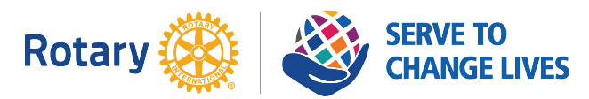
2021-2022 Rotary District 6890 Speech Contest
Application to Participate

Rotary Club Name:_____________________________________________________
Name of Participant:____________________________________________________
School:______________________________________________________________
Anticipated Graduation Date:_____________________________________________
Email Address:________________________________________________________
Telephone Number:____________________________________________________
Mailing Address:_______________________________________________________

The undersigned applicant, with concurrence of the undersigned parent/guardian, is making application to participate in the 2021-2022 Rotary District 6890 Speech Contest hosted by the [Name of Rotary Club].
The contest will be held on [day], [date], 2022, at the [location]. Photos of the contestants may be taken and used by the Club for publicizing the event.
[Name of Rotary Club] is solely responsible for assigning judges to evaluate the contestants and to make the final ratings and awards.
Applications should be sent either by email attachment to [Club Speech Contest Chair Name] at [email address], or can be sent to the following address: [U.S. Post Office address].

Applicant Name:____________________________________________
Applicant Signature:_________________________________________
Date:____________________

Parent or Guardian:__________________________________________
Parent or Guardian Signature:__________________________________
Date:____________________

