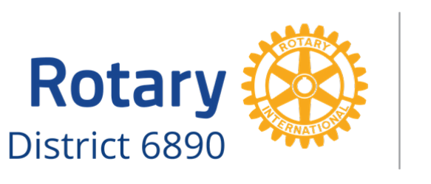
2021 District 6890 Speech Contest

TO: High School Students in Rotary District 6890
FR: [Name], Speech Contest Coordinator
[Name of Rotary Club] | [Telephone Number] | [Email address]
RE: Rotary Clubs of District 6890 Speech Contest
Date: [Fill in date]

I am writing to invite you to consider an excellent opportunity.
Each year Rotary District 6890 sponsors a district-wide speech contest. This is a wonderful experience for you to develop your public speaking skills while learning about the humanitarian work of Rotary International.
Eligibility: The contest is open to all high school students in the area, although children of Rotarians cannot compete within their parent’s Club. Each contestant is asked to speak for five to seven minutes on the same theme: Rotary Opens Opportunities. A panel of judges evaluates the contestants on delivery, originality, and content.
Composition: The topic for this year’s Speech Contest is the 2020-21 Rotary International theme: Rotary Opens Opportunities. Please see www.Rotary.org for information about this theme and the work of Rotary International in general. You may also wish to visit the Rotary District 6890 website: www.rotary6890.org. These are sources upon which you may draw for material, along with considering your own life experiences.
The speech must be between five and seven minutes and will be judged on the following elements: content (40 points), organization (30 points), and delivery (30 points). Notes are allowed but discouraged during the Club Level competition. Notes are not permitted during the Group Level and District Finals.
Competition: There are three rounds of competition. The first round is at the Club Level and will be completed by February 26, 2021. The winner proceeds to the Group Level competition, competing against four or five other Club Level winners. This phase will be completed no later than March 26, 2021. The winner of the Group Level proceeds to District Finals that will be conducted the evening of April 12, 2021 (location TBD).
Monetary prizes. Typically, first prize at the Club Level is $100. The winner of the Group Level usually receives $250. The District Finals winner will receive $1,000.
There are limitations on the number of students that can compete at the Club Level, so please contact me as soon as possible to become a contestant or ask for additional information.
I hope that you will consider this great opportunity!
Sincerely,
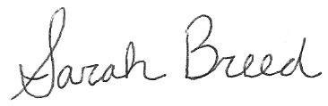
Sarah Breed
District 6890 Speech Contest Chair

