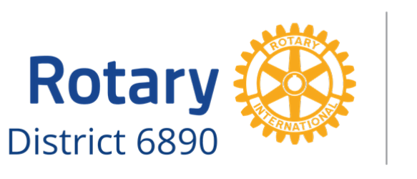
2021 District 6890 Speech Contest
TO: School Administrators and Faculty Members in Rotary District 6890
FR: [Name], Speech Contest Coordinator
[Name of Club] | ]Telephone Number] | [Email address]
RE: Rotary Clubs of District 6890 Speech Contest
Date: [fill in date]

I am writing to tell you about a wonderful opportunity for your students.
Every year Rotary District 6890 sponsors a district-wide speech contest. This is a great experience for students in our community to develop public speaking skills while learning about the humanitarian work of Rotary International.
The contest is open to all high school students in the area. Each contestant is asked to speak for five to seven minutes on the same theme: Rotary Opens Opportunities. A panel of judges evaluates the contestants on delivery, originality, and content.
There are three rounds of competition. The first round is at the Club Level and will be completed by February 26, 2021. The winner proceeds to the Group Level competition, competing against four or five other Club Level winners. This phase will be completed no later than March 26, 2021. The winner of the Group Level proceeds to District Finals that will be conducted the evening of April 12, 2021 (location TBD). School officials should be aware that the early rounds are typically held during weekly Rotary meeting times. Therefore, students may need to miss portions of two school days (or participate virtually).
Monetary prizes are provided. The Club Level prize is typically $100, and Group Level is $250. The District Finals winner will receive $1,000. Smaller cash prizes are awarded at the Club and Group Levels and District Finals for second and third places.
Each Rotary Club is responsible for recruiting its own contestants. Should you know of a student that may be interested in pursuing this opportunity, please contact me for information on becoming a contestant. There are limitations on the number of students that can compete at the Club Level, so please tend to this matter promptly.
We will be providing additional information to the contestants once they are selected. Should you need any information in the interim, please let me know.
I hope that you will consider advancing this opportunity to your students.

Sincerely,
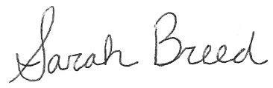
Sarah Breed
District 6890 Speech Contest Chair
sbreed@lakelandchamber.com
(863) 670-9091

