Polk County Rotary Clubs Joint Project
Scholarship House
Work Plan r1
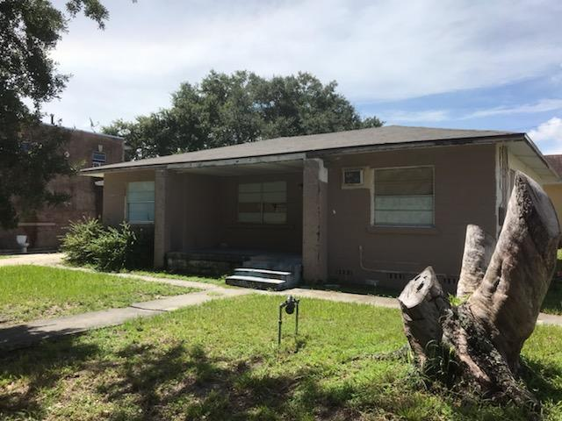
MATERIALS NEEDED
Do you know Rotarians who might contribute these items?
Could your club make a donation to purchase these items?

Range, Fridge, sink, faucet (donated by local builder)
Kitchen cabinets (upper and lowers approx. 3 of each), countertop
Flooring throughout 1800 sq ft house, all subfloor is in and solid
2 single sink vanities with faucets, 2 toilets, shower stall
Landscape materials
5 A/C window units
7 flush ceiling fans with light fixtures

VOLUNTEER WORK NEEDED
Can your club commit volunteers to this project?

Kitchen:
Before 9-28-2019 work day:
- Wall prep including plaster repair
- Change access door for water heater
- Install new 80 gal water heater (provided by Linda Johnson, Group 7)
- Install ceiling fan light fixture

Day of work:
- Install cabinets, countertop
- Paint
Materials Needed:
- Cabinets
- Countertop
- Range, Fridge, hood
- Sink, faucet
Dining Room:
Before 9-28-2019 work day:
- Plaster ceiling repair and wall prep
Day of work:
- Hang ceiling fan with light fixture flush mount
- Paint
Bedrooms 1,2 and 4
Before 9-28-2019 work day:
- wall prep and window prep
Day of work:
- Hang ceiling fan with light fixture flush mount
- Paint
Bedrooms 3
Before 9-28-2019 work day:
- Ceiling plaster repair
Day of work:
- Hang ceiling fan with light fixture flush mount
- Paint

Half Bath
Before 9-28-2019 work day:
- Remove old vanity and toilet
Day of work:
- Install new vanity and toilet
- Paint
Full Bath
Before 9-28-2019 work day:
- Complete design plan
Day of work:
- TBD according to plan
Outside:
- Stump removal
- Fascia on front
- Paint
- High View Tree Services of Lakeland has volunteered to raise the canopies of the surrounding trees

CONNECT TO THIS PROJECT
Volunteers and Donations are critical to our success.

To volunteer OR donate materials, either as an individual or as a club, contact Jane Hammond at 863-255-7965 or email jane.hammond@elderpoint.org

To donate, sends funds to:
The Ridge Foundation of Rotary on the Ridge
Attention Gio Fazzini, Foundation Chair
c/o The Ouellette Law Firm
151 E Central Ave
Lake Wales, Florida 33853

