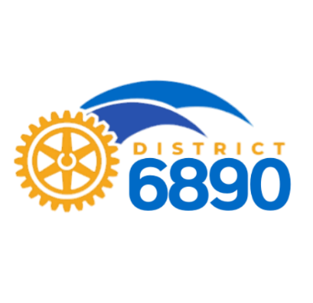
15 August 2020

SEED GRANTS AVAILABLE
Nicole Salinas is an intern with Seed Programs International. SPI is a North Carolina-based nonprofit organization dedicated to providing access to good quality vegetable seeds, expertise, and training materials to humanitarian organizations worldwide to alleviate hunger and poverty. Their mission gives a hand-up to those in need through vegetable production.
Each year, SPI awards a seed grant each year to Rotary Clubs to support the Rotarians Against Hunger (RAH) project. Western North Carolina-based Rotary Clubs in Rotary District 7670 and SPI have partnered for the last three years. The Rotary Clubs in district 7670 leads the RAH project. The project gives vegetable seeds to fellow Rotarians worldwide for nutrition, education, and income development projects. Rotarians can partner up with nonprofits or other community groups who distribute seed for gardening projects. The projects should include gardening training to help people use the seeds effectively. The seed grant would be a perfect opportunity for a stand-alone international club project, a collaboration with multiple clubs in your district or a complementary addition to an existing international project.
Seed Grant Requirements
Apply between August 1st - September 30th. Applications received after that date will not be accepted.
Seed grant decisions will be made in early October, and the seed will be distributed by year-end.
To apply for the seed grant, click on the following link https://seedprograms.org/work-with-us/rotary and fill out the application.
We do not award money, only seeds. You can apply for up to five cartons of seed. Each box holds about 1500 home garden-size packets of vegetable seeds. This is enough seed for 200 households to plant a garden! All SPI seeds are shipped from Michigan. SPI will help you with the seed selection (seed types that are right for the climate, culture, and program goals) and coordinate the shipping.
We support projects involving household gardens, community gardens, microenterprise, farmer cooperatives, school gardens, children's homes, IDP/refugee camps, or other settings. The seed grant is only available to projects outside of the US and Canada.
For Further Information
Please share this information with your Service Chair and let SPI know if you have any questions on how they can help support you and your project. For more information about Seed Programs International, visit www.seedprograms.org and watch the video. You may contact the Program Director, Rosanna Kingston, by email at rosanna.kingston@seedprograms.org or the Program Assistant, Katie Sinn, by email at katie.sinn@seedprograms.org or by phone at (828) 337-8632.

