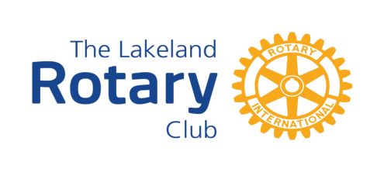 REGISTRATION FORM
HONDURAS MISSION TRIP JANUARY 21-28, 2023

Thank you for your interest in our Rotary Trip to Honduras! This is the first step in beginning your journey to serve the people of La Paz. Don't be surprised if the life that changes, is yours!
- NOTE: A $100 non-refundable deposit will be due along with your application and will secure your spot.
- Please Print Clearly or Type!
Name as it appears on your passport:
Date of Birth:
Address:
Phone:
Email:
Passport Number:
Passport Expiration Date:
Do you speak Spanish?
Do you have any allergies, special food requirements, or physical limitations?

