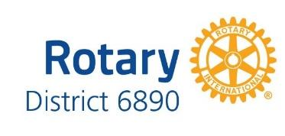

June 18, 2023 Imaginarian
Celebrating Rotary

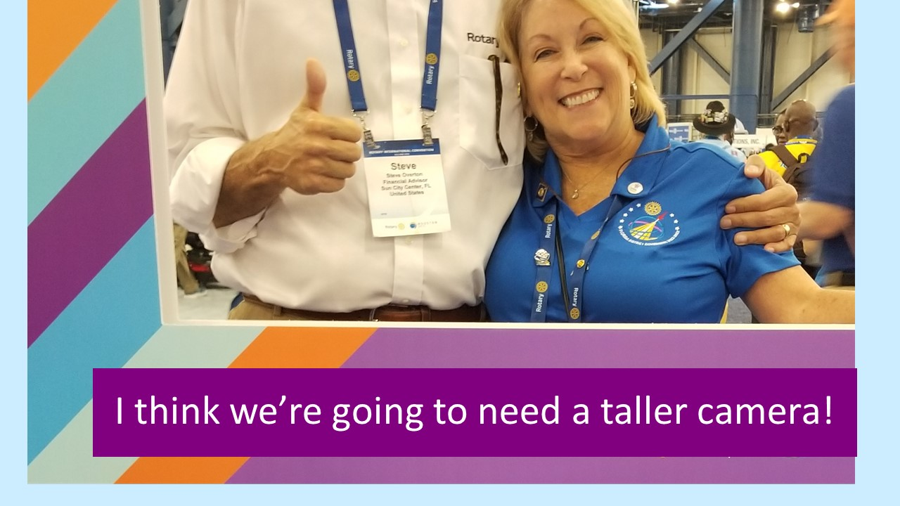
This weekend we celebrated our Rotary Year, as we installed our next District Governor for 2023-2024, Steve Overton. Hosted by the new DG's home club, the Rotarians of Sun City Center, we gathered in a beautiful setting in Apollo Beach. The program's Master of Ceremony was Bob Hite, a retired news broadcaster, who was able to roast Steve like no one else! It was an evening of laughter, fellowship, and recognition of the Good we are doing in the World.
We recognized some special Rotarians as the 2022-2023 Heroes of District 6890! They are Rotarians who shine brightly and embody the best of us. They truly Imagine what Rotary can be!
Disaster Response Hero, Kevin Kitto for his leadership organizing the boots on the ground after Hurricane Ian.
Polio Plus Hero, Nick Hall for his passionate work raising money and awareness for the End Polio Now Campaign.
Director of Fun, Kim Tyson for her hard work organizing and making this year’s District Conference a success.
Assistant Governor of the Year, John Eason for his dedication in supporting the Rotary Clubs in his area.
Service Above Self Award, Deb Amlaw for her never ending support of District.
District Leadership Award, Bill Cox for his strategic leadership ability in both our District and his Club.
Rotarian of the Year, Lesley Zajac for her selfless and never-ending work supporting her Clubs as AG and her work supporting the District as Foundation Grants Chair.
Rotary District 6890 Club of the Year, Sun City Center Rotary Club for Imagining a Rotary Club that increased Membership, Foundation Giving, Community Service, and Visibility.

The rest of June will be filled with Club Installations and end of year celebrations.
Congratulations to all our District's Clubs for your successes this year.
Thank you for being People of Action!
Isn’t it wonderful to see what we can be - and - be the change that we want to see?

