MINUTARIAN from DG MARK For meetings the Week of September 21, 2020
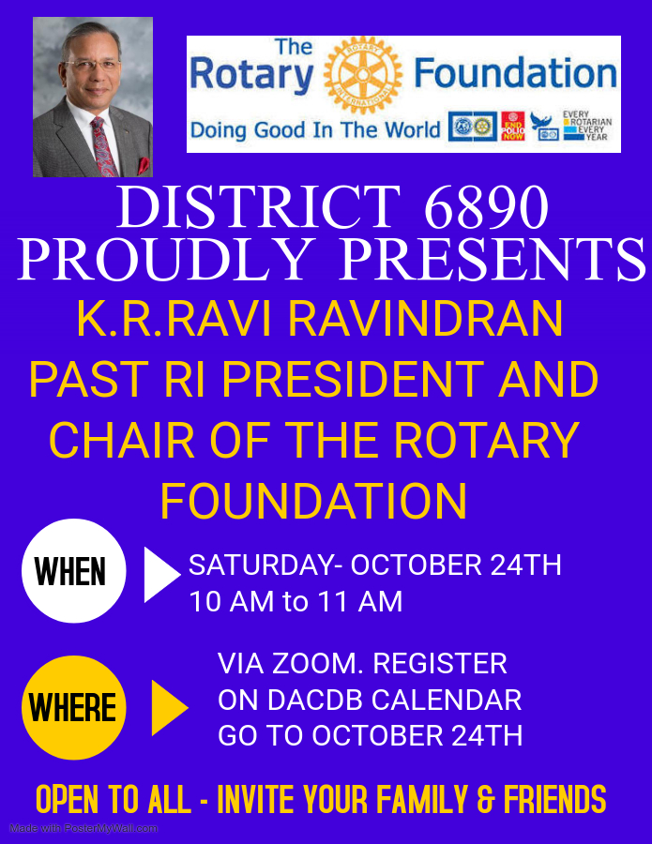
MINUTARIAN from DG MARK For meetings the Week of September 21, 2020
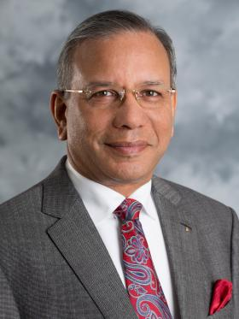
SAVE THE DATE- 10.24.2020! #RotaryDistrict6890 is proud to invite you to share an inspiring hour on World Polio Day listening to Ravi Ravindran, The Rotary Foundation Chair 2020-21, Trustee 2017-21, Rotary Club of Colombo Western Province, Sri Lanka
K.R. "Ravi" Ravindran is a third-generation Rotarian, joining Rotary at age 21. As RI president in 2015-16, he introduced the Rotary Global Rewards program and led a delegation of about 9,000 Rotarians to the Vatican for an audience with Pope Francis in St. Peter’s Square.
Ravindran was the first president of the Sri Lanka Anti-Narcotics Association, which today is the leading agency fighting drug addiction in Sri Lanka. He headed a national committee consisting of Rotary, his country’s health ministry, and UNICEF for the eradication of polio, and worked closely with UNICEF to negotiate a cease-fire in the ongoing civil war with the northern militants to facilitate National Immunization Days. Sri Lanka became the first country in South Asia to become polio-free. He also headed a Rotary project to build 25 modern schools across the country to replace those destroyed by the 2004 tsunami at a cost of over $12 million.
Ravindran is the CEO and founder of a publicly listed company engaged in the print and packaging industry with worldwide clientele. His company, Printcare PLC, is a winner of national and international awards of excellence. He is the recipient of The Rotary Foundation’s Citation for Meritorious Service, Distinguished Service Award, and Service Award for a Polio-Free World. His country conferred on him the title of “Jewel of Sri Lanka” and released a postage stamp in his honor
It is my sincere wish that District 6890 Rotarians will attend this Zoom gathering in large number. This event is being widely promoted among other districts as well. Please go to the DACdb Calendar to register for the Zoom link and be sure to mark your own calendar for this special World Polio Day speaker, 10 am on Saturday, October 24th .

Yours in Rotary – DG Mark

