MINUTARIAN from DG Mark
For meetings beginning the Week of July 20, 2020
Please read the Rotary Vision Statement first and then continue with the script:

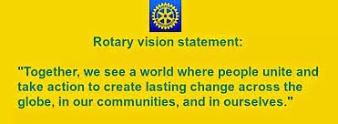

The Rotary Vision statement came about as part of a strategic planning process that examined Rotary’s strengths, weaknesses, opportunities, and threats in order to move the organization in a direction that would allow Rotary to thrive in the years ahead. You may wonder what its relevance is to you. If Rotary were a ship approaching land, our vision statement would be the lighthouse that keeps us from running aground.
Strategic planning is a process, not an event. When you read the vision statement, think about how these 24 words reflect the impact we wish to have in the world. Think about what it means to your club. Look for opportunities to give your input into your club’s strategic planning process.
Every club is being tasked with having at least one strategic planning meeting each year. Use these words and the resources available in the Rotary Learning Center to help guide you. As always, I am here to help in any way I can.

Yours in Rotary – DG Mark

