MINUTARIAN from DG MARK for the WEEK OF June 28, 2021
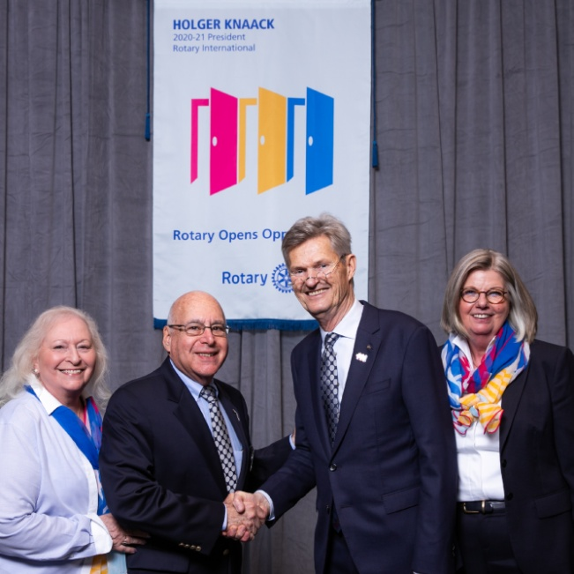
My Family of Rotary - This image of Irma and I with President Holger and Susanne was taken in January 2020 at International Assembly in San Diego. Unknown to us then, this was last time I was able to fly anywhere for Rotary. We had no idea what was in store for us. We were so excited about the great plans for our Rotary year, filled with events, programs, and meetings that all had to be changed. Rotary came through though, because each of our clubs did what they could to stay engaged and help in their communities. Bravo to all of you!
My goals for the year had to be realigned but we all persevered and still worked to reinvigorate our Foundation and End Polio Now efforts. Foundation presentations were made to more than half our district 's clubs. Fifteen clubs had Proclamations for World Polio Day by their local government helping to raise awareness of our continuing work towards eradication of this awful disease. We offered ideas for ways clubs could celebrate World Polio Day safely. We had Foundation Chair Ravi speak to our district from his home in Indonesia for World Polio Day - another way Zoom helped us stay engaged even with a 9-hour time difference!
To help club's find speakers from around the world , we created a Speaker's Bureau that many of you used to have programs with speakers that you likely would not have been able to have under normal conditions. (Another plus for Zoom!) We also offered everyone Virtual Fundraising Ideas, Social Media Ideas, and had some fun online contests.
Clubs still worked on membership plans and strategic planning. Many learned how to do Zoom and then have Hybrid Meetings. There were many people helping to make all these things happen and I thank you all! Every bit of effort has helped foster engagement and kept us going strong! We even have grown our number of Interact Clubs, we have a new Satellite Club, and Rotaractors at UT have been voted the Best New Club on campus. Win, win, and win!
We kept in touch via Zoom of course, but also sharing news with you via weekly Minutarians, monthly Newsletters, and our monthly News Videos. We tried to not inundate you with too many P-mails! I hope that all of this has helped you through this strange and sometimes scary time. I hope you will look back with a few fond memories of Rotary during the pandemic. I know for certain that I will. Thank you all for allowing me this opportunity. It has been my honor to serve as your District Governor 2020-2021.
Yours in Rotary -
DG Mark

