MINUTARIAN from DG MARK for the WEEK OF MAY 3, 2021
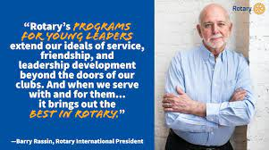
May is Youth Service Month. We should celebrate all of the wonderful activities we do for youth in our communities and around the world. District 6890 has a strong 4STL Program led by Dawn Carson from the FishHawk Riverview RC. This is a great youth leadership training program that we should all be very proud of.
Youth Service Month is a special time in Rotary. Rotary believes in developing the next generation of leaders. Our programs help younger leaders build leadership skills, expand education and learn the value of service. Throughout the month of May, members of Rotary clubs, Rotaract, Interact, and those involved in Rotary Youth Leadership Awards celebrate the opportunities Rotary provides to connect, grow through service, develop leadership skills, mentor or be mentored, and have fun.
Take this month to focus on initiatives that will help your club earn this year’s Rotary Citation. Brainstorm sustainable service projects, ways to increase giving to The Rotary Foundation, and build awareness of Rotary in your community. Young people are looking for a way to make a difference. Show them how Rotary equips them to do so, especially in this time of crisis. And watch your membership grow!
Yours in Rotary -
DG Mark

