MINUTARIAN from DG MARK for the WEEK OF MAY 24, 2021
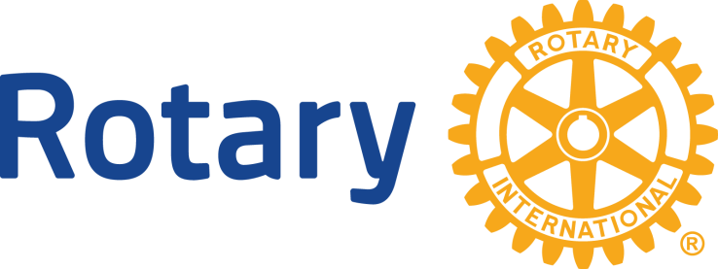
EMBRACING THE LOGO - Together We Can Unite Rotary
This week I offer you a message from RI President Holger and RI President Elect Shekhar:
Rotary’s logos mean so much to us. They’re the visual representation of our identity and values, and they instantly convey who we are. Those of us who’ve been with Rotary for many years have even seen the evolution of that logo. Repeated and consistent use of our logos builds global recognition of what we do. That’s why we all wear our Rotary pins so proudly!
Over the next several months, we’ll ask Rotary, Rotaract, and Interact clubs to update their logos to align with our brand standards. This means using the template in the Brand Center to create a club logo and then using it consistently, like on club websites, social media accounts, and signage, to name a few.
As a leader and brand ambassador, you lead by example when you use Rotary’s logos properly in your district publications. You can also support our efforts by addressing branding during virtual club visits, challenging incoming club leaders to update their club logos, or encouraging district public image chairs and committees to contact clubs to offer hands-on assistance.
We understand that updating a logo might not seem to be a very high priority, especially during a pandemic. But look at it this way: With so many of our clubs supporting their communities during this health crisis, consistently using a unified brand signals to the public — including potential members and donors — that local clubs are supporting the community and those clubs are part of the global Rotary network. It establishes trust in our organization and our members.
Resources are available in the Brand Center and Learning Center, plus you can work with your regional or district public image coordinator for guidance and support.
When every club uses the same visual identity, it builds awareness of who we are and the impact that we make around the world as people of action. Thank you for joining our effort to make the Rotary brand stronger than ever.
Holger Knaack  2020-2021, President, Rotary International | Shekhar Mehta  2021-22, President, Rotary International
District 6890 Rotarians - let's get on this and be sure we are using correct logos wherever and whenever possible! Thank-you!
Yours in Rotary - DG Mark

