MINUTARIAN from DG MARK for the WEEK OF MAY 17, 2021
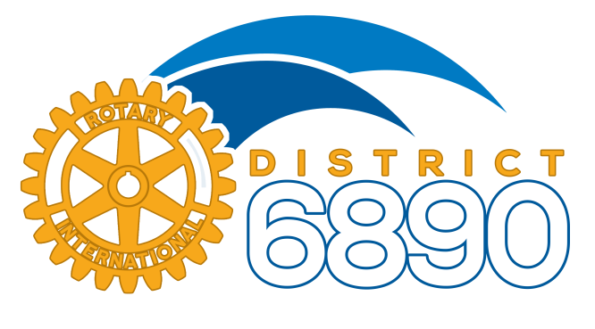
There are two District Challenges going on that I want to be sure you all are aware of and will hopefully be participating in. These have both been started by an idea presented from one person and they have both taken off! First, thank you to Christine Ans from FishHawk Riverview and AG Linda Johnson from Auburndale. Then more thanks to those of you who have stepped up and joined in these efforts.
The District 6890 Membership Challenge that Christine thought of has a goal to add 100 new members to District 6890 before the end of June! We have 37 Rotary Clubs and 9 Rotaract Clubs so this is totally doable! Help spread the word about your club via Social Media...tag your friends, family, and coworkers. Invite them to a meeting. Most importantly though, tell them why you joined Rotary and why you care so much about it. I pledge to honor the club and individual Rotarian who bring in the most new members with Paul Harris points.
The other current challenge is “Rotary Cares a Ton” which is being led by AG Linda Johnson. The goal is to donate 50 tons to local charities by May31st and if each club donates at least one ton, this is totally doable as well! This challenge is an outstanding idea to help others as we give away our unwanted “stuff”. This is recycling at its best! Spring clean your house and garage and give your items to an organization of your choice. Just estimate the weight and tell your club coordinator. There will be prizes so see if your club will win!
Yours in Rotary -
DG Mark

