MINUTARIAN from DG MARK for the WEEK OF MAY 10, 2021
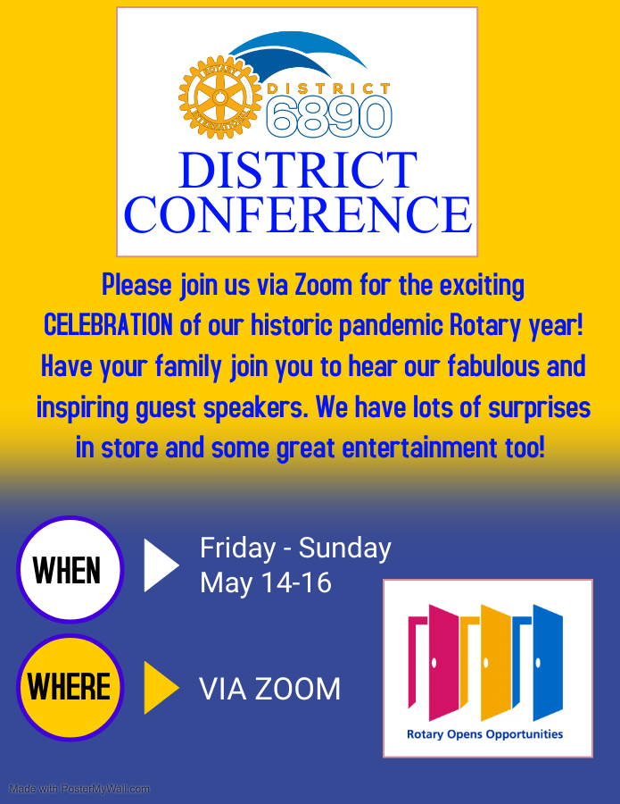
Please make plans to join the Virtual District 6890 Conference for a Historic Celebration! We will we gather on May 14, 15, and 16 to recognize leaders and clubs in our district and enjoy fellowship, entertainment, great speakers, and more! This will be an Historic District Conference and we invite you and your family to attend.
Special Guest Speakers include:
Zone Coordinator Stephanie Urchick
PDG Vanessa Ervin, RC of Jacksonville NC
DG Peter Verbeeck, Key Biscayne FL RC
We are planning some fun entertainment and we have several awards to present. On Sunday morning we will have a Memorial Service to recognize those Rotarians in District 6890 who we lost this past year. If you have never been to one of these services, I urge you to attend. It is very moving.
This District Conference is FREE of charge - that is also Historic! So take advantage and come together to celebrate all things Rotary. It has been a year worthy of celebrating despite the challenges we all faced.
Yours in Rotary -
DG Mark

