MINUTARIAN from DG MARK for the WEEK OF MAY 31, 2021
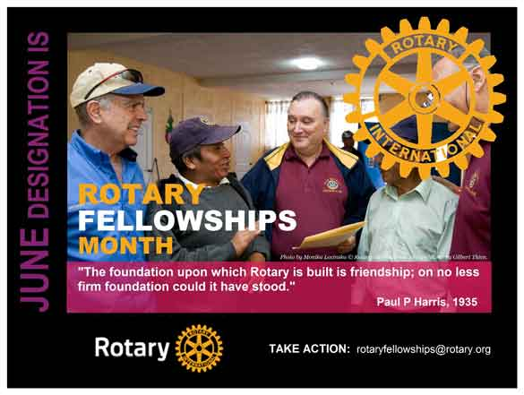
June is designated as Rotary Fellowships Month by the RI Board to recognize the importance of international fellowship and good will among Rotarians with similar recreational interests, vocations, and health and medical issue-oriented interests, to promote increased participation in fellowships and increase understanding of this program. The RI Board encourages fellowships groups to highlight activities through projects, activities, and events in celebration of Rotary Fellowships Month in June.
Rotary Fellowships informally began in 1928 when a group of Rotarians with an interest in Esperanto joined together. In 1947, Rotarians organized a group of boating enthusiasts, which became the Yachting Fellowship.
These activities gained more attention and operated over the years as World Fellowship Activities, International Vocational Contact Groups, Rotary Recreational and Vocational Fellowships, and finally, Rotary Fellowships.
Each Fellowship is officially recognized by the RI Board of Directors, but operates independently of Rotary International, with its own rules, dues requirements, and administrative structure. Membership in fellowships is open to Rotarians, spouses of Rotarians and Rotaractors. Each fellowship must maintain a membership base representing at least three different countries. Each fellowship elects at least three officers to oversee the group’s operations. Fellowships are expected to facilitate communication amongst their members and to maintain regular communication with Rotary International.

Rotary Fellowships are international groups that share a common passion. Being part of a fellowship is a fun way to make friends around the world, explore a hobby or profession, and enhance your Rotary experience. Membership in a fellowship is open to any interested individual. You can contact a fellowship directly by using the links below.

Yours in Rotary -

DG Mark

How do I form a fellowship?
- Read this Guide for Prospective Rotary Fellowships.
- Find others interested in the topic:
  - Join a discussion group or start a new one. It's a great way to share your interest with other members.
  - Use Rotary’s presence on Facebook, Twitter, and LinkedIn to promote your idea.
  - Attend the Rotary International Convention or other Rotary events.
  - Reach out to district leadership in other countries to build membership.
- Apply for official recognition using this online form.

Explore our fellowships
Interested in a particular subject? Visit the group's website or email it to learn more.
- 4x4 vehicles
- Amateur Radio
- Antique Automobiles
- Bathhouse
- Beard and Moustache
- Bee
- Beer
- Bird Watching
- Caravanning
- Chess
- Computer Users
- Corporate Social Responsibility
- Cricket
- Cruising
- Cultural Heritage
- Curling
- Cycling
- Doll Lovers
- Draughts (Checkers)
- E-Clubs
- Editors and Publishers
- Educators
- Environment
- Esperanto
- Ethics
- European Philosophy
- Executive Managers
- Fishing
- Flying
- Genealogists
- Gin
- Go
- Golf
- Gourmet Cooking
- Graphic Designers
- Healthcare Professionals
- Hiking
- Home Exchange
- Honorary Consuls
- Horseback Riding
- Hunting
- Internet
- Italian Culture
- Jazz
- Latin Culture
- Lawyers
- LGBT
- Magicians
- Magna Graecia
- Marathon Running
- Metalhead
- Military Veterans
- Motorcycling
- Music
- Old and Rare Books
- Palmwine
- Past District Governors
- Peace Fellows
- Photographers
- Police and Law Enforcement
- Public Health
- Quilters and Fiber Artists
- Railroads
- Recreational Vehicles
- Rotary Global History
- Rotary Heritage and History
- Rotary Means Business
- Rotary on Pins
- Rotary on Stamps
- Rowing
- Rum
- Scouting
- Scuba
- Shooting Sport
- Singles
- Skiing
- Social Networks
- Strategic Planning
- Surfing
- Table Tennis
- Tennis
- Travel and Hosting
- Triathlon
- Wellness and Fitness
- Whisk(e)y
- Wildlife Conservation
- Wine
- Yachting
- Yoga

Related Stories and Resources

RESOURCES
- Rotary Fellowships flier
- Rotary Fellowships Officer Reporting Form
- Rotary Fellowships Annual Report
- Rotary Fellowships PowerPoint
- Rotary Fellowships Code of Policies
- Rotary Fellowships Visual Identity Guidelines
- Build international friendships through Rotary

