MINUTARIAN FROM DG MARK - WEEK OF APRIL 5, 2021
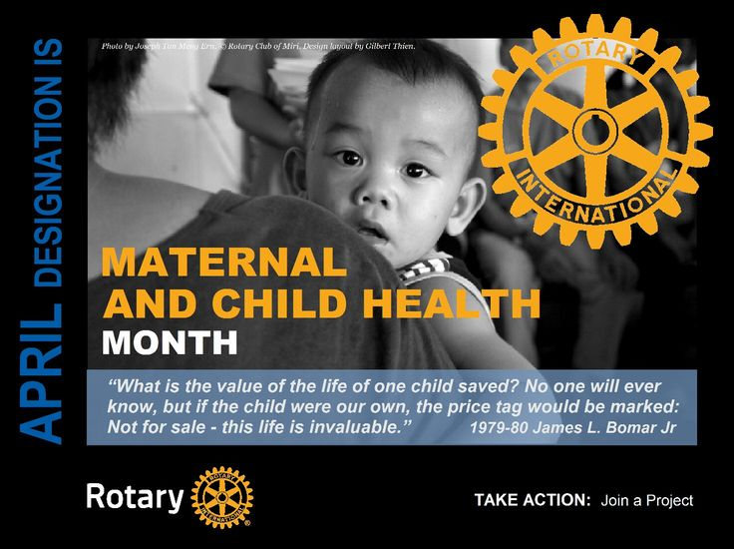
During April, Rotary Maternal and Child Health Month, take action to support mothers and children!
An estimated 7 million children under the age of five die each year because of malnutrition, inadequate health care, and poor sanitation — all of which can be prevented. Rotary members expand access to quality care, so mothers and children everywhere can have the same opportunities for a healthy future.
Members provide education, immunizations, birth kits, and mobile health clinics. Women are taught how to prevent mother-to-infant HIV transmission, how to breast feed, and how to protect themselves and their children from disease.
Rotary’s projects ensure sustainability by empowering the local community to take ownership of health care training programs. Maternal and Child Health Care is also recognized as one of Rotary’s Seven Areas of Focus.
Here are some ideas of ways you and your club can help locally or with a project somewhere else in the world:
- Address the issue of Malnutrition’s in Children and Pregnant Women
- Develop a Hygiene Education program for school aged children
- Conduct Awareness Seminars
- Provide low-income women with the knowledge, skills and opportunities to improve their diet, physical activity, and other life habits to prevent, delay, or control chronic diseases
- Promote School Health
- Promote the adoption of physical activity in early child care centers, schools and work sites
Thank you and please share your ideas and projects on Facebook @RotaryDistrict6890 .
Yours in Rotary Service-
DG Mark

