MINUTARIAN WEEK OF APRIL 26, 2021
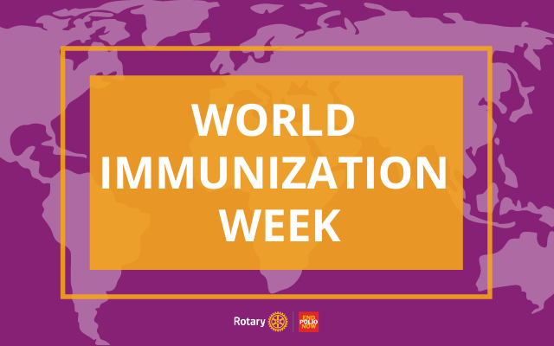
World Immunization Week is 24-30 April
Join with Rotary to promote the power of vaccines.
During World Immunization Week, 24-30 April, join with Rotary to combat vaccine hesitancy and misinformation by spreading the facts about why #VaccinesWork.
With decades of experience fighting polio, Rotary plays a key role in informing people about the power and effectiveness of vaccines. As COVID-19 vaccines become more available, Rotary members are using our experience in fighting polio to help communities with their vaccination education and organization efforts. And today, because we and our partners have worked so hard, wild poliovirus remains endemic in only two countries: Afghanistan and Pakistan. But to eradicate it there and to prevent a resurgence in other parts of the world, we must continue to build trust in vaccines and raise funds for polio eradication, including vaccine delivery.
This year, you can take action for World Immunization Week in three easy ways:
- Download and share our new two-minute video, “Rotary Inspires Leaders in Global Health,” and show it to your club. In it, global health leaders like U.S. infectious disease expert Dr. Anthony Fauci, Bill & Melinda Gates Foundation Co-Chair Bill Gates, UNICEF Executive Director Henrietta H. Fore, and World Health Organization Director-General Dr. Tedros Adhanom Ghebreyesus talk about what Rotary has achieved in the fight to end polio.
- Post graphics and other content from Rotary’s World Immunization Week Toolkit on social media with the hashtags #EndPolio and #VaccinesWork.
- Donate to Rotary’s PolioPlus Fund to help us and our partners deliver polio vaccines to vulnerable children. Your contribution will be tripled, thanks to the Gates Foundation.
Consider giving District Designated Funds (DDF) to PolioPlus. DDF allocations will be matched 100% by The Rotary Foundation’s World Fund through 30 June. It’s vital that we continue raising $50 million each year for polio eradication.
Yours in Rotary - DG Mark

